Templates Manager ‒ Manual

Table of contents
1 Introduction 3
1.1 Languages 3
1.2 Editions 3
1.2.1 The SPFX extension 3
1.2.2 The Sandboxed Solution 3
1.2.3 PowerShell Edition 4
1.3 Requirements 4
1.4 Permissions 4
1.4.1 Use Templates Manager 4
1.4.2 Upload and Install the SPFX extension 4
1.4.3 Install and Activate the Sandboxed Solution 4
1.4.4 Install with a PowerShell Script 4
2 Installation 5
2.1 SPFX extension 5
2.1.1 Deploy in an App Catalog 5
2.1.2 Install in a Site 6
2.2 Sandboxed Solution 7
2.2.1 Install with a Microsoft 365 Group 7
2.2.2 Upload to a Solutions Gallery 8
2.2.3 Activate for a Site 9
2.3 PowerShell Edition 9
3 The “TMTemplates” Library 10
3.1 Create a “TMTemplates” Library 10
3.1.1 Example Data 11
3.2 Test Example 11
3.2.1 Upload a Template to “TMTemplates” 12
3.2.2 Hide “TMTemplates” from the Site Navigation 12
4 Use Templates Manager 13
4.1 Find Templates 13
4.2 Select a Template 13
4.2.1 Sort Templates 13
4.2.2 Search Templates 13
4.2.3 See Template Details 14
4.2.4 Create a New Document 14
5 Registration 16
6 Upgrade 17
6.1 Upgrade the SPFX extension 17
6.2 Upgrade Templates Manager Sandboxed Solution 17
6.3 Upgrade with a PowerShell Script 18
7 Remove 18
8 Contact 18
8.1 SharePoint Tips 18

Introduction
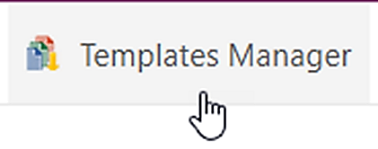
Templates Manager for SharePoint uses the Search feature in SharePoint to pick templates from all template libraries that each user has access to. The templates are displayed when the user clicks on the ‘Templates Manager’ button that is visible in all document libraries in sites where Templates Manager is installed.
This manual describes installation, use and licensing of Templates Manager for SharePoint. The screenshots in the manual are taken from Microsoft 365 SharePoint Online, but Templates Manager works with all editions of SharePoint 2013 and above.
Chapter 4 of this manual is intended for all users, while the rest is meant for the administrator.

Languages
The language of Templates Manager is automatically set to the same as on the SharePoint site. The supported languages are: Danish, Dutch, English, French, German, Italian, Norwegian, Portuguese, Spanish and Swedish. When SharePoint has an unsupported language, English is used instead.
The templates may of course be in any language. The language support limitation is only relevant for a few Templates Manager buttons.

Editions
Templates Manager comes in three editions, SPFX extension, Sandboxed solution and PowerShell package. They are installed in different ways, but they have the same version number and features.
One subscription is valid for all editions, so you can use any combination of editions you wish.

The SPFX extension
The SPFX extension, or modern client extension, only supports SharePoint Online, but it is very easy to install and upgrade so we recommend that you use it when possible.
The SPFX extension ZIP file includes a SPPKG file, and as soon as this file has been deployed in the tenant's app catalog, it is available to all users to install in a site via the ‘Add an app’ command.
To upgrade the web part, replace the file in the tenant’s app catalog. All installations in the tenant will then be upgraded automatically.

The Sandboxed Solution
The sandboxed SharePoint solution ZIP file includes a WSP file, which is uploaded to a SharePoint solution gallery. After that, Templates Manager can be activated on each site where it should be used.
The sandboxed solution supports SharePoint 2013, 2016, 2019 and Online, but it can only be installed in sites that have the Solutions gallery in the site settings – by default modern Team sites without a Microsoft 365 group and classic Team sites with and without a group. To add the gallery to other sites, refer to https://www.kalmstrom.com/Tips/SharePoint-Online-Course/Allow-Custom-Script-In-SharePoint.htm.

PowerShell Edition
The PowerShell edition is most useful when you need to automate the process of installing Templates Manager in multiple sites. This edition comes as a ZIP file that includes a PowerShell script, which must be modified for each organization before it is run.

Requirements
To use Templates Manager, you need to have SharePoint 2013 or higher (in-house or hosted) or Microsoft / Office 365 SharePoint Online.
Supported browsers are Microsoft Edge and the latest version of Google Chrome and Mozilla Firefox.

Permissions
Standard SharePoint permissions are used for Templates Manager.

Use Templates Manager
Users must have at least Contribute permission on the libraries they use. Users also need at least Read permission on the “TMTemplates” libraries they should get templates from.

Upload and Install the SPFX extension
To upload the SPPKG file to an app catalog, you need to be a Global or SharePoint Admin of your tenant.
To install the app in a site, you need to have at least Contributor permission on the site. The default Edit permission for site members will work fine.

Install and Activate the Sandboxed Solution
To install the sandboxed solution in a site, you need to be at least a Site admin, and to activate the solution for the site you must be at least Site owner.

Install with a PowerShell Script
You need to be a SharePoint Admin of the farm or tenant to run the PowerShell script that installs Templates Manager on all sites included in the script,

Installation
The recommended way to test Templates Manager is to create a new site for testing. Once the testing is completed, you should start over by installing Templates Manager imultiple production sites. It is however also possible to continue with the test installation.
When you start using Templates Manager in your organization, you probably want to have multiple installations for different teams. Be aware that Microsoft recommends use of many sites instead of very big sites with several levels. SharePoint works best that way
When you have organized your sites in hub families, you should install Templates Manager in the hub site and create a templates library there, see below. As all sites in the hub family have access to the hub site, you don’t have to create templates libraries in the other sites if they don’t have special needs. You just need to install Templates Manager, so that users get access to the ‘Templates Manager’ button.

SPFX extension
The Templates Manager SPFX extension can be used in all SharePoint Online sites, modern as well as classic. It is downloaded from the kalmstrom.com website to your PC and then extracted and uploaded to the organization’s app catalog. After that, it is available to the whole farm or tenant via the ‘Add an app’ command.

Deploy in an App Catalog
- Download the SPPKG file from the kalmstrom.com website to any folder on your computer and extract it.
- Go to your app catalog site. (If you have not already created such a site, here is a description on how to do it: https://www.kalmstrom.com/FAQ/TemplatesManager/0020.htm)
- Find the document library "Apps for SharePoint" and upload the SPPKG file there.
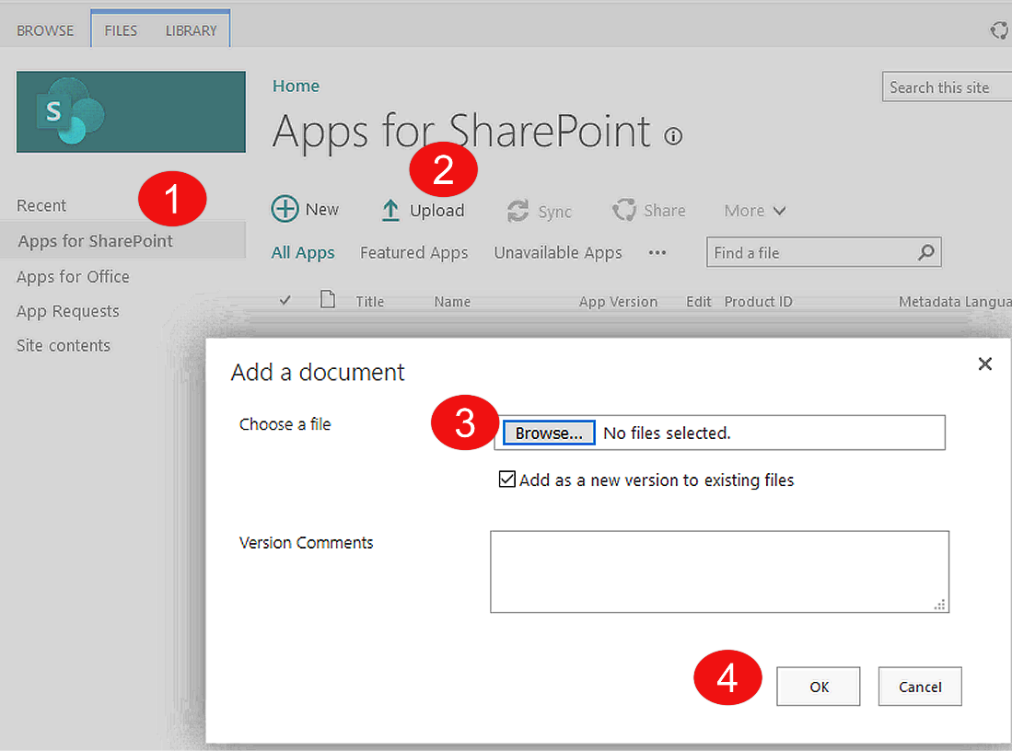
- You will get a dialog asking you to trust the file. Of course you need to trust it to use it. Express that trust by clicking on the ‘Deploy’ button. Here is the description of our security and privacy work: https://www.kalmstrom.com/Security.htm
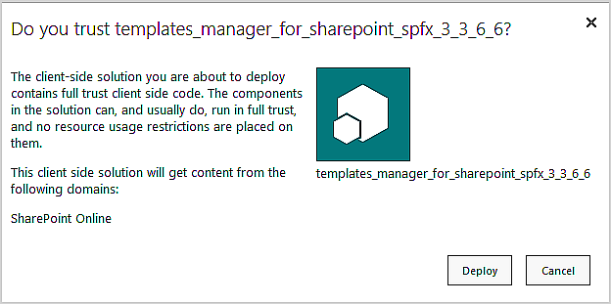

Install in a Site
- In the site where you want to use Templates Manager, click on the settings icon in the top navigation bar and select ‘Add an app’. You can also open the Site contents with the modern interface and click on ‘+ New’ and ‘App’.
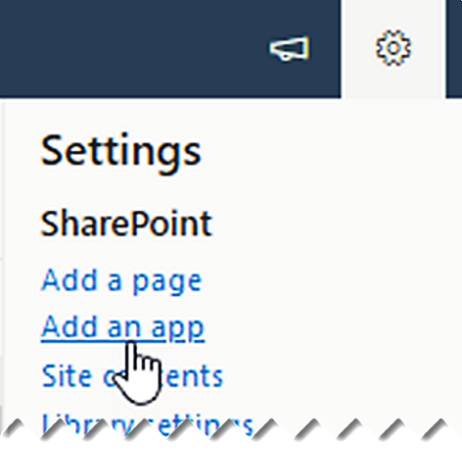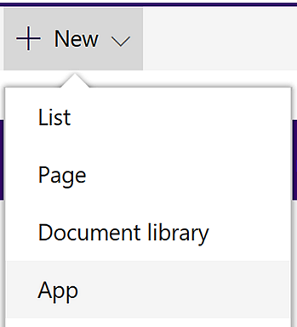
- Select "From your organanization" in the left menu.
- Click on the Templates Manager app.
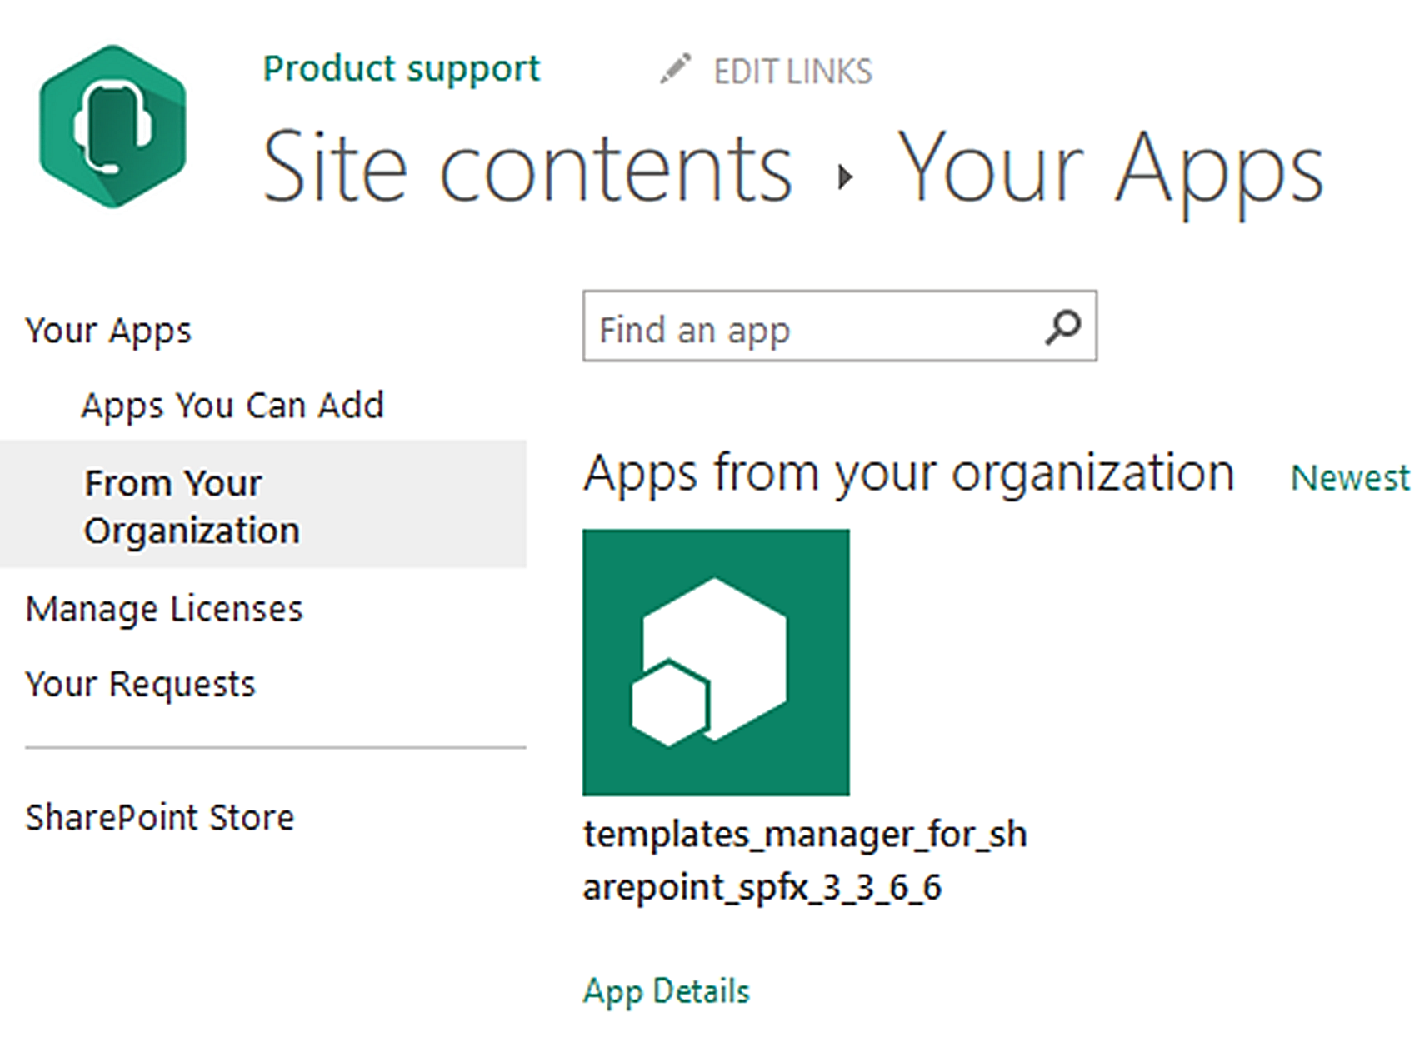
Now Templates Manager will be installed in the site. In a minute or so, the ‘Templates Manager’ button will show up in the command bar or ribbon in all document libraries in the site.
Repeat the 'Add an app' process for each site where you want to use Templates Manager.

Sandboxed Solution
The Templates Manager sandboxed solution is uploaded as a SharePoint Solution in a site, and it needs to be activated for each site where it will be used.
The SharePoint Sandboxed Code Services must be activated in the site where the sandboxed solution is installed, refer to https://www.kalmstrom.com/FAQ/TemplatesManager/3002.htm.

Install with a Microsoft 365 Group
The sandboxed solution cannot be installed in a modern Group Team site. Instead of the user created Group Team site, Global and SharePoint administrators can create a classic site from the SharePoint Admin center >Sites >Active sites >Create >Other options >More templates.
A link under the settings icon in the top navigation bar, makes it easy to associate the classic Team site with a new Microsoft 365 Group. Classic sites can use modern pages and the modern app interface, and on top of that you will have more Site settings features than in the user created Group Team site. Among them, is the possibility to upload solutions!

Upload to a Solutions Gallery
Download the file TemplatesManagerSP.zip from the kalmstrom.com website to any folder on your computer and extract it. Then follow these steps to add Templates Manager to the site collection.
- Go to the root site of the SharePoint site collection where you want to use Templates Manager and click on the Settings icon in the top navigation bar.
- Select the Site settings option, or select Site information and then Site settings.
- (If you don’t see these options, most likely you don’t have the appropriate permissions. You need to be Site admin to install solutions.)
- Under Web Designer Galleries, click on ‘Solutions’.
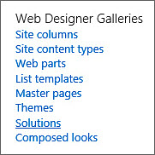
- Click on the ‘Upload Solution’ button and browse to the WSP file you downloaded from kalmstrom.com. (Open the SOLUTIONS tab if the ‘Upload Solution’ button is not visible.)
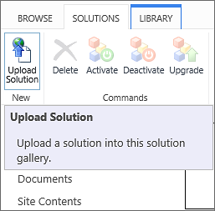
- When the file has been uploaded, you will be shown a dialog where you can activate the solution for the site collection.
Now Templates Manager is available for the site and any subsites.

Activate for a Site
Before Templates Manager can be used, the solution must be activated on each site or subsite where users should see the ‘Templates Manager’ button in the document libraries and/or where you want to add a templates library.
- Click on the settings icon in the top navigation bar and click on ‘Site settings’. You might need to first click on ‘Site information’.
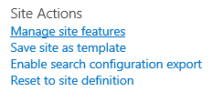
- Click on ‘Manage site features’ under the Site Actions heading. (If you don’t see this option, most likely you don’t have the appropriate permissions. You need to be Site owner to manage site features.)
- Find Templates Manager in the list of Site features.
- Click on the ‘Activate’ button to activate the Publisher feature.
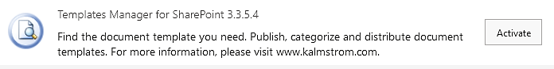
- The activation adds a ‘Templates Manager’ button to all document libraries in the site.

PowerShell Edition
If you want to automate the process of installing in multiple sites, we recommend the PowerShell edition. This edition comes as a zipped package that includes a PowerShell script.
- Extract the ZIP file.
- Open PowerShell ISE as an administrator.
- Open the .ps1 file from the Templates Manager package in PowerShell ISE.
- Modify the script, so that it connects to your farm or tenant and includes the sites where you want to install Templates Manager.
- Run the script.
- Now the script installs Templates Manager in each site that has been added to the script.
The demo on the download page shows the process, but you still need to have some experience of PowerShell to use this edition.

The “TMTemplates” Library
All templates that are shown to users when they click on the ‘Templates Manager’ button in a document library come from “TMTemplates” libraries. A “TMTemplates” library is a standard SharePoint document library, where we have added two extra single line of text columns: Description and Template Category.
Templates Manager uses the SharePoint Search engine to get templates from all “TMTemplates” libraries across the tenant or farm that the user has access to. This means that you can direct different templates to different users.

Create a “TMTemplates” Library
A “TMTemplates” library can be created via the ‘Templates Manager’ button in any site where Templates Manager has been installed. The permission level for the creation is however different, depending on if templates are loaded or not:
- When no templates are loaded, Templates Manager will give an option to create a “TMTemplates” library. Answer Yes, and the library will be created. In this case, any user with Edit permission or higher can create a “TMTemplates” library.
- When templates are loaded from other sites in a site where no “TMTemplates” library has been created, Site admins will see a ‘Create a templates library’ button below the loaded templates. In this case, only Site admins can create a new “TMTemplates” library. (By default, Site owners also have Site admin permission.)
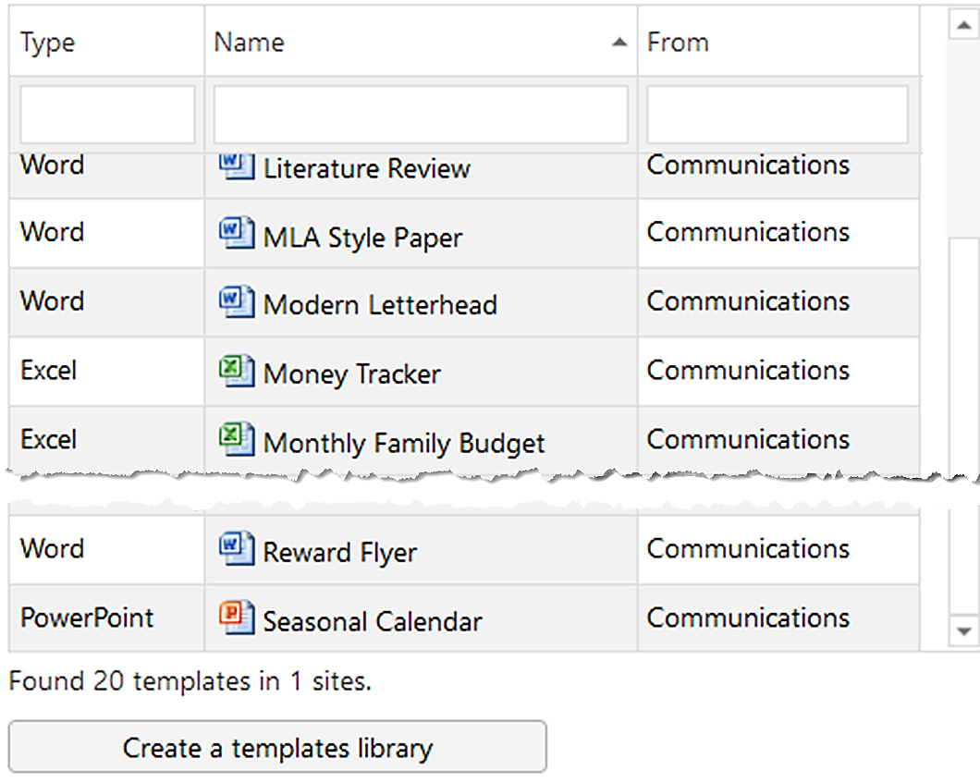

Example Data
You can select to create example data when the “TMTemplates” library has been created.
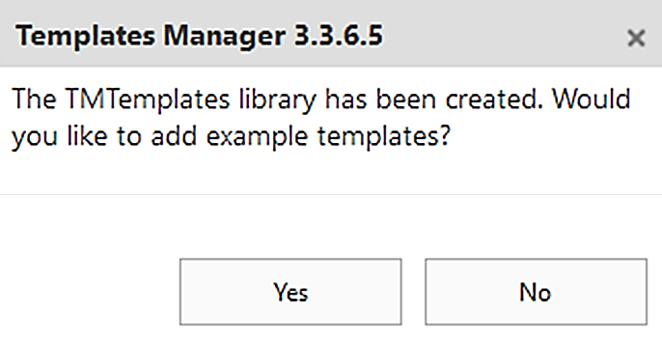
Note that all example data are the same, so when you create example data in multiple libraries, you will have multiple example templates of the same kind. You can however see below the list of templates how many libraries they are fetched from, and you can also see the site name to the right of every template.
If you create Example data, you should remove it before you start using Templates Manager with your own templates. To remove the Example data, open the Site contents and delete the whole “TMTemplates” library. When you click on the ‘Templates Manager’ button again, you can create a new “TMTemplates” library.
(You can of course also delete the actual template files, but as the SharePoint search feature tends to search removed files and libraries in the index for some time, removing the entire library and starting afresh is a better option in most cases.)

Test Example
Below is a simple example, where Templates Manager is installed in four sites and has three "TMTemplates" libraries. We assume that staff only have access to their own department site and to the Home site.
- Add a “TM Templates” library to the Home site. All users have access to this site, so this “TM Templates” library should contain templates that everyone might need to use now and then.
- Add another “TM Templates” library to the Sales site. In this “TM Templates” library you should add templates for quotations, contracts and other documents that the Sales staff might need.
- Add a third “TM Templates” library in the IT site. Here, you should add templates for technical documents needed by the IT staff.
- The Production site has no “TM Templates” library.
When a sales person clicks on the ‘Templates Manager’ button in any library, templates from the Home site and from the Sales site will be displayed.
When an IT person clicks on the ‘Templates Manager’ button in any library, templates from the Home site and from the IT site will be displayed.
When a person from the production team clicks on the ‘Templates Manager’ button in any library, templates from the Home site will be displayed.

Upload a Template to “TMTemplates”
Create a new template by uploading any Word, Excel or PowerPoint file to the “TMTemplates” library. In SharePoint, you don't have to create a real template. You can use any document of the same type that have the background, header and footer, font, colors and so on that you wish to use in new documents.
When a document has been uploaded to the “TMTemplates” library, you can fill out a category and a short descripion. This is not necessary but will make it easier for user to find the correct template for each new document.
You can also use the categorization to help and instruct users on which template to use and what business rules to apply for each template.

Hide “TMTemplates” from the Site Navigation
By default, a link to the “TMTemplates” library is displayed in the Site navigation/Quick launch. If the library only should be managed by a few people, you can hide the link:
- Open the Library settings in the “TMTemplates” library.
- Click on the ‘List name, description and navigation’ link under General settings.
- At ‘Display this document library on the Quick Launch?’, select the radiobutton ‘No’.

Use Templates Manager
Templates Manager adds a new button to each document library in sites where it has been installed. This button opens the templates that each user has access to.

Find Templates
In the modern library interface, you can find the ‘Templates Manager’ button in the command bar.
In the classic interface, there is a ‘Templates Manager’ button under the FILES tab.
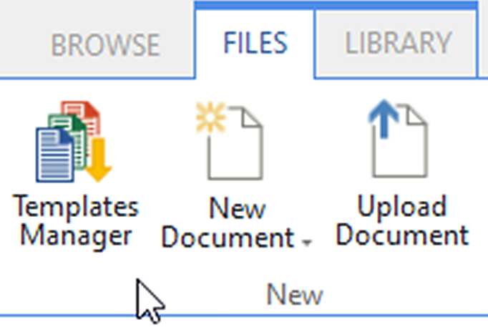
When you click on the button, a page or a dialog with a list of templates will open.

Select a Template
When you have clicked on the ‘Templates Manager’ button, all templates that you have access to will be displayed. You can sort them or search to find the best template for your purpose.
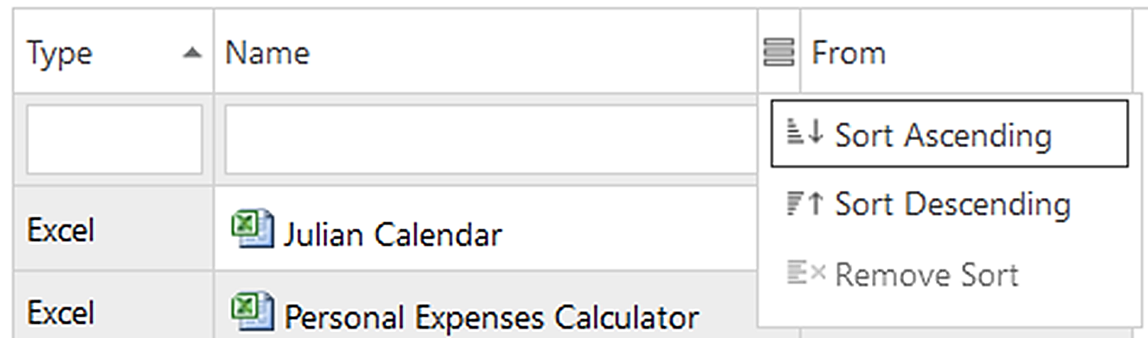

Sort Templates
Hover the mouse cursor over the parameter you want to sort: Type, Name or From. A sort icon will be displayed, and when you click on it, a dropdown with the options will open.
A little arrow to the right of the name, as at ‘Type’ in the image above, shows that the parameter has been sorted. Click on the arrow to change sort order.

Search Templates
Start writing in the empty fields below the template parameters, to search by keyword. Templates Manager has instant search, so it begins searching immediately. When you write more in the Search field, the hits will be more exact.
When you delete the search text, the search filter will be removed and all the templates become visible again.

See Template Details
Click on a template name to open a details pane with a description and a preview. The site where the template is stored and the template category is also displayed in the details pane.
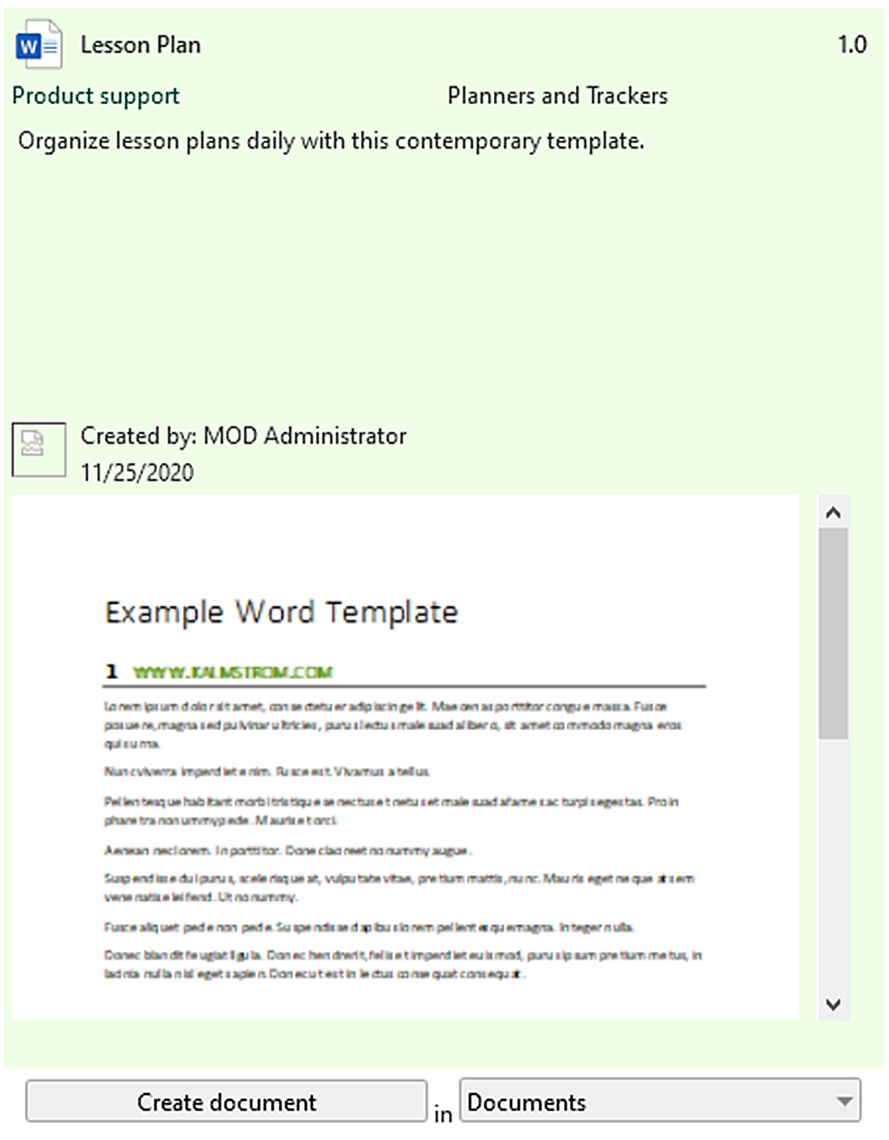

Create a New Document
When you have found the template you want to use, you can select which library the new document should be stored in, if the site has multiple document libraries. When the site only has one document library, there is no choice. The document will be stored in that library.
Click on the ‘Create a document’ button to open the template and start modifying it.
Note that you must make any library selection before you click on the ‘Create a document’ button.
The templates document opens in the same tab, and you can start working with the document at once. It will have the correct formatting, metadata and everything else that is pre-defined in the template.
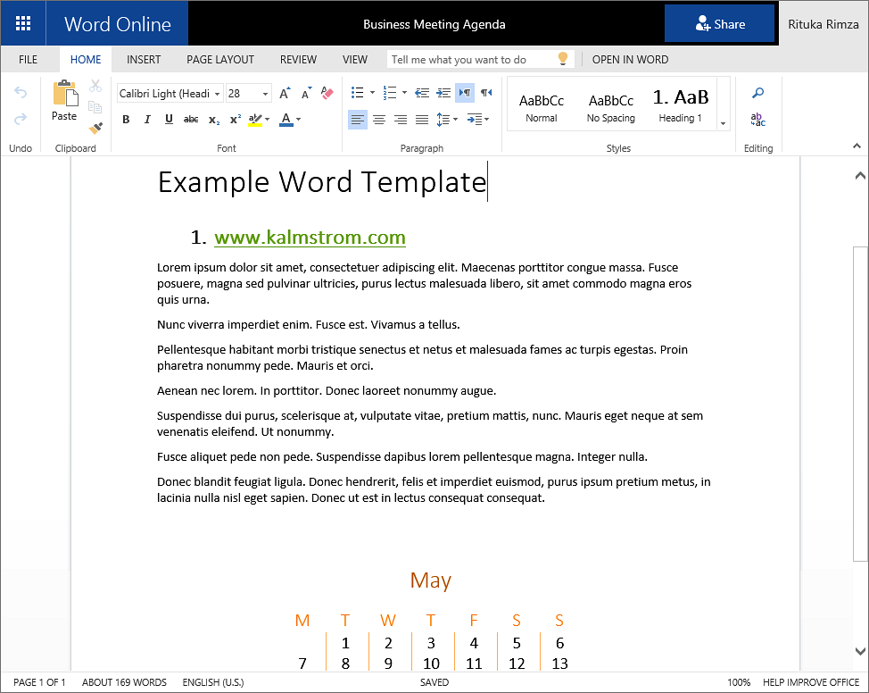

Registration
You may evaluate Templates Manager without cost and with full functionality for 30 days.
If you want to continue using the Templates Manager after the trial period, you must subscribe to the solution. We supply a Premium version, which does not require registration, but organizations who select the Standard plan must register each site installation of Templates Manager.
Standard subscribers will be given a registration key, which allows the organization to continue using Templates Manager for the duration of the subscription.
When the 30 days trial period has expired, you will be promted to register and a register dialog will be displayed.
To register, enter an e-mail address with your company/organization domain and the registration key you have received from kalmstrom.com. Then click on ‘Registration’.
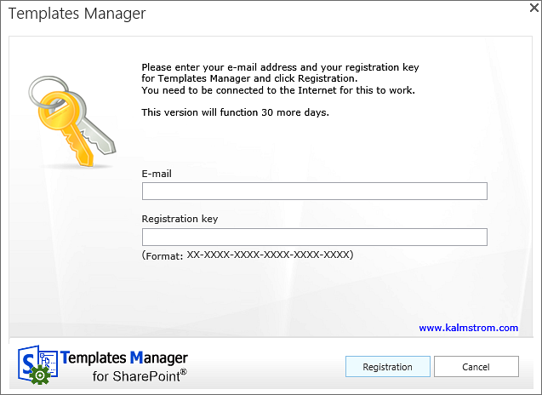
The registration must be done once in every site collection where Templates Manager is used.
The registration key will continue to work as long as the company/organization is a kalmstrom.com subscriber.
Templates Manager will automatically verify that your registration key is still valid every 30 days. No private information will be collected. There will be a count-down during 30 days and then an automatic renewal for another 30 days and so on, as long as the company/organization has a valid subscription. Should the subscription be cancelled, there will be no renewal.

Upgrade
Upgrades are free for all subscribers, and we recommend that you always use the latest version of Templates Manager. That is the only version we support, so we have made our outmost to make the upgrade process easy and quick.
We of course hope that you will be satisfied with Templates Manager, but if you want to remove it from a site that is also an uncomplicated process.
Premium subscribers will have an e-mail when their uniqie copies of Templates Manager have been updated. Standard subscribers can download the new version of Templates Manager from the kalmstrom.com website.
You can see all revisions and file numbers at https://www.kalmstrom.com/products/Templates-Manager/RevisionsSP.htm
The sandboxed solution och PowerShell editions use the same folders, so you can very well upgrade the sandboxed solution installations with the PowerShell script and vice versa.
The ​SPFX edition is different, so if you upgrade these installations with one of the other editions, there is a risk that you get double Templates Manager buttons.

Upgrade the SPFX extension
All the tenant’s installations of Templates Manager will be upgraded automatically when you add the new SPPKG file to the app catalog.
- Download the file.
- Remove the old Templates Manager SPPKG file from the app catalog.
- Upload the new SPPKG file to the app catalog.
- Deploy the SPPKG file.
- All Templates Manager installations will now be upgraded automatically.

Upgrade Templates Manager Sandboxed Solution
To upgrade Templates Manager, replace the old TemplatesManagerSP.wsp file with a new version of the file. This is the upgrade process for each site collection where Templates Manager is used:
- Deactivate Templates Manager under Site settings >Manage site features on each site.
- Deactivate the old Templates Manager .wsp file under Site settings >Solutions in the root site.
- Delete the old TemplatesManagerSP.wsp file.
- Upload the new TemplatesManagerSP.wsp file to the Solutions gallery in the root site.
- Activate the new TemplatesManagerSP.wsp file in the Solutions gallery.
- Activate the new TemplatesManagerSP.wsp file under ‘Manage site features’ on each site.

Upgrade with a PowerShell Script
Use this upgrade method if you have installed Templates Manager with the PowerShell edition or with the sandboxed solution and want to upgrade using PowerShell.
- Download the new ZIP file and extract it.
- Modify the script so that it suits your installations. This is quickly done if you have saved the part of the old script that contains the sites where Templates Manager was installed.
- Run the script to upgrade the installations in all sites that are included in the script.

Remove
If your organization cancels the Templates Manager subscription, the product must be removed on all sites.
To remove the Templates Manager client-side web part, remove it from the app catalog.
To remove the Templates Manager sandboxed solution, follow step 1-3 in the Upgrade instruction above.
To remove Templates Manager with a PowerShell script, run the parts of the script that remove Templates Manager. Please refer to the last demonstration on the Templates Manager Demonstrations page.

Contact
If you have any kind of problem or questions about Templates Manager, there are several ways of contacting us:
E-mail | support@kalmstrom.com – Technical issues
 | sales@kalmstrom.com – Subscription and general issues
 | finance@kalmstrom.com – Invoices, payments
Telephone | +46 739 206 106

SharePoint Tips
You surely have noticed that Templates Manager uses what is best in SharePoint, and that the Templates Manager libraries may be handled just like other SharePoint libraries. For tips on SharePoint usage in general, please refer to the Tips section of the kalmstrom.com website.

