Pivot Explorer Manual
Table of content

1 Introduction 2
1.1 Languages 2
1.2 Requirements 3
2 Install Pivot Explorer 3
2.1 Get from SharePoint Store 3
2.2 Download from kalmstrom.com 4
2.3 Permissions 4
2.3.1 Add-in 4
2.3.2 Users 4
3 First Time Usage 5
3.1 Example List 5
3.1.1 Remove the Example List 6
4 The Configuration Page 7
4.1 Custom Views 7
4.2 Clear Cache 7
5 Use Pivot Explorer 8
5.1 Toolbar 8
5.1.1 Open and Save Custom Views 9
5.1.2 Pivot Explorer Configuration 9
5.1.3 Export 10
5.2 Visualization Options 10
5.2.1 Filter Values 16
5.3 Aggregate Function 17
5.3.1 Sorting 17
6 Upgrade 20
7 Registration 21
8 Contact 22
9 Remove Pivot Explorer 22
10 More SharePoint Tips 22

Introduction
Pivot Explorer for SharePoint Lists is designed for analysis and display of multidimensional data online. Just as you explore Excel data in an Excel Pivot Table, you can explore data from any SharePoint list with Pivot Explorer. The data is represented in compact yet interactive visual reports — multidimensional tables and charts that are fully customizable for your needs.
With Pivot Explorer you can analyze data and look at the same information in different ways with just a few mouse clicks. The product supports a range of different graphs as well as tables which you can modify by simply pivoting the measures.
Use Pivot Explorer to create and analyze reports based on SharePoint lists data and to display data in a way that is easy to understand. Pivot Explorer offers filtering and sorting of simple or hierarchically arranged values, and analysis results can be exported in various ways.
Pivot Explorer supports all SharePoint lists, including document libraries.
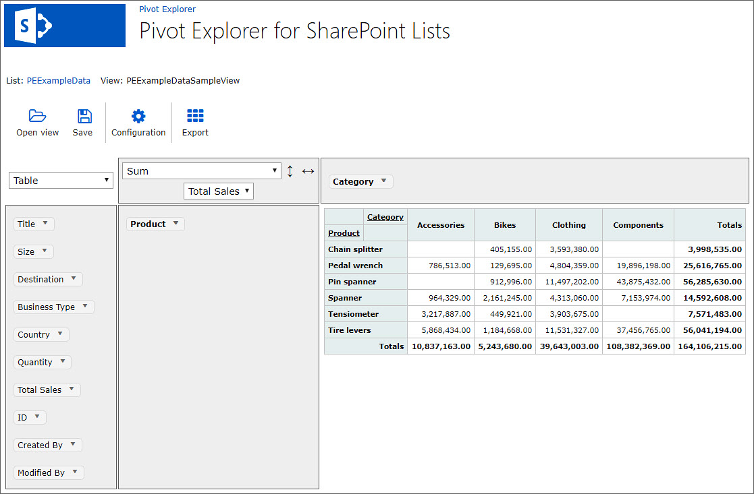

Languages
The language of Pivot Explorer is automatically set to the same as on the SharePoint site. The supported languages are: Danish, Dutch, English, French, German, Italian, Norwegian, Portuguese, Spanish and Swedish. When the SharePoint site has another language, Pivot Explorer will be in English.
The Example list that can be generated for evaluation purposes are in English, and therefore SharePoint Store does not allow us to add more supported languages in the description. Pivot Explorer will however work on all supported languages, even if you install it from SharePoint Store.

Requirements
To use Pivot Explorer you need to have SharePoint 2013 or above (in-house or hosted) or Office 365 SharePoint Online.
Supported browsers are Microsoft Edge, Internet Explorer 9 and higher and the latest versions of Google Chrome and Mozilla Firefox.

Install Pivot Explorer
Pivot Explorer is available on SharePoint Store or can be downloaded from the kalmstrom.com website.

Get from SharePoint Store
Go to the SharePoint site where you want to use Pivot Explorer and click on Site Contents.
In the ‘Site Contents’ click on ‘New’ and ‘App’.
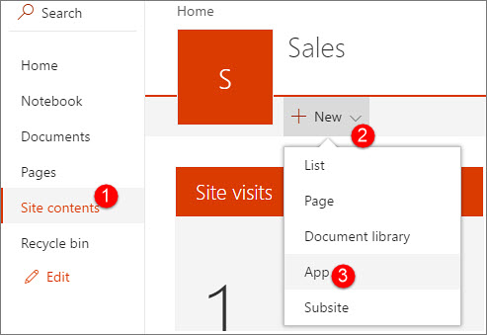
Click on SharePoint Store in the left panel and select Pivot Explorer for SharePoint Lists.
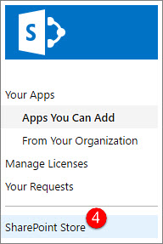

Download from kalmstrom.com
You can also download Pivot Explorer directly from the kalmstrom.com website to your PC and then upload it to the farm’s or tenant’s App Catalog.
When this is done, you can install Pivot Explorer on any site by going into Site Contents and add an app as described under Get from SharePoint Store. Select ‘Apps You Can Add’ and choose Pivot Explorer.

Permissions
Pivot Explorer uses standard SharePoint permissions. The permission for the Add-in itself is set automatically when the download is trusted.

Add-in
Pivot Explorer needs Manage permission on the site collection where it is installed. Thanks to this permission restriction, the Pivot Explorer cannot make any changes on the SharePoint site collection, no matter what permission the user has.
Pivot Explorer sets the required add-in permission when you have clicked on the Trust-it button during the installation.

Users
Users who should use all the Pivot Explorer functionalities must have Contribute permission.
Users who only need to see the list data in Pivot Explorer and not save views or create a sample list only need Read permission over the site.

First Time Usage
When Pivot Explorer has been installed in a site collection, a “Get Started” page will be shown when you click on “Pivot Explorer” in the Site Contents.
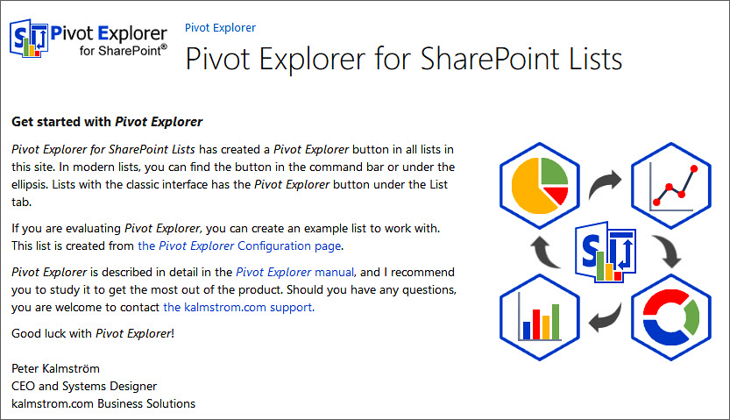
From the “Get Started” page you can either go to the product configuration page or generate an Example list. You can also reach the Manual web page, to download this manual.

Example List
If you choose to first generate an Example list for the evaluation, click on the ‘Create Example List’ button in the Configuration page.
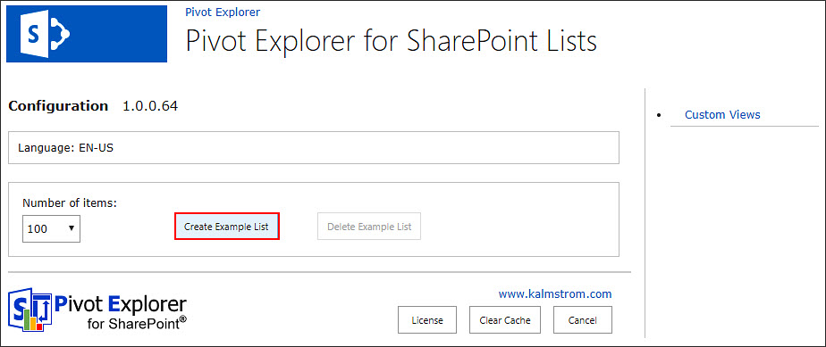

Remove the Example List
If you have created the Example list and do not want to use it anymore, you can delete it using the ‘Delete Example List’ button in the configuration page:
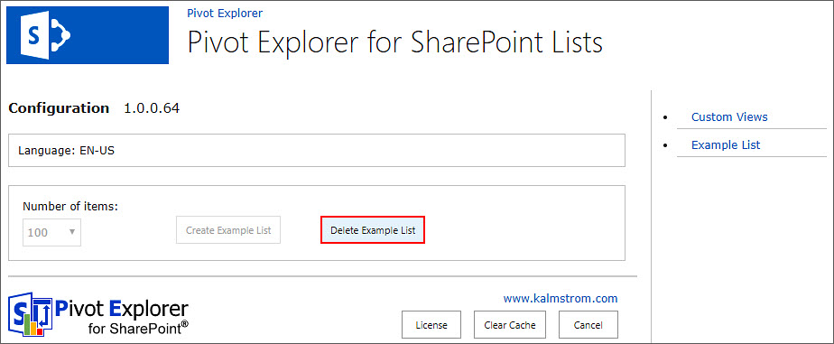

The Configuration Page
Open the Configuration page from the Pivot Explorer toolbar.
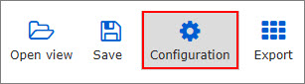
In the Configuration page you can see add-in details, create an example list, delete the example list, open the Custom Views list, register the license and clear the cache.
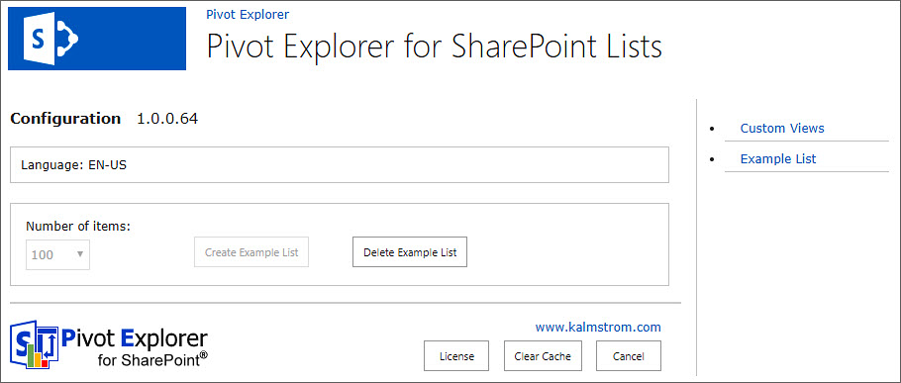

Custom Views
The ‘Custom Views’ list is a Pivot Explorer list that stores all users’ saved pivot views of the current site.

Clear Cache
To increase performance, Pivot Explorer saves a cache of all the used list data. Sometimes this cache gets corrupt. If that happens once, click on the ‘Clear Cache’ button to resolve the problem. If it happens often, please contact the kalmstrom.com support!

Use Pivot Explorer
You can reach Pivot Explorer by clicking on the ‘Pivot Explorer’ button in any SharePoint list in the site where Pivot Explorer has been installed.
The modern experience has the button either in the command bar or under the ellipsis.
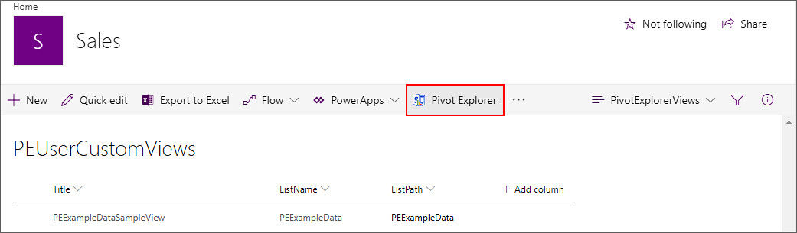
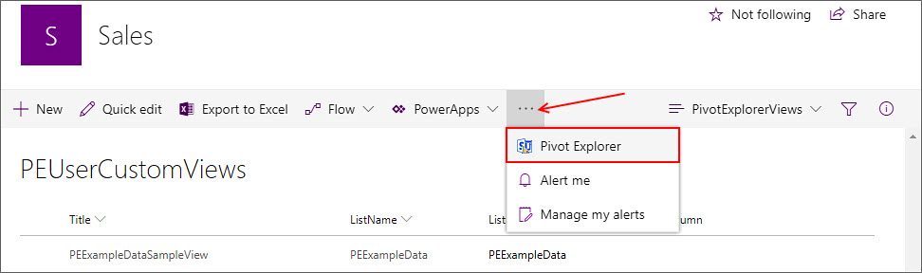
In the classic experience you can find the button under the LIST tab.
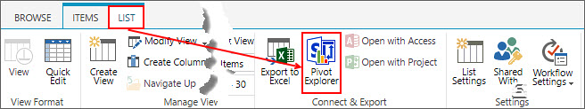
Now you can start analyzing the list data with the help of the Pivot Explorer.

Toolbar
The most used Pivot Explorer features can be easily accessed via the toolbar. Below the controls are described from left to right.
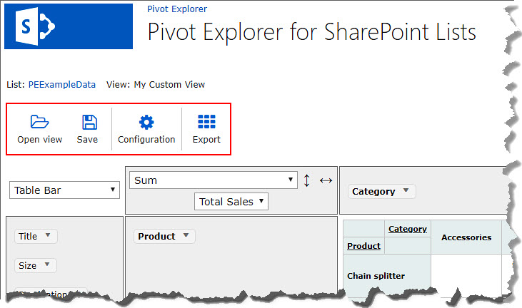

Open and Save Custom Views
You can save and load your favorite views to be used later. This saved view will be available to all users of the current site.
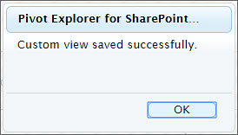
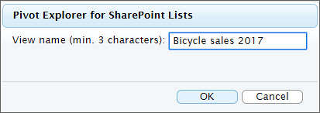
Select a previous saved custom view to be opened.
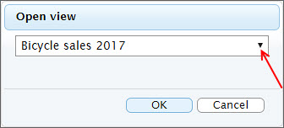

Pivot Explorer Configuration
This option redirects to the Pivot Explorer Configuration page described in chapter 4.

Export
Under the Export button you can export the view data to IMAGE, EXCEL or PDF formats. The EXCEL and PDF formats depend on the visualization options. Note that Microsoft Edge does not support the export. Use another browser for the export, even if you normally use Edge.
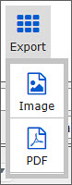
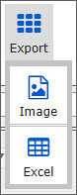

Visualization Options
Use the dropdown to select a chart that is appropriate to visualize the list data.
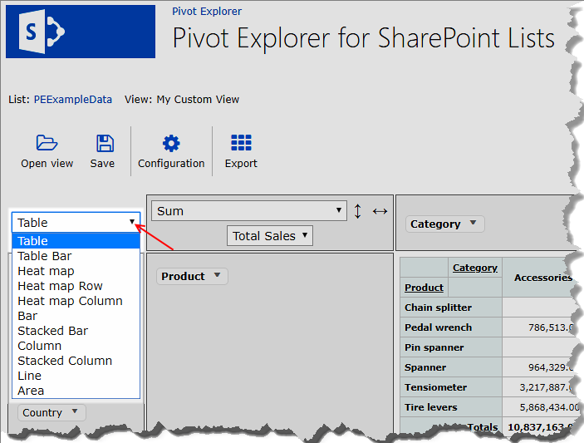
The Pivot Explorer charts are interactive. Pivot Explorer supports the following chart types: Table, Table Bar, Heat map, Heat map Row, Heat map Column, Bar, Stacked Bar, Column, Stacked Column, Line and Area.

Table
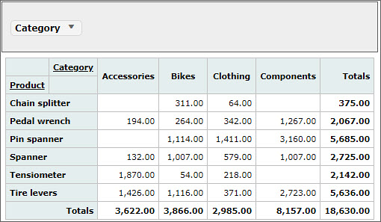
Table Bar
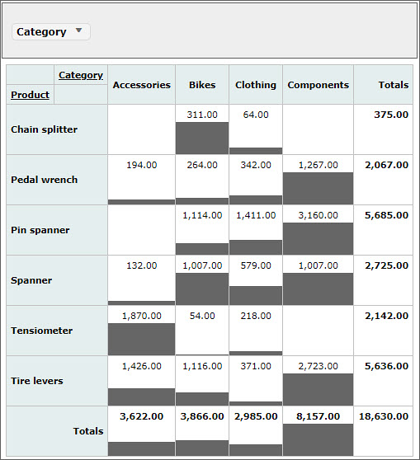

Heat map
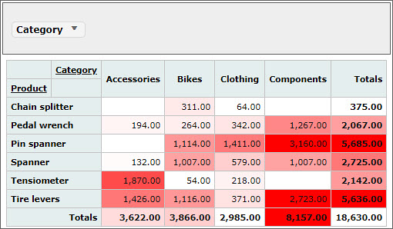
Heat map Row
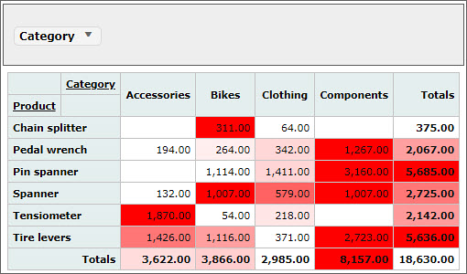
Heat map Column
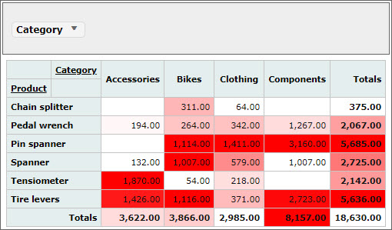

Bar
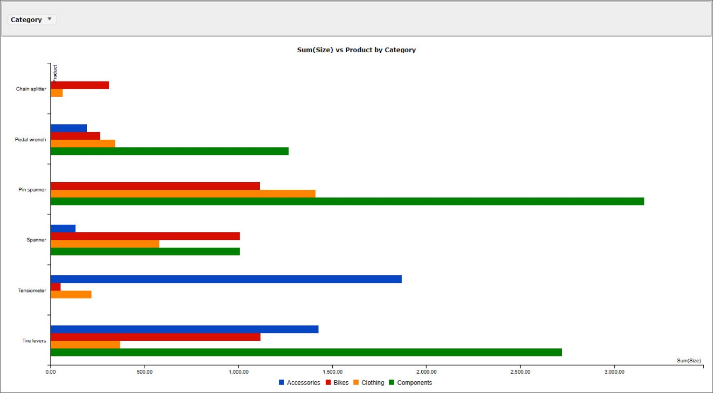
Stacked Bar
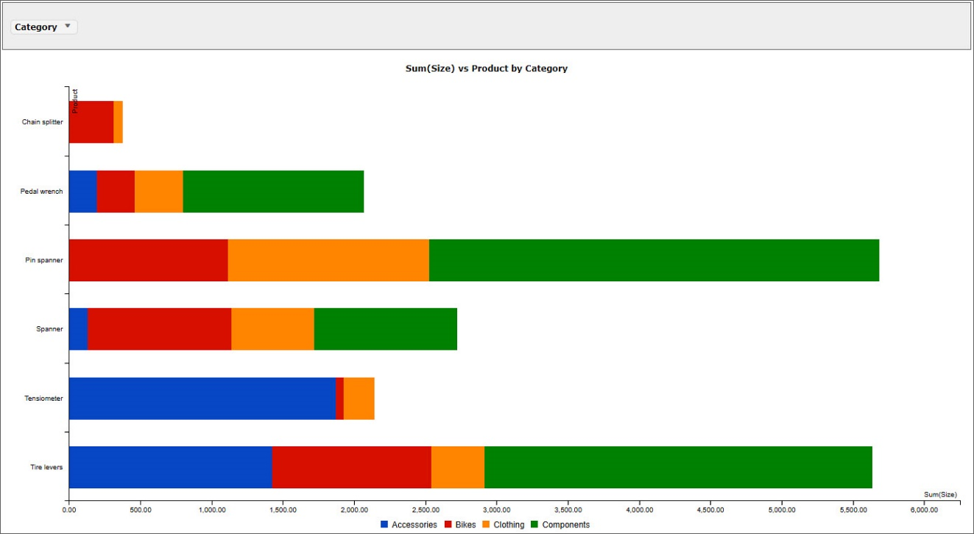

Column
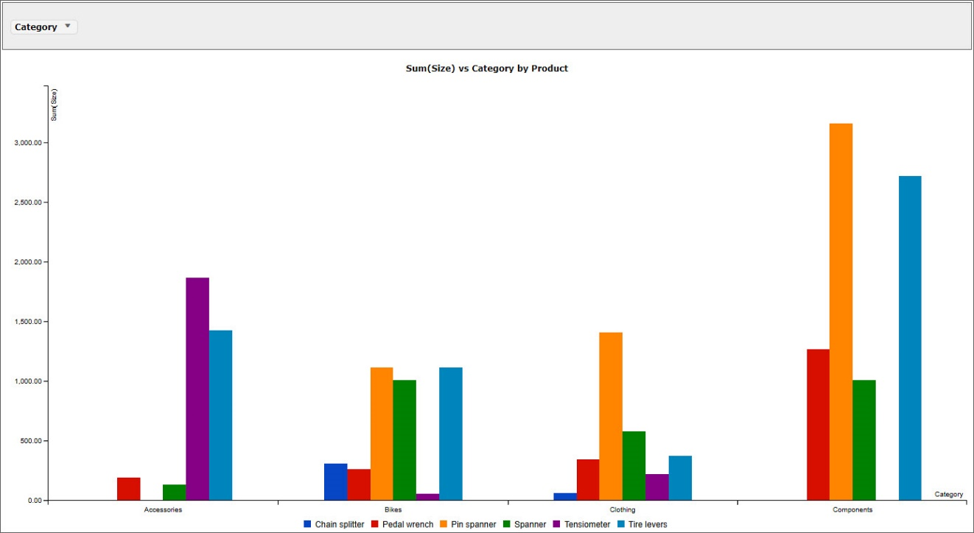
Stacked Column
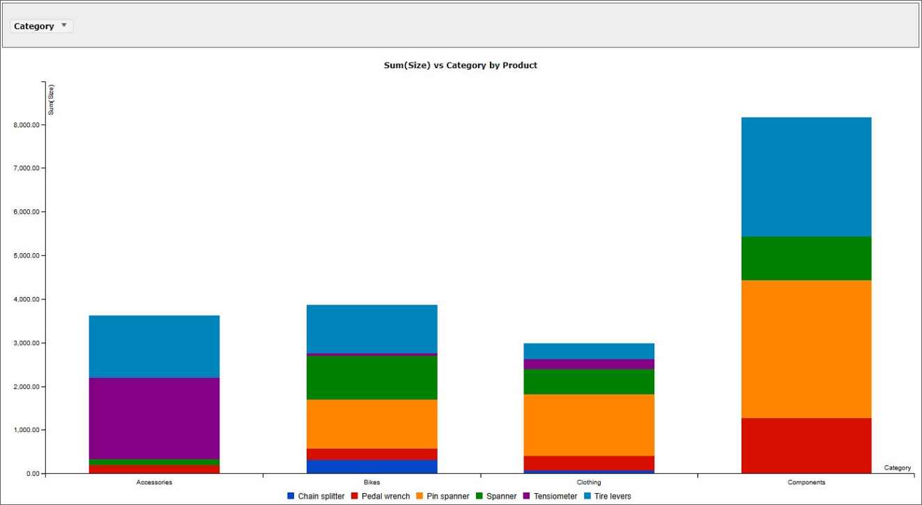

Line
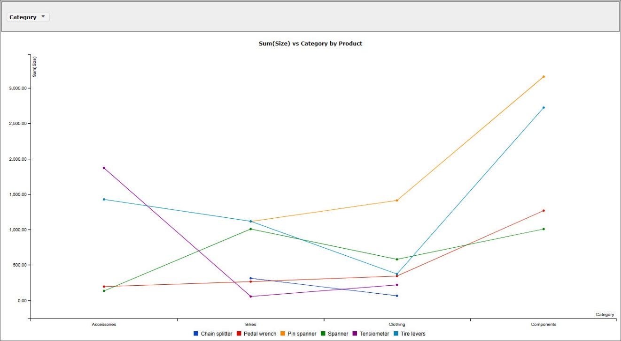
Area
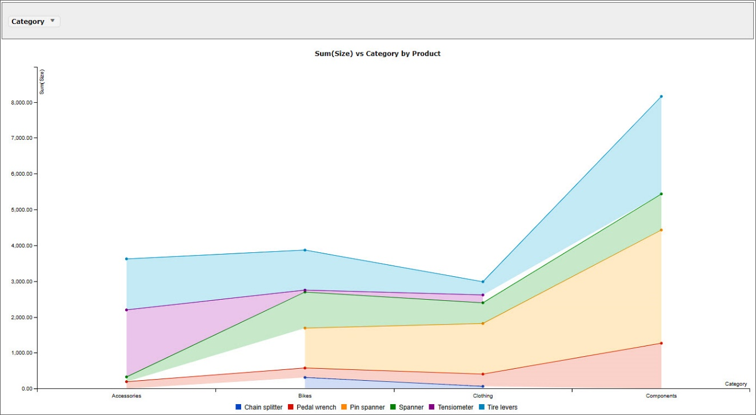

Filter Values
You can filter the values by expanding the particular drop down. The filtered values caption will be shown in italics.
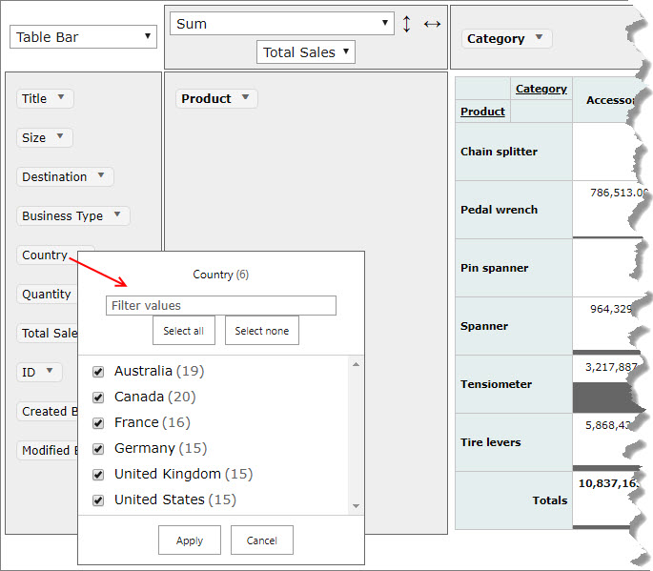
All column names from the source list are displayed in the left section. They can be dragged and dropped to the right columns.
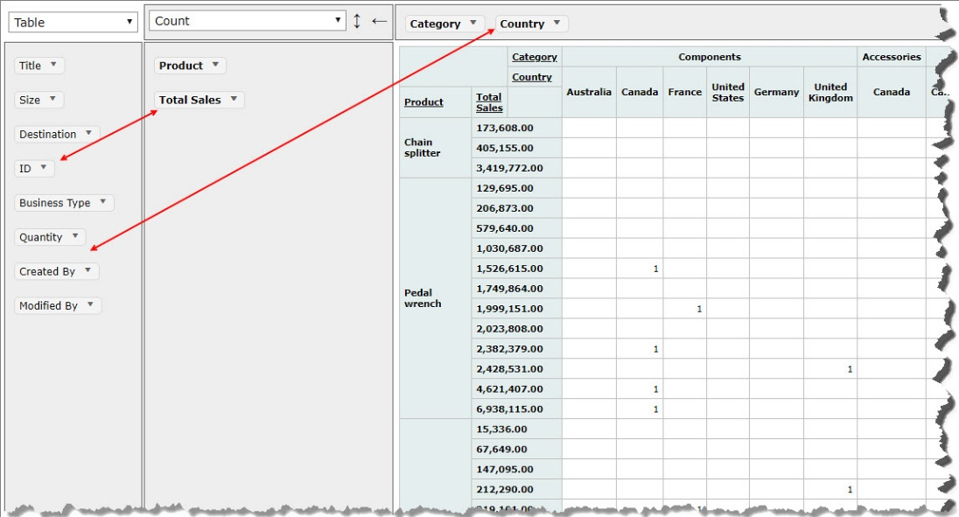

Aggregate Function
This Aggregate function allows you to apply various functions with different parameters.
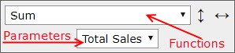
Supported Functions
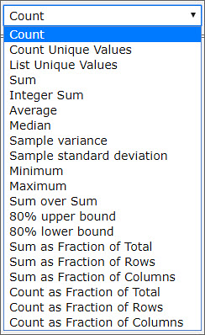
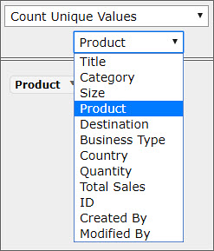
The parameter’s options depends on the function which has been selected.
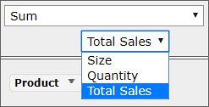

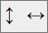
Sorting
The values in the charts can be arranged, alphabetically or numerically, in ascending and descending orders.
Click on the arrows to change the sorting order. The vertical arrow reflects the rows, and the horizontal arrow reflects the columns.
Vertical Arrow
Upward: sorts the totals of the numeric values in descending order.
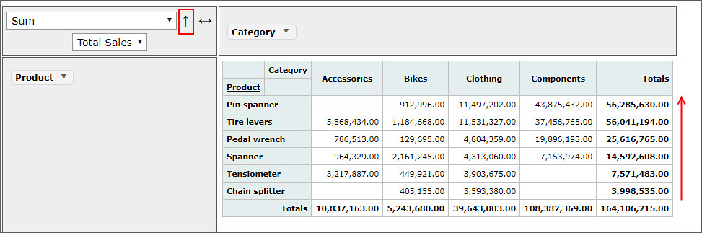
Downward: sorts the totals of the numeric values in ascending order.
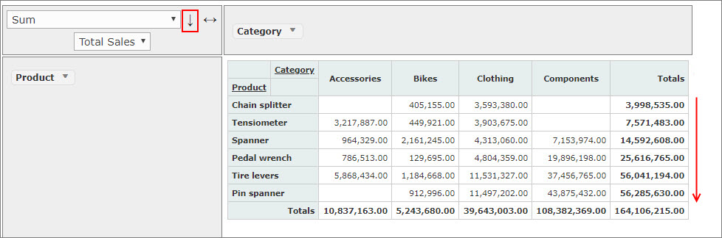
Double side headed: sorts the alphabetic values in ascending order.
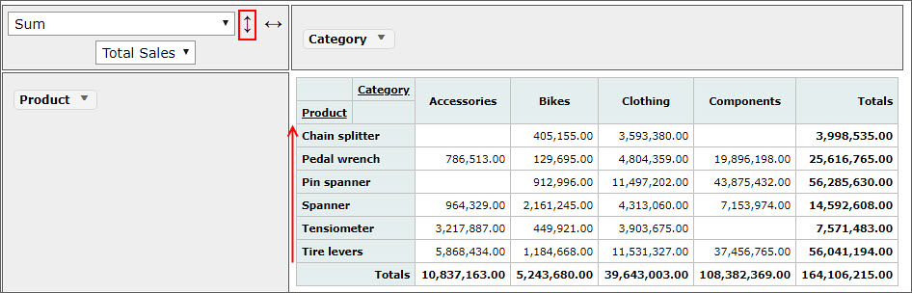
Horizontal Arrow
Right-sided: sorts the totals of the numeric data in ascending order.
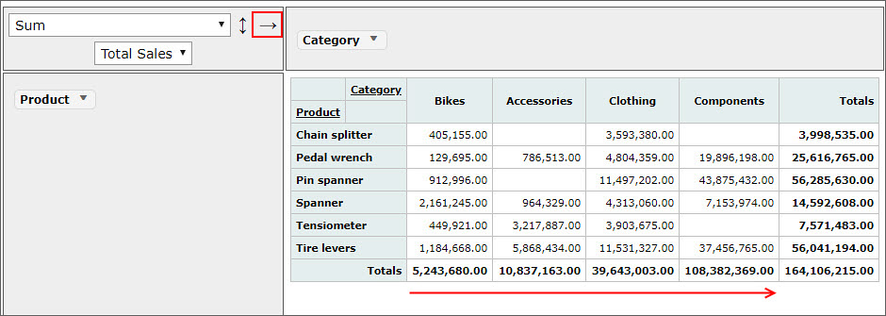
Left sided: sorts the totals of the numeric values in descending order.
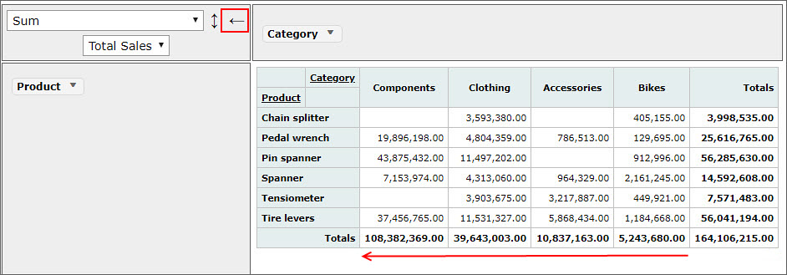
Double side headed: sorts the alphabetic values in ascending order.
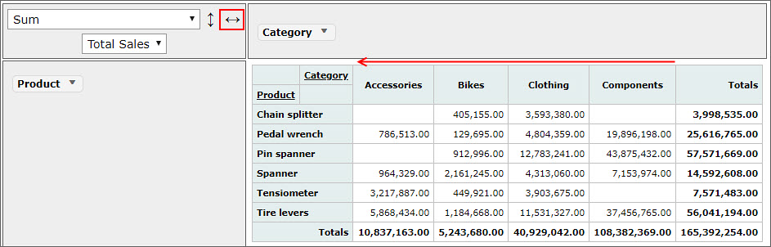

Upgrade
When a new version of Pivot Explorer is available, there will be a message about it from Microsoft.
- On each site where Pivot Explorer is installed, a message about the new version will be displayed in the Site Contents.
- Click on the GET IT button and then on Trust It.
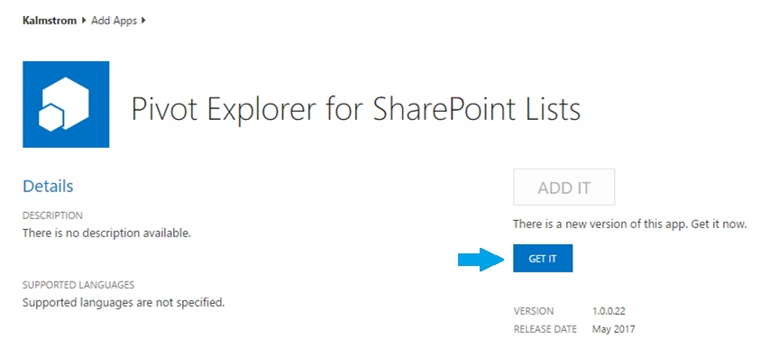
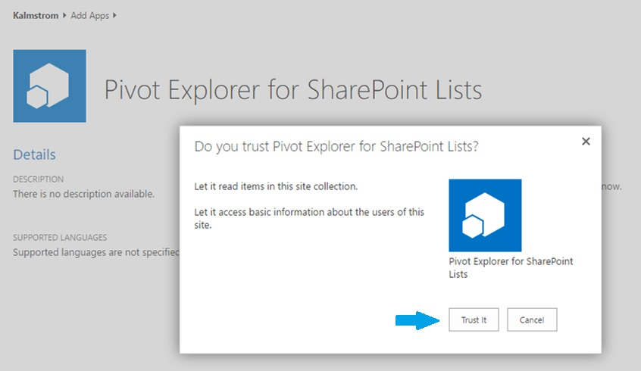
- The Site Contents page will open again with the notice ‘We are updating your app’ on the Pivot Explorer tile.

Registration
You may evaluate Pivot Explorer without cost and with full functionality for 30 days.
If you want to continue using Pivot Explorer after the trial period, you must subscribe to the solution. We supply a Premium version, which does not require registration at all, but organizations who select the Standard plan must register their installations of Pivot Explorer.
Standard subscribers will be given a registration key which allows the organization to continue using Pivot Explorer for the duration of the subscription.
To register, open the Configure page, click on the License button, and a registration dialog will open.
Enter an e-mail address with your company domain and the registration key you have received from kalmstrom.com and click on ‘Registration’.
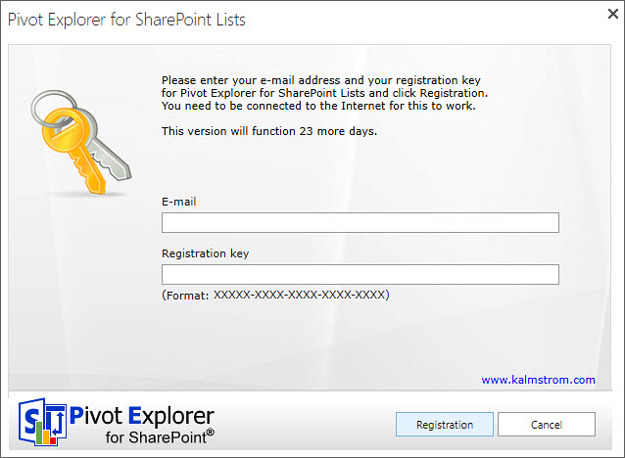
The registration must be done once on every site where Pivot Explorer is used. In the future we plan to give our customers an easier way to register all installations.
The registration key will continue to work as long as the organization is a kalmstrom.com Subscriber.

Contact
If you have any kind of problem or questions about Pivot Explorer for SharePoint Lists, there are several ways of contacting us:
E-mail | support@kalmstrom.com – Technical issues
 | sales@kalmstrom.com – Subscriptions, general issues
 | finance@kalmstrom.com – Invoices, payments
Telephone | +46 739 206 106

Remove Pivot Explorer
Should Pivot Explorer not be used anymore, you can remove it. Currently the removal can only be done in the classic experience, as Microsoft has not supplied a removal feature for add-ins in the new experience.
To remove, go to the Site Contents and find Pivot Explorer for SharePoint Lists. Right click on the ellipses(…) and select REMOVE from the context menu.
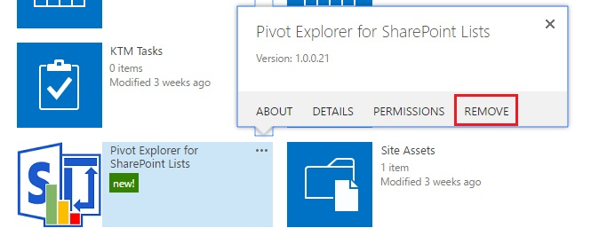

More SharePoint Tips
You surely have noticed that Pivot Explorer is a great tool for improving the SharePoint experience. For tips on SharePoint usage in general, please refer to the Tips section of the kalmstrom.com website.

