PDF Creator Manual
Table of Contents

1 Overview 2
1.1 Languages 2
1.2 Requirements 2
1.3 Editions 2
1.3.1 The SPFX edition 3
1.3.2 The Sandboxed Solution 3
1.3.3 Permissions 3
1.4 Third Party JavaScript libraries 4
2 Installation Details 5
2.1 SPFX edition 5
2.1.1 Deploy in an App Catalog 5
2.1.2 Add the SPFX edition to Teams 9
2.2 Sandboxed Solution 9
2.2.1 Manual Installation 9
2.2.2 PowerShell Package 11
3 Use PDF Creator 12
3.1 Preview 12
4 Registration For Standard Users 15
5 Upgrade and Removal 16
5.1 Upgrade 16
5.1.1 Upgrade the SPFX edition 16
5.1.2 Upgrade the Sandboxed Solution Manually 16
5.1.3 Upgrade with a PowerShell Script 17
5.2 Remove PDF Creator 17
6 Contact and Tips 18
6.1 SharePoint Tips 18

Overview
PDF Creator for SharePoint adds a button to all SharePoint lists in the sites where PDF Creator is installed. A click on that button saves the list as a PDF file. Select one or more items, and only these will be included in the PDF file. With the SPFX edition, you can also save Office files in SharePoint document libraries as PDF.
PDF Creator is a new kalmstrom.com product that we hope to enhance in the future, but even the first edition is stable and useful. PDF Creator already supports all column types and rich text format.
PDF Creator supports all custom SharePoint lists, also called generic lists, whether open in the modern interface, the classic interface or Microsoft Lists. All lists created from the modern SharePoint interface are custom, but some classic lists, such as Events and Tasks, have special features are and not yet supported.

Languages
The language of PDF Creator is automatically set to the same as on the SharePoint site. The supported languages are: Arabic, Danish, Dutch, English, French, German, Italian, Norwegian, Portuguese, Spanish and Swedish. When the SharePoint site has another language, PDF Creator will be in English.

Requirements
To use PDF Creator, you need to have SharePoint 2013 or above (in-house or hosted) or Microsoft/Office 365 SharePoint Online.
Tested browsers are Microsoft Edge and the latest versions of Google Chrome and Mozilla Firefox.

Editions
PDF Creator comes in two editions, SPFX edition and Sandboxed solution. They are installed in different ways, but they have the same version number and features.
One subscription is valid for both editions, so you can use any combination of editions you wish. If you want to use SharePoint Online with both the classic and modern experience you need to install both editions, as Microsoft does not support SPFX extensions in the classic experience.
The kalmstrom.com team offers installation assistance with a PowerShell script for both editions. This service is free for Premium subscribers.
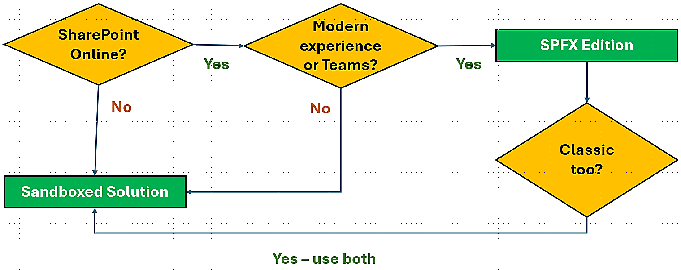

The SPFX edition
The PDF Creator SPFX edition, or modern client-side extension, only supports SharePoint Online and the modern interface, but it is very easy to install and upgrade so we recommend that you use it when possible. This edition supports integration in Microsoft Teams.
If you combine the SPFX edition with the Sandboxed solution edition, you can use PDF Creator in classic SharePoint Online sites too.

The Sandboxed Solution
The Sandboxed solution supports SharePoint 2013, 2016, 2019, SE and Online. In the classic experience, a PDF file can be created from one or multiple selected items or from all items in a list. In the modern experience, a PFD file can be created from one item or from all items in a list.
In SharePoint 2013, 2016 and Online, the Sandboxed solution only supports classic experiences lists. In the SharePoint 2019 and Subscription editions, single items and whole lists can also be printed to PDF in modern lists.
The PDF Creator Sandboxed SharePoint solution can be installed in two ways, manually or by running a PowerShell script.

Manual Installation
For manual installation, a WSP file is downloaded from the kalmstrom.com site and uploaded to a SharePoint Solutions gallery and activated there. After that, PDF Creator must be activated on the site and on each subsite where it should be used.

PowerShell Installation
The PowerShell package of the Sandboxed solution is most useful when you want to automate the process of installing PDF Creator in multiple sites. This edition comes as a ZIP file that includes a PowerShell script, which must be modified for each organization before it is run. The PowerShell package works in both Online and On-Premises SharePoint.

Permissions
Standard SharePoint permissions are used for PDF Creator.

Upload and Install the SPFX edition
To upload the PDF Creator SPPKG file to an App catalog, you need to have access to it. Global admins always have that permission and normally also SharePoint admins. Deployment to all sites can be done in the same process.
If PDF Creator is not enabled for all sites in the upload process, it can be installed in a single site by the Site owner.

Install and Activate the Sandboxed Solution
To upload the PDF Creator Sandboxed solution .wsp file to the Solutions gallery and activate it there, you need to be at least Site admin.
To activate the solution for the site you must be at least Site owner. Often – but not always – the same person has both these roles.

Install with a PowerShell Script
You need to be a SharePoint Admin of the farm or tenant to run the PowerShell script that installs PDF Creator in all sites included in the script.

Third Party JavaScript libraries
The kalmstrom.com team has modified and extended two third-party JavaScript libraries to create PDF Creator: jQuery and PFDMake. No extra license is necessary to use these libraries in PDF Creator.

Installation Details
The recommended way to test PDF Creator is to create a new site for testing. Once the testing is completed, you should start over by installing PDF Creator in multiple production sites. It is however also possible to continue with the test installation.
Within Microsoft's limitations we have tried to make our products as easy as possible to install. All installation methods are described below and in video demonstrations on the PDF Creator Demonstrations page at https://www.kalmstrom.com/products/PDF-Creator/Demonstrations.htm. There are also videos on each Download page.
Another option is to use the kalmstrom.com installation assistance, please refer to: https://www.kalmstrom.com/Services/Installation-Assistance.htm

SPFX edition
The PDF Creator SPFX edition can be used in all modern SharePoint Online libraries. It comes as an SPPKG file that gives a modern SPFX client-side extension. The SPPKG file is downloaded from the kalmstrom.com website to your PC and then extracted and uploaded to the tenant's App catalog.
After that, PDF Creator can be either added to all sites at once or be made available to the whole tenant via the 'Add an app' command. To work in libraries, PDF Creator also needs to be given API access to Microsoft Graph.
The file can also be loaded from SharePoint Store directly to the App catalog/Apps site. In that case, use the SharePoint 'Add an app' command and select SharePoint Store. When the file has been loaded, you can go directly to step 4 below.

Deploy in an App Catalog
- Download the PDF Creator file from the kalmstrom.com website to any folder on your computer and extract it.
- Go to your App catalog. (If you have not already created such a site, it will be created the first time you click on the 'Open' button in the SharePoint Admin center >More features >Apps.)
- Upload the SPPKG file. (If there is a warning message for add-ins, it can be ignored. It does not apply to SPPKG files.)
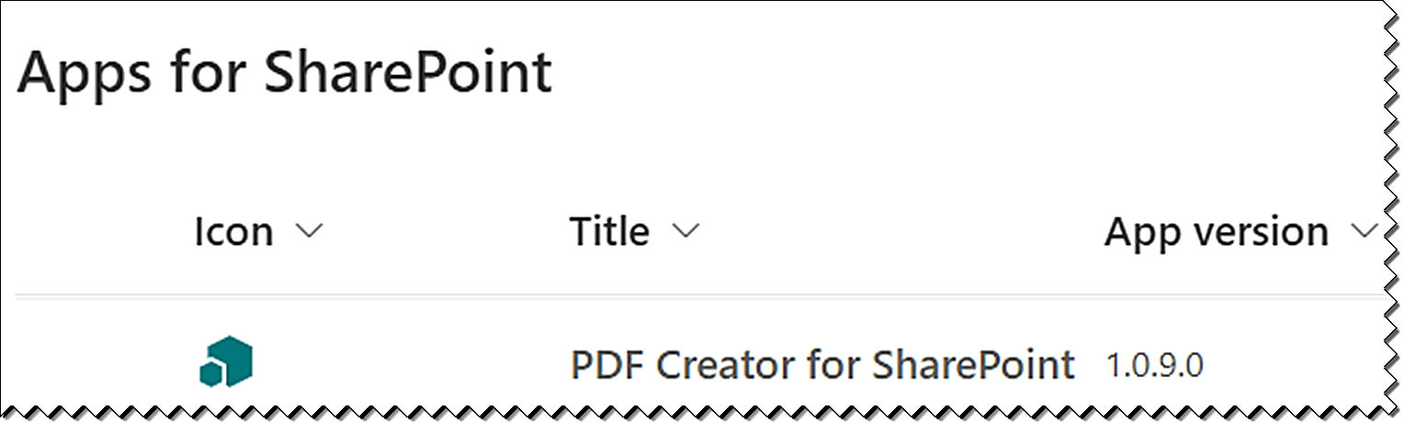
- A right Enable app pane opens. Select one of the options:
- Enable the file.
- Enable the file and add PDF Creator to all sites (default).
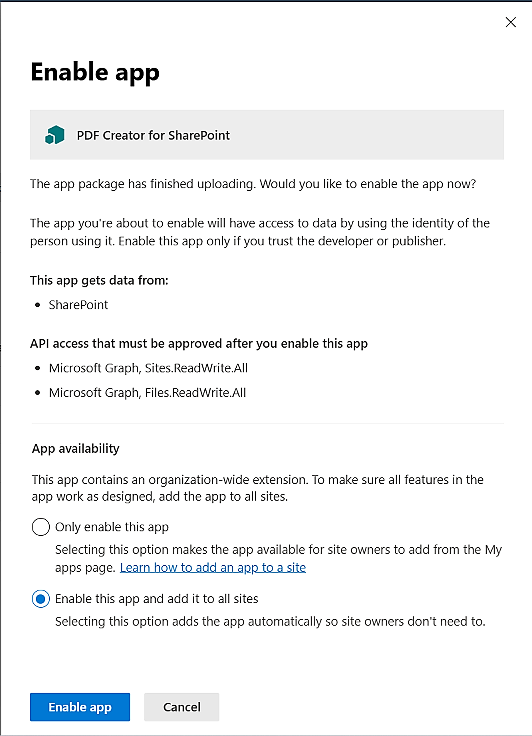
- Click on the 'Enable app' button.
- Now a new right pane opens. To create PDF files from files in document libraries, PDF Creator needs to be given ReadWriteAll Site and File permissions on Microsoft Graph. If you don't want to allow API access, click on 'I'll do it later'. PDF Creator will still work in lists, but not in libraries.
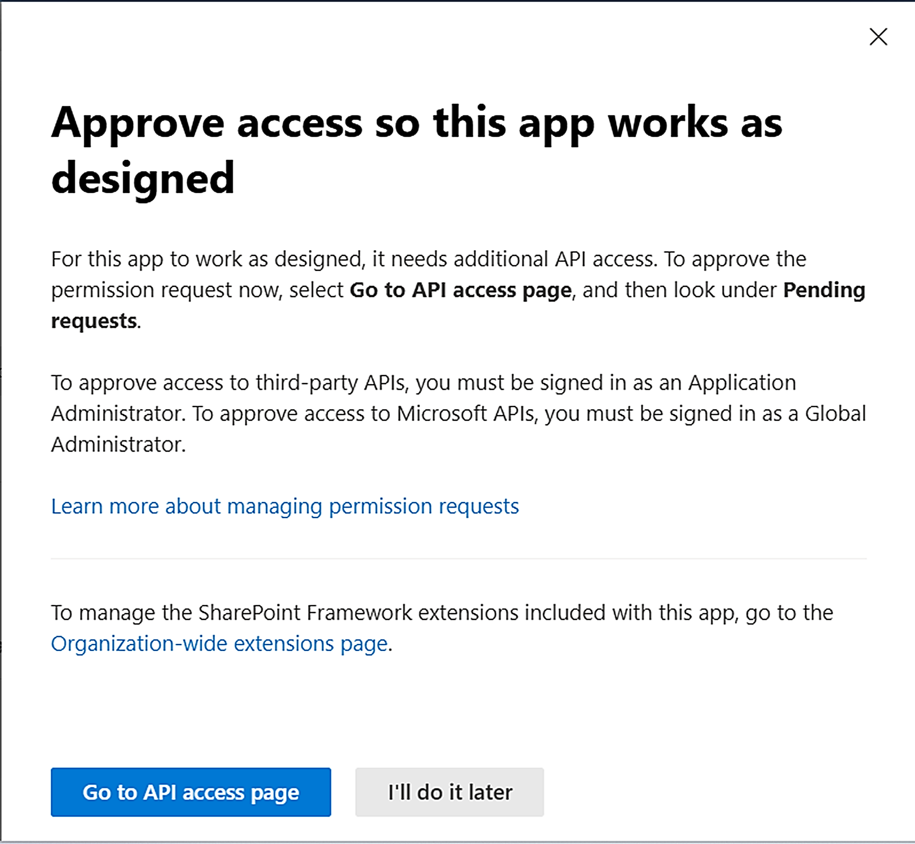
- Click on the 'Go to API Access page' button, and the page will open in a new tab.
- Select the pending request and click on the 'Approve' button above the list of requests.
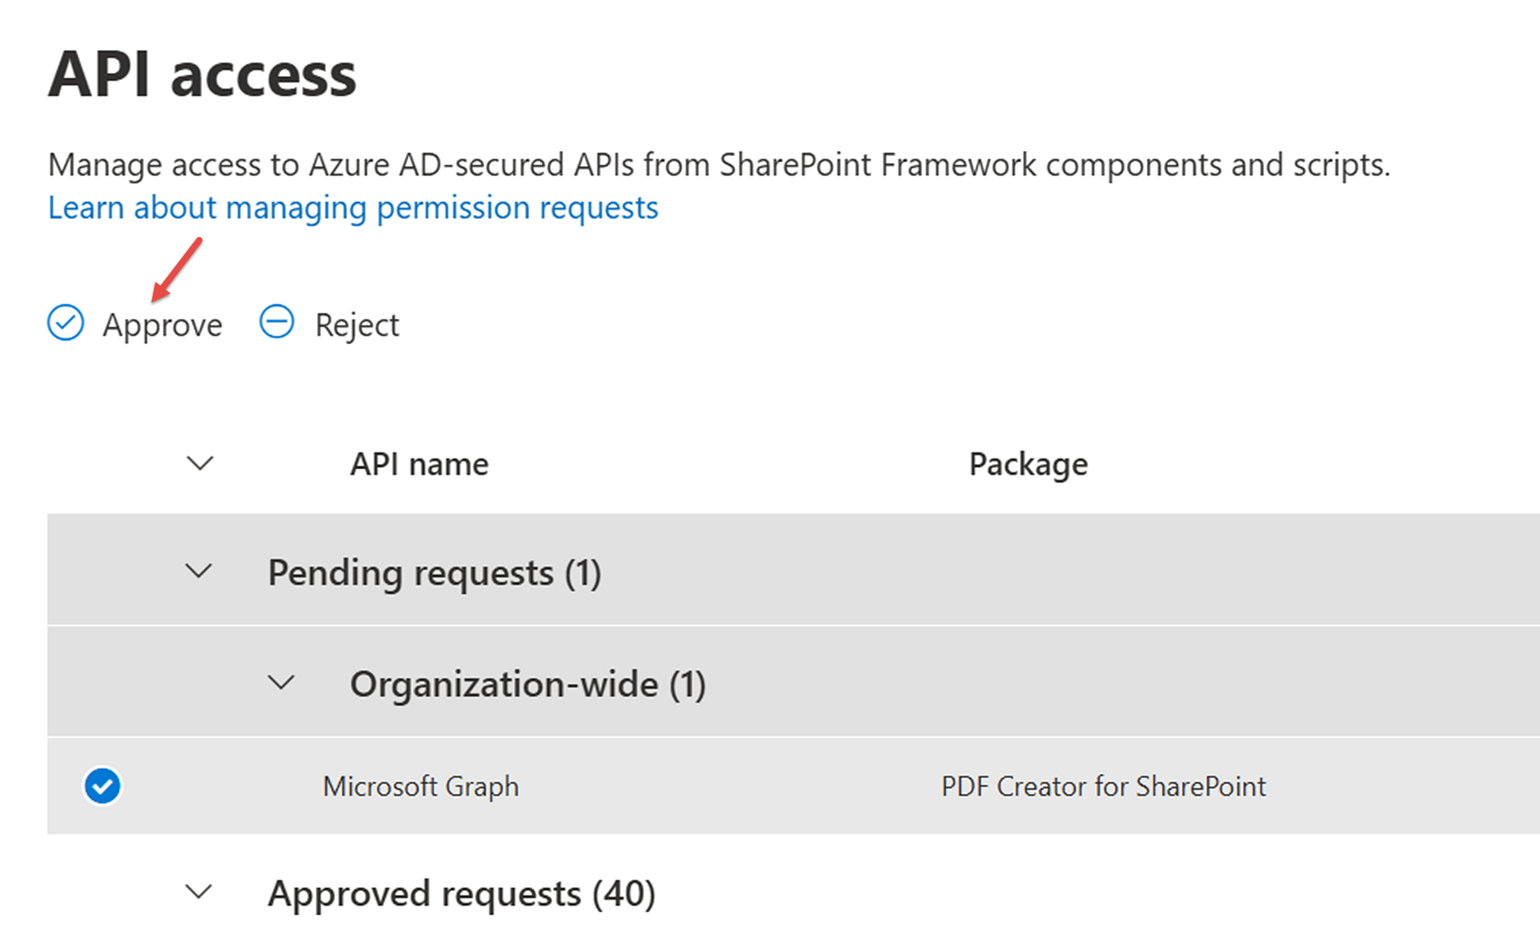
- Confirm the approval in the right pane that opens.
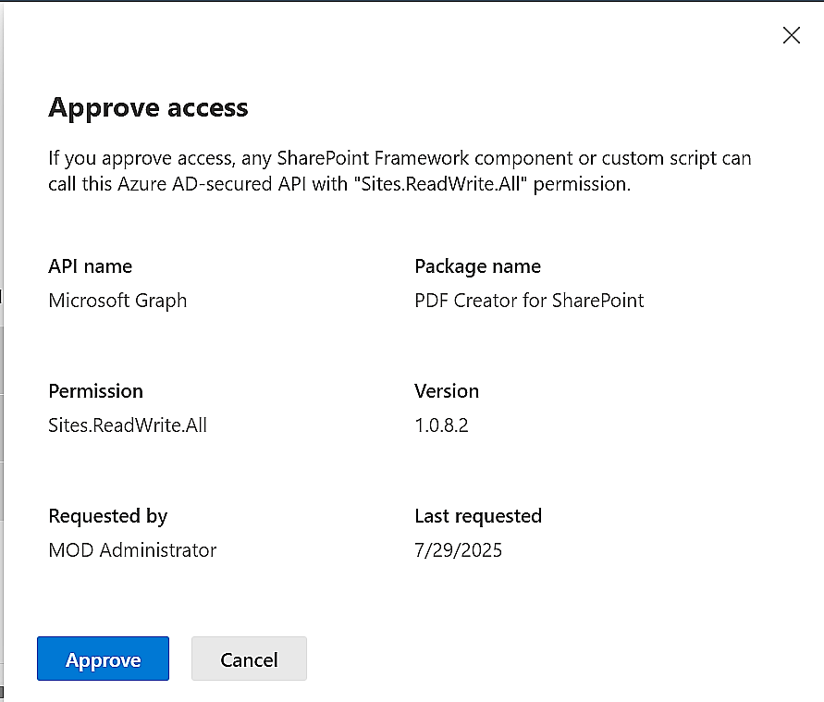
The SPI Access only needs to be allowed at first installation. You will get the prompt at upgrades too, but you can just skip that step because there is no pending request.

Install in a Site
If you have selected to only enable the file but not add it to all sites, Site owners must deploy PDF Creator manually in each site where it should be used.
- In the site where you want to use PDF Creator, click on + New >App in the modern homepage or Site contents, or click on the settings icon in the top navigation bar and select 'Add an app'.
- Select "All" or "From your organization" in the left menu.
- Click on the PDF Creator tile.
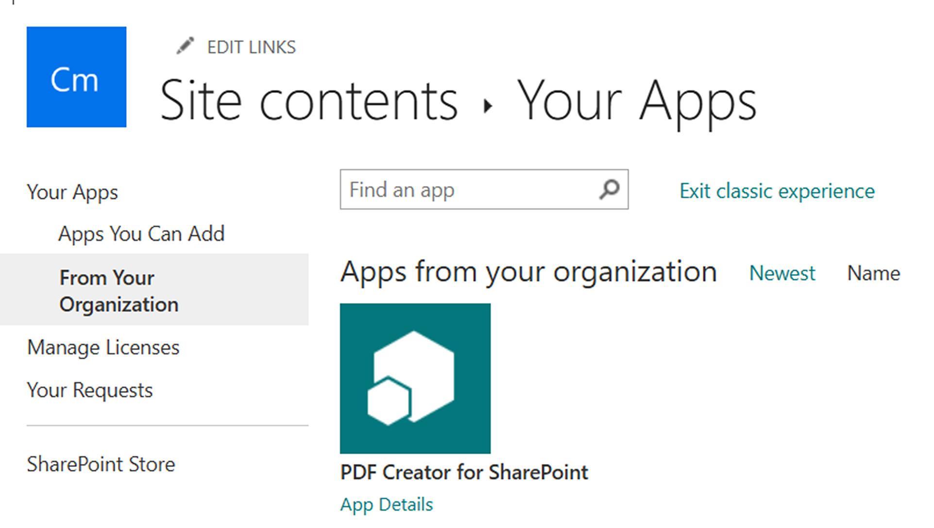
Now PDF Creator will be installed in the site where you initiated the 'Add an app' command. In a minute or so, the PDF Creator button will show up in the command bar in all the site's lists and libraries that have the modern interface.
Repeat the process for each site where you want to use PDF Creator.

Add the SPFX edition to Teams
To use PDF Creator in Microsoft Teams, add a list where PDF Creator is installed to a modern SharePoint page. Then add that page to a new Teams tab. It works as in the list or library, but due to technical limitations it is not possible to show a preview of the PDF file in Teams.
You can start in SharePoint or open the Files tab in the Teams channel you wish to use and go to SharePoint from the link under the ellipsis.
- Create a new modern page
- We recommend that you delete the comments section and not add any additional web parts to this page.
- Use a one column section with a List web part. Add a list or library from a site where PDF Creator is installed.
- It is recommended to delete the comments section and to not add any additional web parts to this page.)
- Give the page a name – it will be visible on the Teams tab.
- Publish the page.
- Add a new SharePoint Page tab to the Teams channel and select the page you created or paste its link.
The process is described in a demo at https://www.kalmstrom.com/products/PDF-Creator/Demonstrations.htm.

Sandboxed Solution
The PDF Creator Sandboxed solution is uploaded as a SharePoint Solution in a site, and it needs to be activated for the site and any subsites where it will be used. This can be done manually or with a PowerShell script.
If you use SharePoint on-premises and have problems with the activation, please make sure that the Sandboxed code service is running on the SharePoint server.

Manual Installation
Download the PDF Creator Sandboxed solution file from the kalmstrom.com website to any folder on your computer and extract it. Then follow the steps below to add PDF Creator to the site collection.

Site Assets
Before you start the installation, make sure that the site has a Site Assets library. If there is no such library, activate the Wiki Page Home Page feature under Site settings >Site actions >Manage site features, to create the library. (Your homepage will not be affected by this.)

Only for SharePoint Online
If you want to use the Sandboxed solution in SharePoint Online, custom scripts must be allowed in the site during installation and upgrade. This is done in the SharePoint Admin center >Active sites >the sites Details pane >Settings, by a Global or SharePoint administrator.

Upload to a Solutions Gallery
- Go to the root site of the SharePoint site collection where you want to use PDF Creator and click on the Settings icon in the top navigation bar.
- Select the Site settings option or select Site information and then Site settings.
- (If you don't see these options, most likely you don't have the appropriate permissions. You need to be Site admin to install solutions.)
- Under Web Designer Galleries, click on 'Solutions'.
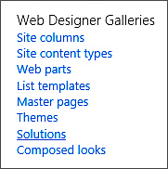
- Click on the 'Upload Solution' button and browse to the WSP file you downloaded from kalmstrom.com.
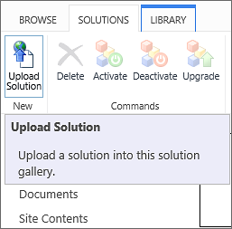
- When the file has been uploaded, you will be shown a dialog where you can activate the solution for the site collection.
Now PDF Creator is available for the site and any subsites.

Activate for a Site
Before PDF Creator can be used, the solution must be activated on each site or subsite where users should see the PDF Creator button in the lists.
- Click on the settings icon in the top navigation bar and click on 'Site settings'. You might need to first click on 'Site information'.
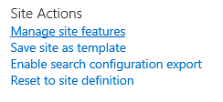
- Click on 'Manage site features' under the Site Actions heading. (If you don't see this option, most likely you don't have the appropriate permissions. You need to be Site owner to manage site features.)
- Find PDF Creator in the list of Site features.
- Click on the 'Activate' button to activate the PDF Creator feature.
- The activation adds a PDF Creator button to all lists in the site.

PowerShell Package
If you want to automate the process of installing the Sandboxed solution in multiple sites, we recommend the PowerShell package. It comes as a .zip file that includes a PowerShell script.
Changes that must be made for each organization are explained in the script, and the demos on the download page shows the process, but you should still have some experience of PowerShell to use this installation method.
It is the same script for all SharePoint editions, but note that SharePoint Online only supports PS7, which does not work with PowerShell ISE.
- Open PowerShell ISE or Visual Studio Code as an administrator.
- Open the .ps1 file included in the downloaded .zip file.
- Modify the script:
- Change to your SharePoint version if necessary.
- (For SharePoint Online, add your Client ID.)
- Include the sites where you want to install PDF Creator.
- Connect to your farm or tenant.
- Run the script.
- Now the script installs PDF Creator in each site that has been added to the script.

Use PDF Creator
When PDF Creator has been installed in a site, supported lists and libraries have a PDF Creator button. In the modern experience you can find it visible in the command bar or under the command bar ellipsis. In the classic experience, the button is found above the list of items.
When you click on the PDF Creator button in a list where no item is selected, the whole list will be printed to PDF. Select one or more items to create a PDF file from the selected item(s). Note that multiple selected items cannot be printed to PDF in the SharePoint 2019 and SE modern experience.
In libraries, the button is only available when an item with an Office file has been selected. In the selected item, the file will be saved as PDF. PDF Creator cannot yet merge multiple files.

Preview
When you click on the PDF Creator button, a dialog (SPFX edition) or a new page (Sandboxed solution) opens. It shows a preview of the PDF file that will be created and gives some options on what to do with the new file.
The preview dialog has commands on top, explained in tooltips, among them a print possibility. The download icon in the top banner lets you choose where to put the downloaded file, while the download icon at the bottom of the dialog downloads the file to your default download folder.
The PDF file can also be printed or saved to a library in the current site. If there are multiple document libraries in the site, there is a library selector, as in the image below. If the site only has the default document library, the preview dialog only has a save button and the PDF file will be saved to that library.
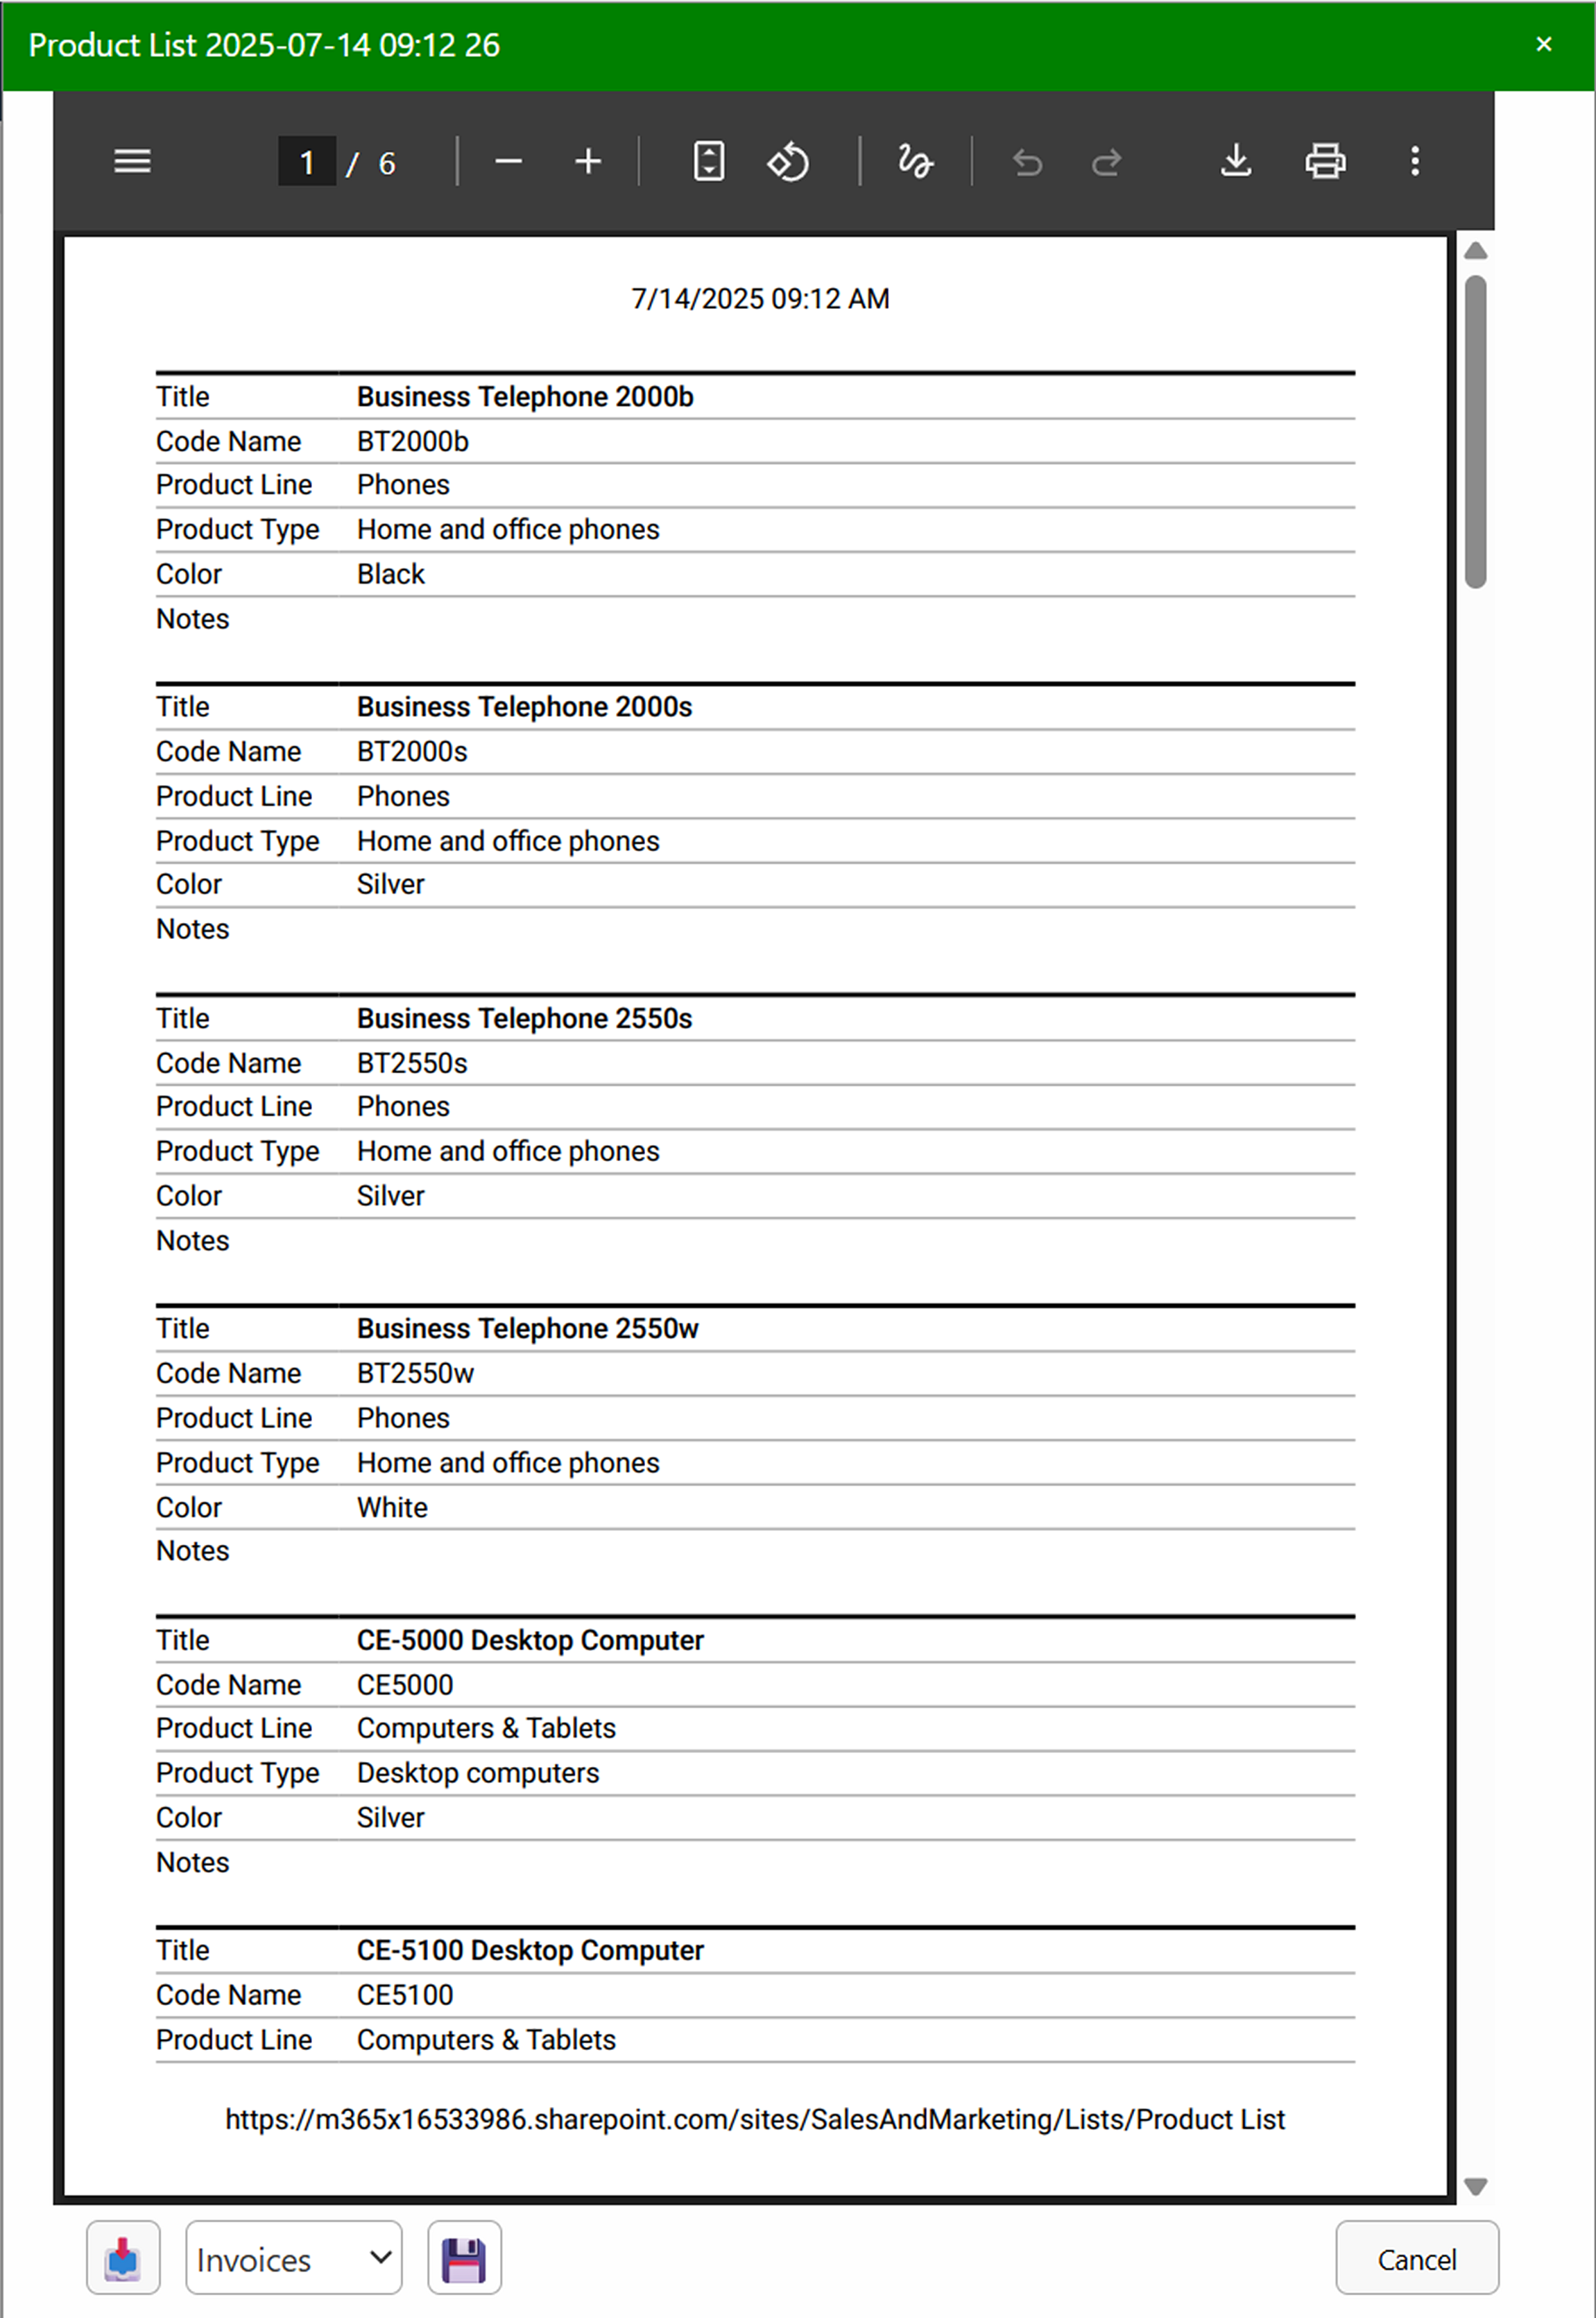
If you are testing PDF Creator, an hourglass icon will appear after around 5 seconds. Click on that icon to register PDF Creator, refer to chapter 4.

Note 1: When you add a list or library to Microsoft Teams, refer to 2.1.2, no preview can be displayed inside the dialog, but a PDF file can still be created and managed.
Note 2: There is a simple tool for drawing, highlighting and erasing in the top banner, but the preview is only for actual previewing. Since it is displayed inside an iframe inside a dialog inside SharePoint, the editing features of this browser supplied PDF viewer don't work. If you want to edit the PDF in any way, save it to your computer or a library and work with the file from there.

Registration For Standard Users
You may evaluate PDF Creator for 30 days with full functionality but without cost.
If you want to continue using PDF Creator after the trial period, you must start a subscription. We supply a Premium version of PDF Creator, which does not require registration at all, but organizations who select the Standard plan must register their installations of PDF Creator.
Standard subscribers will be given a registration key, which allows the organization to continue using PDF Creator for the duration of the subscription year. When that year is near its end, we will send a new invoice for another year.
Follow these steps to register:
- Click on the PDF Creator button in any list (or library) to open the preview dialog.
- Click on the hourglass icon. Now a new dialog opens.
- Enter an e-mail address with your company/organization domain and the registration key you have received from kalmstrom.com.
- Click on 'Registration'.
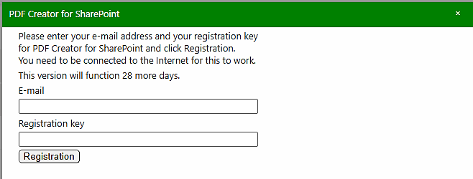
The person who registers PDF Creator should have at least Owner permission on the site. Each site installation needs to be registered.
The registration key will continue to work for as long as the organization is a kalmstrom.com Subscriber.
PDF Creator will automatically verify that your registration key is still valid every 30 days. No private information will be collected. There will be a count-down during 30 days and then an automatic renewal for another 30 days and so on. Should the subscription be cancelled, there will be no renewal.

Upgrade and Removal
We have made our utmost to make the PDF Creator upgrade process easy and quick, and we also want the removal process to be smooth if your organization should decide not to use PDF Creator anymore.

Upgrade
Upgrades are free for all subscribers to kalmstrom.com products, and we recommend that you always use the latest version of PDF Creator. That is the only version we support, so we have made our utmost to make the upgrade process easy and quick.
Premium subscribers will have an e-mail when their unique copies of PDF Creator have been updated. Standard subscribers can download the new version of PDF Creator from the kalmstrom.com website. At major updates, we will send an e-mail also to Standard subscribers.
You can see all the revisions and file numbers at:
https://www.kalmstrom.com/products/PDF-Creator/Revisions.htm
The Sandboxed solution och PowerShell package use the same folders, so you can very well upgrade the Sandboxed solution installations with the PowerShell script and vice versa.
The ​SPFX edition is different, so if you upgrade these installations with one of the other editions, there is a risk that you will get double PDF Creator buttons.
If you still have the old version after upgrade, it is probably left in your browser cache. Please clear the cache to solve that problem.

Upgrade the SPFX edition
All the tenant's installations of PDF Creator will be upgraded automatically when you add the new SPPKG file to the app catalog.
- Download the file.
- Remove the old PDF Creator SPPKG file from the app catalog.
- Upload the new SPPKG file to the app catalog.
- Enable the SPPKG file.
- All PDF Creator installations will now be upgraded automatically.

Upgrade the Sandboxed Solution Manually
To upgrade PDF Creator, replace the old PDF Creator WSP file with a new version of the file. This is the upgrade process for each site collection where PDF Creator is used:
- Deactivate PDF Creator under Site settings >Solutions (in the root site).
- Delete the old PDF Creator WSP file.
- Delete any PDF Creator files in the Site Assets library.
- Upload the new PDF Creator WSP file to the Solutions gallery in the root site.
- Activate the new WSP file in the Solutions gallery.
- Activate PDF Creator under 'Manage site features' on each site.

Upgrade with a PowerShell Script
Use this upgrade method whether you have installed PDF Creator with the PowerShell script or with the WSP file and want to upgrade using PowerShell.
- Open the new PDF Creator script in PowerShell ISE or Visual Studio Code.
- Modify the script so that it suits your installations. This is quickly done if you have saved the part of the old script that contains the sites where PDF Creator was installed.
- Run the script to upgrade the installations in all sites that are included in the script.

Remove PDF Creator
We of course hope that you will be satisfied with PDF Creator, but if you want to remove it from a site that is an uncomplicated process.
If your organization cancels the PDF Creator subscription, the product must be removed in all sites.
- To remove the PDF Creator SPFX edition, remove the file from the App catalog/Apps site.
- To remove the PDF Creator Sandboxed solution WSP installation, follow step 1-3 in the Upgrade instruction above.
- To remove PDF Creator with a PowerShell script, run the parts of the script that remove PDF Creator.

Contact and Tips
If you have any kind of problem or questions about PDF Creator, there are several ways of contacting us:
E-mail | support@kalmstrom.com – Technical issues
 | sales@kalmstrom.com – Subscription and general issues
 | finance@kalmstrom.com – Invoices, payments, quotations
Telephone | +46 739 206 106
Teams: | peter@kalmstrom.com – Chats, remote sessions
Zoom: | peter@kalmstrom.com – Chats, remote sessions

SharePoint Tips
You surely have noticed that PDF Creator is a great tool for improving the SharePoint experience. For tips on SharePoint usage in general, please refer to the Tips section of the kalmstrom.com website.

