List Copier Manual
Table of Contents
1 Overview 2
1.1 Languages 2
1.2 Requirements 2
1.3 Editions 2
1.3.1 The SPFX edition 3
1.3.2 The Sandboxed Solution 3
1.3.3 Permissions 3
1.4 Third Party JavaScript library 3
2 Installation Details 4
2.1 SPFX edition 4
2.1.1 Deploy in an App Catalog 4
2.1.2 Add the SPFX edition to Teams 6
2.2 Sandboxed Solution 6
3 Use List Copier 9
3.1 List Tab 9
3.2 Views Tab 10
3.3 Items Tab 10
3.4 Columns Tab 11
3.5 Finish 11
4 Registration For Standard Users 13
5 Upgrade and Removal 14
5.1 Upgrade 14
5.1.1 Upgrade the SPFX edition 14
5.1.2 Upgrade the Sandboxed Solution 14
5.2 Remove List Copier 14
6 Contact and Tips 16
6.1 SharePoint Tips 16

Overview
List Copier for SharePoint adds a button to all SharePoint lists in the sites where List Copier is installed. A click on that button opens a dialog where you can select how the list copy should be configured. By default, the copy gets the same structure, views, columns and items as the original, but that can easily be modified.
List Copier is a new kalmstrom.com product that we hope to enhance in the future, but even the first edition is stable and useful. List Copier already supports all column types and rich text format. Only Attached files are not yet supported.
List Copier supports all custom SharePoint lists, also called generic lists. All lists created from the modern SharePoint interface are custom, but some classic lists, such as Tasks and Events, have special features and are not yet supported.

Languages
The language of List Copier is English. Please contact kalmstrom.com if you need List Copier in another language!

Requirements
To use List Copier, you need to have SharePoint 2013 or above (in-house or hosted) or Microsoft/Office 365 SharePoint Online.
Tested browsers are Microsoft Edge and the latest versions of Google Chrome and Mozilla Firefox.

Editions
List Copier comes in two editions, SPFX edition and Sandboxed solution. They are installed in different ways, but they have the same version number and features. Both editions can create modern as well as classic list copies.
One subscription is valid for both editions, so use any combination of editions you wish.
The kalmstrom.com team offers installation assistance with a PowerShell script for both editions. This service is free for Premium subscribers.
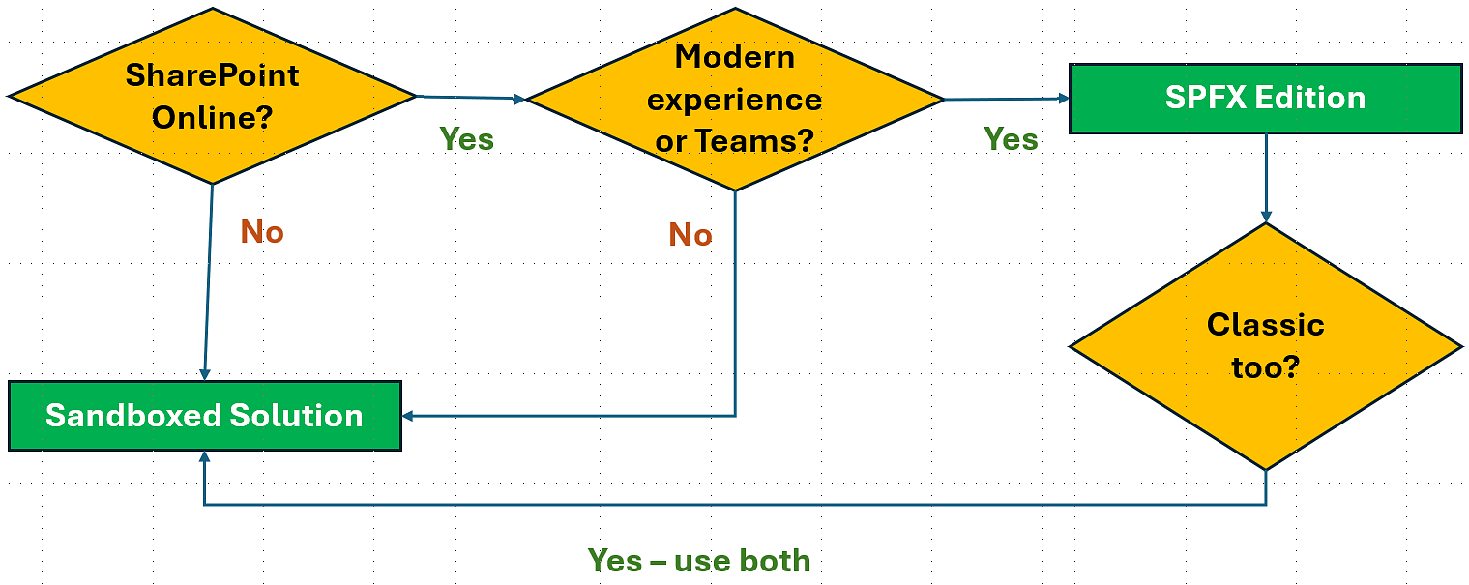

The SPFX edition
The List Copier SPFX edition, or modern client-side extension, only supports SharePoint Online and the modern interface, but it is very easy to install and upgrade so we recommend that you use it when possible. This edition supports integration in Microsoft Teams.
The List Copier SPFX edition gives a List Copier button in Microsoft Lists and the modern SharePoint interface.
If you combine the SPFX edition with the Sandboxed solution edition, you can use List Copier in classic SharePoint Online sites too.

The Sandboxed Solution
The Sandboxed solution supports SharePoint 2013, 2016, 2019, SE and Online. It gives a List Copier button in the classic SharePoint interface. Switch temporarily to the classic experience if you want to copy a modern list.

Permissions
Standard SharePoint permissions are used for List Copier.

Upload and Install the SPFX edition
To upload the List Copier SPPKG file to an App catalog, you need to have access to it. Global admins always have that permission and normally also SharePoint admins. Deployment to all sites can be done in the same process.
If List Copier is not enabled for all sites in the upload process, it can be installed in a single site by the Site owner.

Install and Activate the Sandboxed Solution
To upload the List Copier Sandboxed solution .wsp file to the Solutions gallery and activate it there, you need to be at least Site admin.
To activate the solution for the site you must be at least Site owner. Often – but not always – the same person has both these roles.

Third Party JavaScript library
The kalmstrom.com team has modified and extended a third-party jQuery JavaScript library to create List Copier. No extra license is necessary to use this library in List Copier.

Installation Details
Within Microsoft's limitations we have tried to make our products as easy as possible to install. All installation methods are described below and in video demonstrations on the List Copier Demonstrations page at https://www.kalmstrom.com/products/Link-Copier/Demonstrations.htm. There are also videos on each Download page.
Another option is to use the kalmstrom.com installation assistance, please refer to: https://www.kalmstrom.com/Services/Installation-Assistance.htm

SPFX edition
The List Copier SPFX edition can be used in all modern SharePoint Online lists. It comes as an SPPKG file that gives a modern SPFX client-side extension. The SPPKG file is downloaded from the kalmstrom.com website to your PC and then extracted and uploaded to the tenant's App catalog. After that, List Copier can be either added to all sites at once or be made available to the whole tenant via the 'Add an app' command.

Deploy in an App Catalog
- Download the List Copier file from the kalmstrom.com website to any folder on your computer and extract it.
- Go to your App catalog. (If you have not already created such a site, it will be created the first time you click on the 'Open' button in the SharePoint Admin center >More features >Apps.)
- Upload the SPPKG file. (If there is a warning message for add-ins, it can be ignored. It does not apply to SPPKG files.)
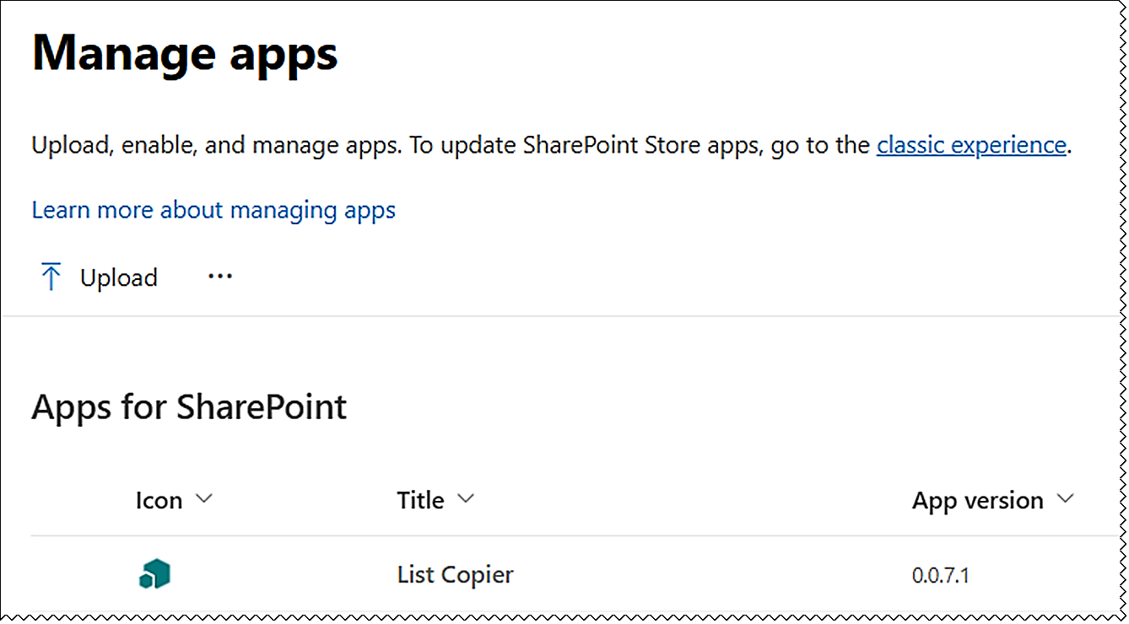
- A right Enable app pane opens. Select one of the options:
- Enable the file.
- Enable the file and add List Copier to all sites (default).
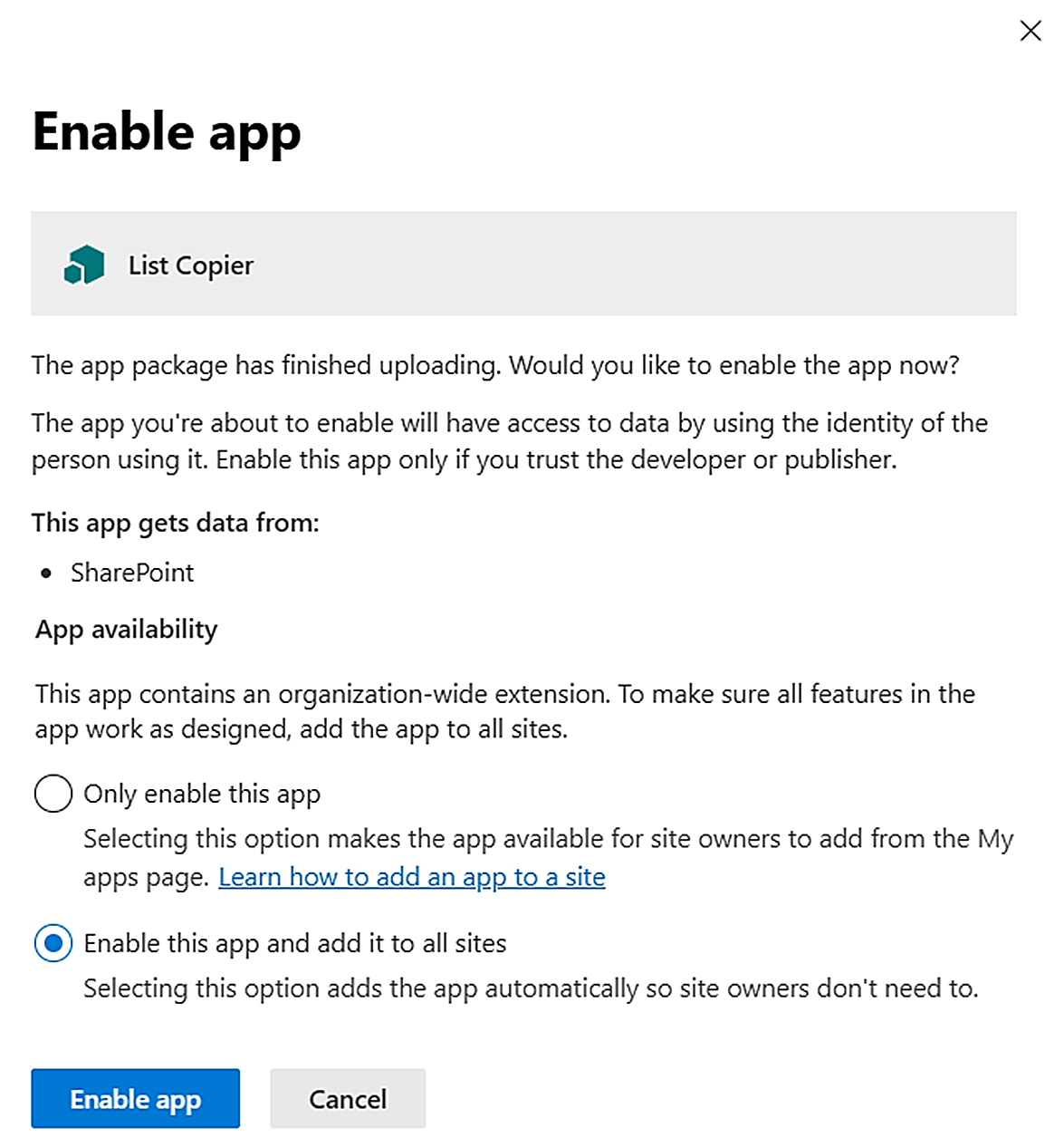
- Click on the 'Enable app' button.

Install in a Site
If you have selected to only enable the file but not add it to all sites, Site owners must deploy List Copier manually in each site where it should be used.
- In the site where you want to use List Copier, click on + New >App in the modern home-page or Site contents, or click on the settings icon in the top navigation bar and select 'Add an app'.
- Select "All" or "From your organization" in the left menu.
- Click on the List Copier tile.
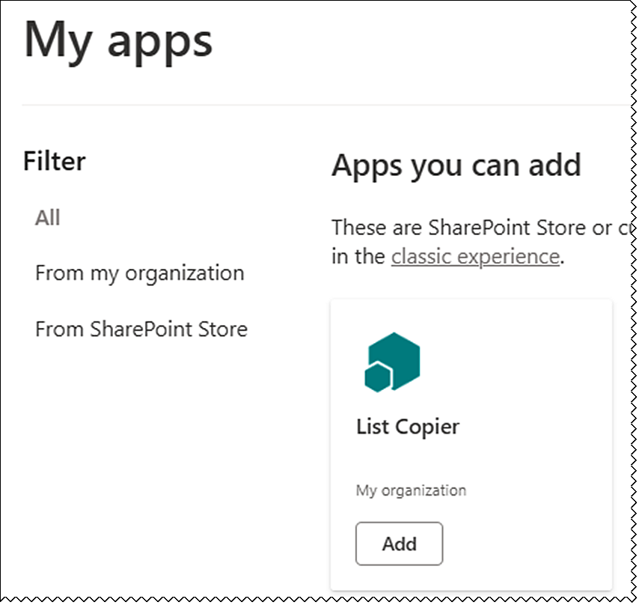
Now List Copier will be installed in the site where you initiated the 'Add an app' command. In a minute or so, the List Copier button will show up in the command bar in all the site's lists that have the modern interface.
Repeat the process for each site where you want to use List Copier.

Add the SPFX edition to Teams
To use List Copier in Microsoft Teams, add a list where List Copier is installed to a modern SharePoint page. Then add that page to a new Teams tab. List Copier will work in the same way as in SharePoint.
You can start in SharePoint or open the Files tab in the Teams channel you wish to use and go to SharePoint from the link under the ellipsis.
- Create a new modern page
- We recommend that you delete the comments section and not add any additional web parts to this page.
- Use a one column section with a List web part. Add a list from a site where List Copier is installed.
- Give the page a name – it will be visible on the Teams tab.
- Publish the page.
- Add a new SharePoint Page tab to the Teams channel and select the page you created or paste its link.

Sandboxed Solution
The List Copier Sandboxed solution is uploaded as a SharePoint Solution to a site, and it needs to be activated for the site and any subsites where it will be used.
If you use SharePoint On-Premises and have problems with the activation, please make sure that the Sandboxed code service is running on the SharePoint server.

Site Assets
The installation will add a .js file in the Site Assets library, so make sure that the site really has a Site Assets library before you start the installation. If there is no such library, activate the Wiki Page Home Page feature under Site settings >Site actions >Manage site features, to create the library. (Your homepage will not be affected by this.)

Only for SharePoint Online
If you want to use the Sandboxed solution in SharePoint Online, custom scripts must be allowed in the site during installation and upgrade. This is done in the SharePoint Admin center >Active sites >the sites Details pane >Settings, by a Global or SharePoint administrator.

Upload to a Solutions Gallery
Download the List Copier Sandboxed solution file from the kalmstrom.com website to any folder on your computer. Then follow the steps below to add List Copier to the site collection.
- Go to the root site of the SharePoint site collection where you want to use List Copier and click on the Settings icon in the top navigation bar.
- Select the Site settings option or select Site information and then Site settings.
- (If you don't see these options, most likely you don't have the appropriate permissions. You need to be Site admin to install solutions.)
- Under Web Designer Galleries, click on 'Solutions'.
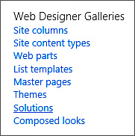
- Click on the 'Upload Solution' button and browse to the WSP file you downloaded from kalmstrom.com.
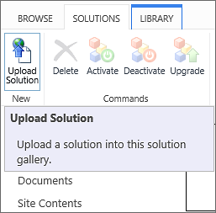
- When the file has been uploaded, you will be shown a dialog where you can activate the solution for the site collection.
Now List Copier is available for the site and any subsites.

Activate for a Site
Before List Copier can be used, the solution must be activated on each site or subsite where users should see the List Copier button in the lists.
- Click on the settings icon in the top navigation bar and click on 'Site settings'. You might need to first click on 'Site information'.
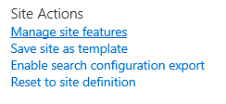
- Click on 'Manage site features' under the Site Actions heading. (If you don't see this option, most likely you don't have the appropriate permissions. You need to be Site owner to manage site features.)
- Find List Copier in the list of Site features.
- Click on the 'Activate' button to activate the List Copier feature.
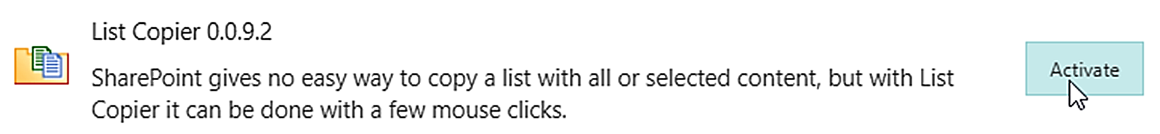
- The activation adds a List Copier button to all lists in the site.
Please contact peter@kalmstrom.com if you want to automate the process of installing the Sandboxed solution in multiple sites with a PowerShell script.

Use List Copier
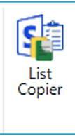
When List Copier has been installed in a site, supported lists have a List Copier button. In the modern experience, you can find it visible in the command bar or under the command bar ellipsis.
In the classic experience, the button is found in the ribbon under the List tab.
When you click on the List Copier button a dialog will open. Here, you are given many options on how to copy the list. The alternatives are gathered under four tabs.
The dialog adapts to the current list, as you probably want to keep the settings or just make a few changes, so it might look different than the default settings in the image below.
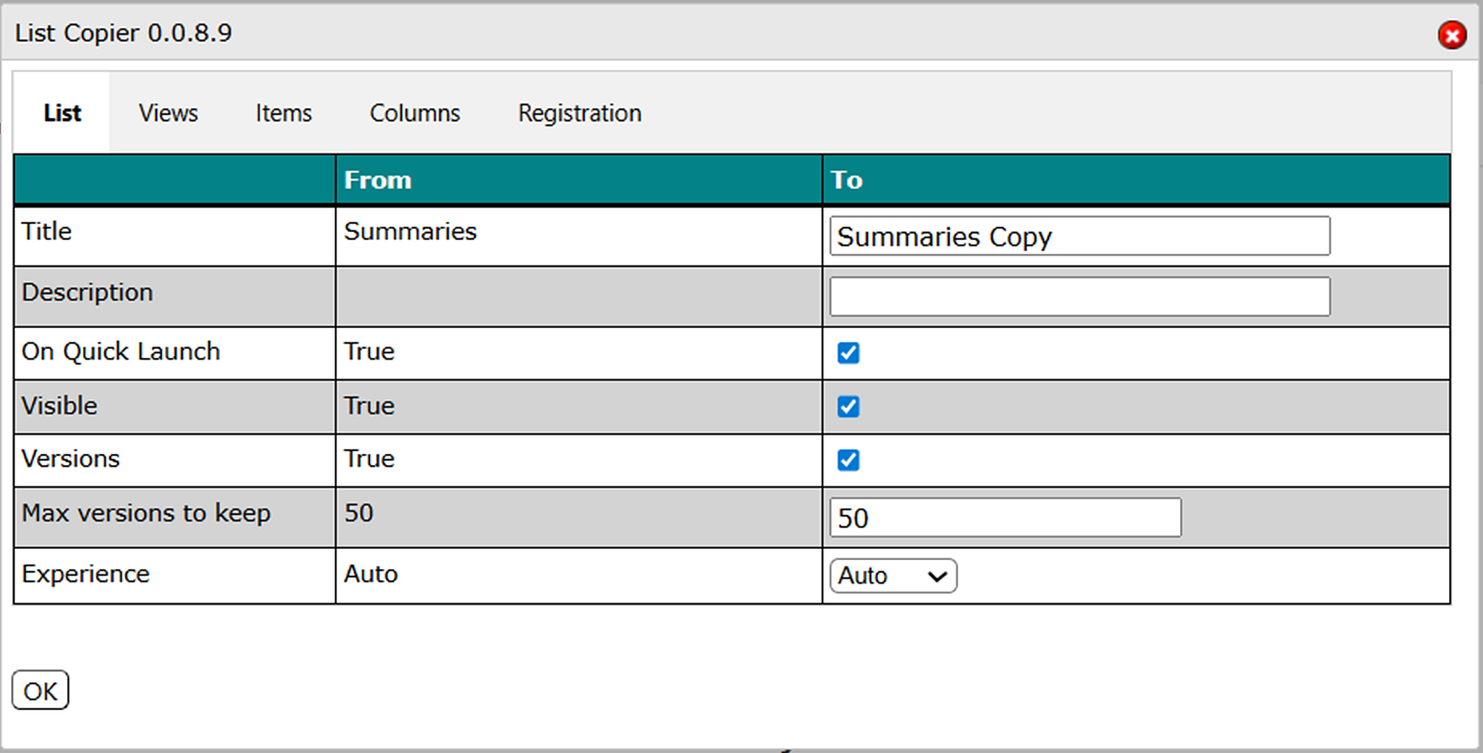
For evaluators and Standard subscribers, the dialog also has a Registration tab.

List Tab
Under the List tab, you can change the following parameters:
- Title. The new title of the list copy. By default, it is the same as the original list name + Copy.
- Description. A description of the new list.
- On Quick Launch. By default, the new list is added to the Site navigation/Quick launch. Uncheck the box at On Quick Launch True if you don't want that.
- Hide. By default, the new list is visible. Even if you uncheck the On Quick Launch box, it will be visible in the Site contents. Uncheck the Hide True box if you want the list to be hidden there too.
- Versions. In the first version of List Copier, the version history for each item cannot be copied, but the versioning settings are copied if you keep the box checked. In the row below, at Max versions to keep, you can set the maximum number of versions to keep.
- Experience. Set the default experience for the list. Auto means that it follows the default experience for the site.

Views Tab
Under the Views tab, you can select which public views should be included in the copy.
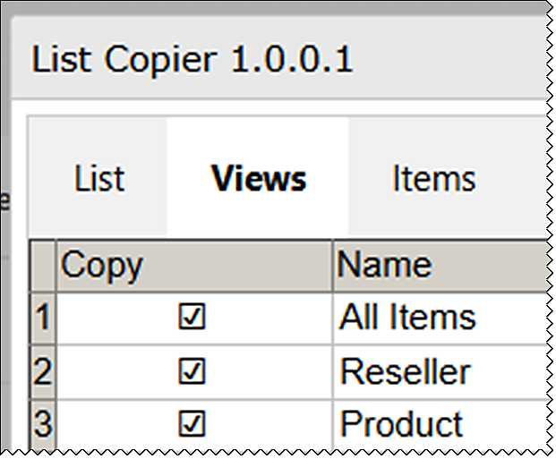
By default, all views are included.

Items Tab
By default, all list items are included in the copy. Uncheck the boxes for items you want to exclude from the copy or select All (default) or None.
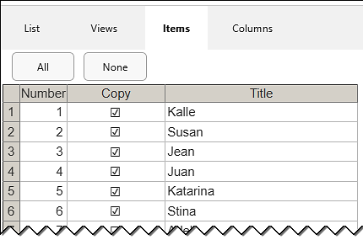
You can copy up to 3000 items in a list at the same time.
When you hover over a Column name under the Items tab, you will see a menu icon. Here, you can sort the items ascending or descending and filter which column values you want to include in the copy.
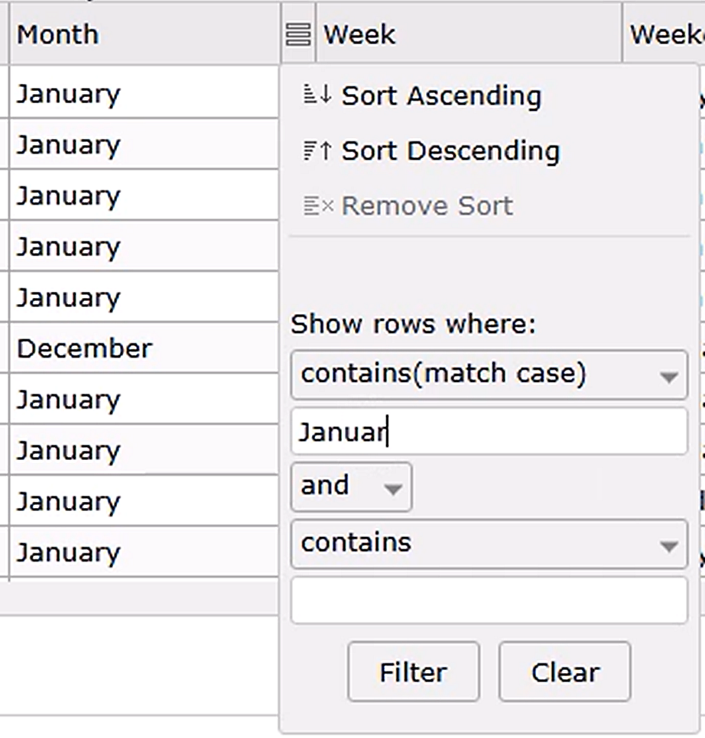

Columns Tab
By default, all columns in the original list are included in the copy. Uncheck the boxes for columns you want to exclude from the copy.
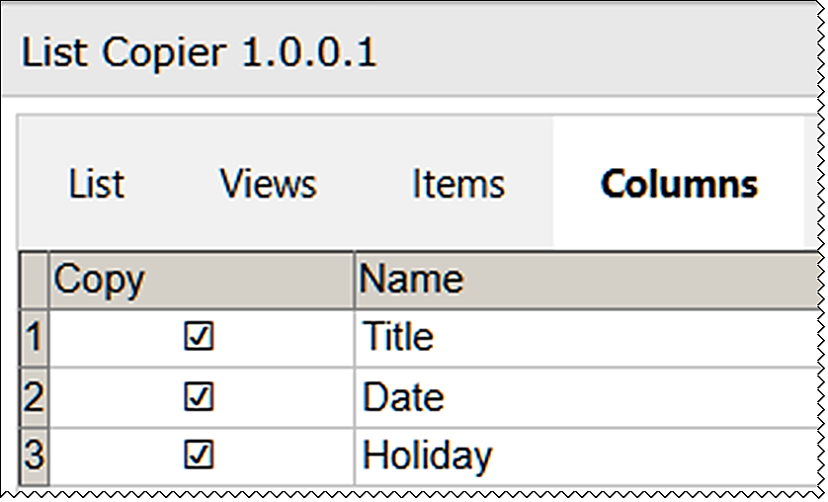
Note that you might get an unwanted result if you uncheck boxes for columns that are included in the selected view(s). The same applies if you deselect a column is needed for a calculated value in a column that you keep.

Finish
When you have made your settings for the list copy, click on the OK button below the grid. Now the new list will be created in the same site, and you can follow the process on the page. When it is finished, a link to the new list will be visible on top.
In a future version, we plan to make it possible to save the copy in another site.
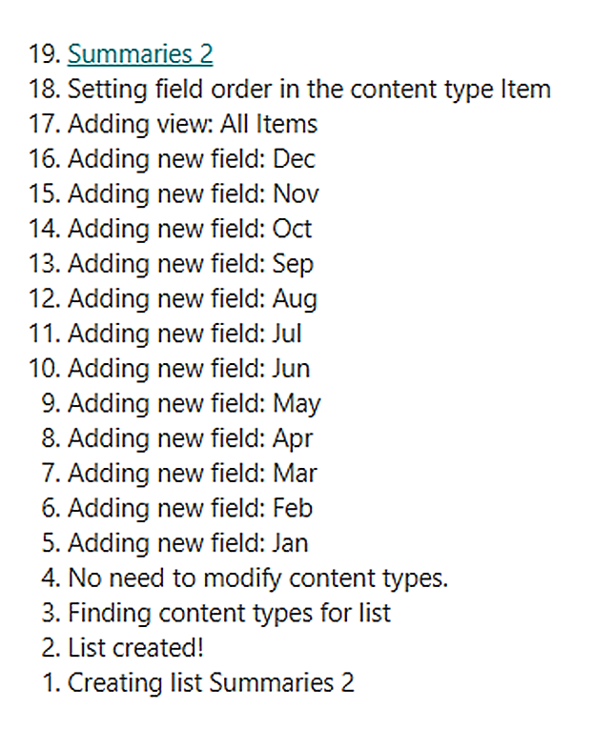

Registration For Standard Users
You may evaluate List Copier for 30 days with full functionality but without cost.
If you want to continue using List Copier after the trial period, you must start a subscription. We supply a Premium version of List Copier, which does not require registration at all, but organizations who select the Standard plan must register their List Copier installations.
Standard subscribers will be given a registration key, which allows the organization to continue using List Copier for the duration of the subscription year. When that year is near its end, we will send an invoice for another year if the subscription has not been cancelled.
Follow these steps to register:
- Click on the List Copier button in any list to open the settings dialog.
- Open the Registration tab.
- Enter an e-mail address with your company/organization domain and the registration key you have received from kalmstrom.com.
- Click on 'Registration'.
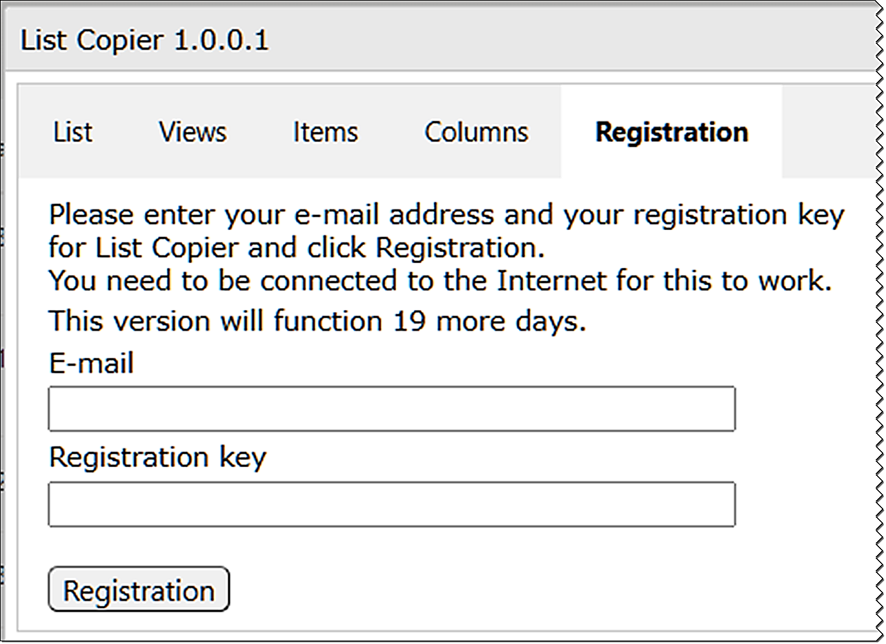
The person who registers List Copier should have at least Owner permission on the site. Each site installation needs to be registered.
The registration key will continue to work for as long as the organization is a kalmstrom.com Subscriber.
List Copier will automatically verify that your registration key is still valid every 30 days. No private information will be collected. There will be a count-down for 30 days and then an automatic renewal for another 30 days and so on. Should the subscription be cancelled, there will be no renewal.

Upgrade and Removal
We have made our utmost to make the List Copier upgrade process easy and quick, and we also want the removal process to be smooth if your organization should decide not to use List Copier anymore.

Upgrade
Upgrades are free for all subscribers to kalmstrom.com products, and we recommend that you always use the latest version of List Copier. That is the only version we support, so we have made our utmost to make the upgrade process easy and quick.
You can see all the revisions and file numbers at:
https://www.kalmstrom.com/products/List-Copier/Revisions.htm
If you still have the old version after upgrade, it is probably left in your browser cache. Please clear the cache to solve that problem.

Upgrade the SPFX edition
All the tenant's installations of List Copier will be upgraded automatically when you add the new SPPKG file to the app catalog.
- Download the file.
- Remove the old List Copier SPPKG file from the app catalog.
- Upload the new SPPKG file to the app catalog.
- Enable the SPPKG file.
- All List Copier installations will now be upgraded automatically.

Upgrade the Sandboxed Solution
To upgrade List Copier, replace the old List Copier WSP file with a new version of the file. This is the upgrade process for each site collection where List Copier is used:
- Deactivate List Copier under Site settings >Solutions in the root site.
- (Refresh the page.)
- Delete the old List Copier WSP file.
- Delete the List Copier.js file in the Site Assets library.
- Upload the new List Copier WSP file to the Solutions gallery in the root site.
- Activate the new WSP file in the Solutions gallery.
- Activate List Copier under 'Manage site features' on the site and any subsites.

Remove List Copier
We of course hope that you will be satisfied with List Copier, but if you want to remove it from a site that is an uncomplicated process.
If your organization cancels the List Copier subscription or decides to not use List Copier after the evaluation period has ended, the product must be removed in all sites.
- To remove the List Copier SPFX edition, remove the file from the App catalog/Apps site.
- To remove the List Copier Sandboxed solution WSP installation, follow step 1-4 in the Upgrade instruction above.

Contact and Tips
If you have any kind of problem or questions about List Copier, there are several ways of contacting us:

E-mail | support@kalmstrom.com – Technical issues
 | sales@kalmstrom.com – Subscription and general issues
 | finance@kalmstrom.com – Invoices, payments, quotations
Telephone | +46 739 206 106
Teams: | peter@kalmstrom.com – Chats, remote sessions
Zoom: | peter@kalmstrom.com – Chats, remote sessions

SharePoint Tips
You surely have noticed that List Copier is a great tool for improving the SharePoint experience. For tips on SharePoint usage in general, please refer to the Tips section of the kalmstrom.com website.

