Document Tagger for SharePoint ‒ Manual
1 Introduction 2
1.1 Language processing service 2
1.1.1 Relevance 2
1.1.2 Security 2
1.2 Languages 2
1.3 Requirements 3
1.4 Formats 3
2 Installation 4
2.1 Install and Activate for Site Collection 4
2.2 Activate on Site 5
2.3 Site Settings Link 5
2.4 Permissions 5
2.4.1 Users 6
2.4.2 Administrator 6
2.4.3 Visitors 6
2.5 Add as Web Part 6
2.5.1 When a SharePoint library has been added to a page, you can tag the documents in the same three ways as you tag them in the classic interface, refer to 4.1.2 Tagging in the Modern Interface 7
2.6 Term Store 9
3 First Time Usage 10
3.1 Example Library 10
3.2 Remove Example Library 11
4 How to Tag and Use Tags 13
4.1 Tag a Document 13
4.1.1 Tagging in the Modern Interface 14
4.1.2 Tagging in the Classic Interface 15
4.2 Tag Multiple Documents 16
4.3 Filter by Tag 18
4.3.1 Filter Icon In The Modern Interface 18
4.3.2 Filter In The Classic Interface 20
4.4 View by Tag 20
5 Upgrade 26
6 Registration 27
7 Contact 28
8 Removal and Deactivation 28
9 More SharePoint Tips 28

Introduction
Document Tagger for SharePoint tags documents in SharePoint document libraries with keywords, which helps organizations to take full advantage of their site's metadata driven SharePoint Search. But better search is just one advantage. You can also filter by tag and create SharePoint views for certain tags.
Document Tagger sends your document to a language processing engine, Google Cloud Natural Language, which quickly analyzes it and sends back the top 15 suitable keywords. Review the suggestions, remove those that are not relevant and add more keywords if needed. Then click on the ‘Apply tags’ button, to apply the tagging.
This way the addition of SharePoint metadata is much quicker than adding each word manually. You can find a detailed description of the possibilities Document Tagger gives in chapter 4 of this manual.
Documents are tagged in different ways depending on which interface you work with: classic or modern. Most of the images in the manual are taken from the modern interface, but when there are significant differences we show both interfaces.

Language processing service
Document Tagger uses the Google Cloud Natural Language for the text analysis. As Google Cloud Natural Language supports document of the size less than 1MB, the current version of Document Tagger only reads the first 1MB of documents that are bigger than 1MB.

Relevance
Systems for text analysis are continuously improved, but semantic word processing is still a young science and you will probably have some suggestions you don’t want to use. For best result, you should therefore always review the keyword suggestions and uncheck the ones you find irrelevant. Document Tagger still makes the process of tagging documents much easier and quicker than manual tagging.

Security
As Document Tagger sends documents to Google Cloud Natural Language for text analysis, Google Cloud's security model ensures that your organization's information is secure.
The content is purged immediately after the successful extraction of metadata. Also refer to the Google Cloud Natural Language security policy.

Languages
The language of Document Tagger is automatically set to the same as on the SharePoint site. The supported languages are: Danish, Dutch, English, French, German, Italian, Norwegian, Portuguese, Spanish and Swedish. When the SharePoint site has another language, Document Tagger will be in English.
For document analysis, as we use Google Cloud Natural Language, the languages that are supported for tagging are: English, Chinese, French, German, Italian, Japanese, Korean, Spanish and Portuguese: [https://cloud.google.com/natural-language/docs/languages]
When Google Cloud Natural Language starts supporting more languages in the future, Document Tagger will automatically support the analysis in those languages also.

Requirements
To use Document Tagger you need to have SharePoint 2013 or above (in-house or hosted) or Office 365 SharePoint Online.
Supported browsers are Microsoft Edge, Internet Explorer 9 and higher and the latest version of Google Chrome or Mozilla Firefox.

Formats
Document Tagger supports DOCX, PDF, PPTX, TXT and XLSX files.

Installation
Document Tagger is installed as a SharePoint Solution in a Site Collection, and it needs to be activated for each site where it will be used.

Install and Activate for Site Collection
Download the file DocumentTagger.wsp from the kalmstrom.com website to any folder on your computer. Then follow these steps to add Document Tagger to a site collection.
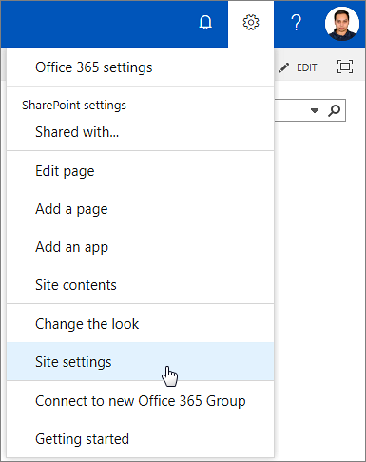
- Go to the root site of the SharePoint site collection where you want to use Document Tagger and click on the Settings icon at the top.
- Select the Site settings option.
(If you don’t see this option, most likely you don’t have the appropriate permissions. You need to be the site collection Administrator to install solutions.)
- Under Web Designer Galleries, select “Solutions”.
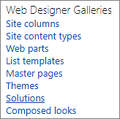
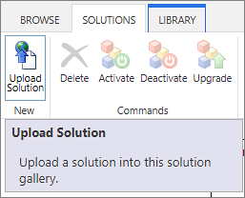
- Next step is to upload the solution – which is the .wsp file you downloaded from the kalmstrom.com website. Click on the ‘Upload Solution’ button and browse to the file DocumentTagger.wsp on your computer. (Open the SOLUTIONS tab if the ‘Upload Solution’ button is not visible.)
- When the file has been uploaded, you will be shown a dialog where you can activate the solution.
- Now Document Tagger is available for all sites in this site collection.
If you want to use Document Tagger in multiple site collections, you need to follow the steps above for each site collection. Premium subscribers may request a PowerShell script for installation in multiple site collections.

Activate on Site
When Document Tagger is installed in a site collection you need to activate the solution for each site it should be used on.
- Go to the site where you want to activate Document Tagger and once again select Site settings.
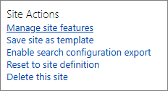
- Select “Manage site features” under Site Actions. (If you don’t see this option, most likely you don’t have the appropriate permissions. You need to be a site owner or site designer to manage site features.)
- Find the Document Tagger entry in the list of Site Features. Click on the Activate button to activate it.
When Document Tagger is activated on a SharePoint site, a ‘Tag Document’ button is added to all the document libraries in that site.

Site Settings Link
When Document Tagger has been activated for a site, there is a Document Tagger link in the Site settings, under the Web Designer Galleries heading.
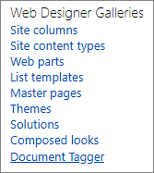
When you click on this link, a ‘Get Started’ page will be displayed. Refer to First Time Usage.

Permissions
Standard SharePoint permissions are used for Document Tagger.

Users
People who should work with tagging documents must have at least Contribute permission over the document library/libraries where they need to tag documents, within the SharePoint site where Document tagger is installed.

Administrator
The Document Tagger administrator must have Full control over the site where Document Tagger is activated.
At first time use, refer to chapter 3 below, the admin must have Full control over the site collection.

Visitors
For people who just need to see the documents, it is sufficient with Read permission over document library. Visitors will not be able to tag documents or remove tags, but they will be able to use the keywords to find documents and to view the tagged documents.

Add as Web Part
Document Tagger can also be used when a SharePoint library is added as a classic web part or app part.:
- Go to the SharePoint site where Document Tagger is installed.
- Click on ‘Edit’ on the top right of the SharePoint page where you want to add the web/app part. The page will open in Edit mode.
- Open the INSERT tab and click on ‘Web Part’.
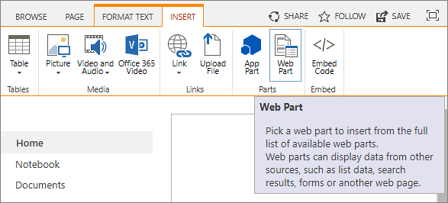
- Select the SharePoint library you wish to add, here 'DTExamples'.
- Click on ‘Add’.
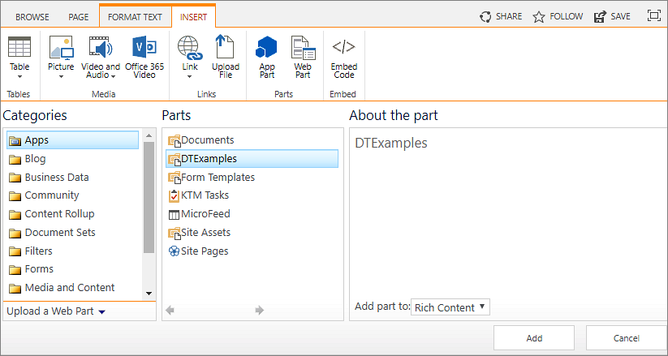
- Click on ‘Save’.
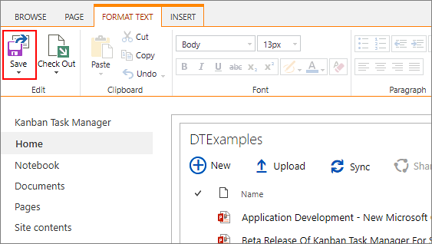
- Now the SharePoint library is added as a web part to the page.

When a SharePoint library has been added to a page, you can tag the documents in the same three ways as you tag them in the classic interface, refer to 4.1.2 Tagging in the Modern Interface
In the modern interface, tagging can be done in two ways:
- Select a document and click on the ‘Tag Document’ button in the command bar.
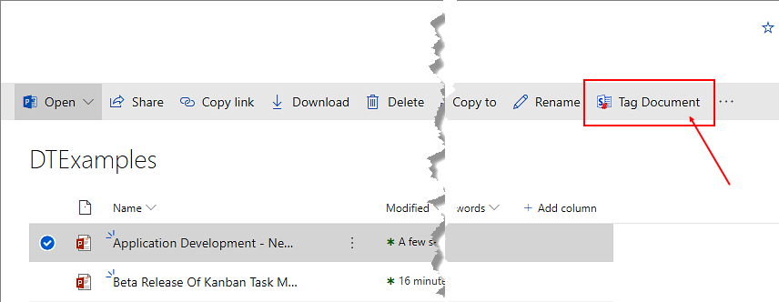
- Select a document, click on the vertical ellipsis and then on ‘Tag Document’.
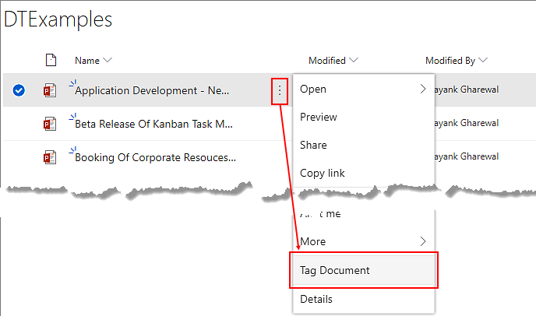
Tagging in the Classic Interface.
Note: Due to a SharePoint bug, that we hope will be solved soon, Document Tagger currently doesn’t work with document libraries that are embedded in modern SharePoint pages.

Term Store
All Document Tagger keywords are added to the Enterprise Keywords folksonomy, which is stored in the SharePoint Admin center Term Store and available across the farm or tenant. The concept of tagging is well-known from social media, and usually this freedom of suggesting keywords, or tags, works in SharePoint too.
If you still need to edit the keywords, for example to remove wrongly spelled or inappropriate words, this is done in the Term Store. You need to be a SharePoint admin to perform this action.
- In the SharePoint Admin center, click on the 'term store' link in the left pane.
- (The first time this is done, add yourself as Administrator of the Term Store.)
- Open the Keywords accordion and move or delete keywords.

First Time Usage
When Document Tagger has been activated on a site, a “Get Started” page is shown when you click on the “Document Tagger” link in the Site settings.
From the “Get Started” page, you can generate an example library if you don't want to try Document tagger with your own files. You can also reach the Manual web page, to download this manual.
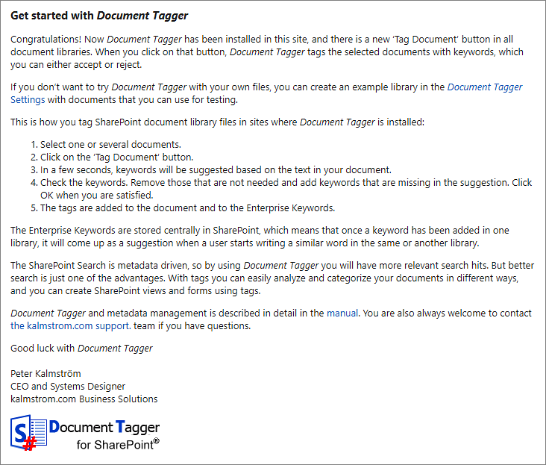

Example Library
If you choose to first generate an example library for the evaluation, click on the ‘Document Tagger Settings’ link in the “Get Started” page. Then click on ‘Create Example Library’ to create an Example library called ‘DTExamples’ with different file formats.
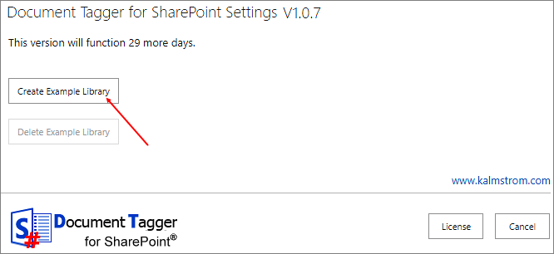

Remove Example Library
To remove the example library, go to the Document Tagger Settings from the ‘Document Tagger’ link under ‘Web Designer Galleries’ in the Site settings. Then click on ‘Delete Example Library’, and your example library will be deleted.
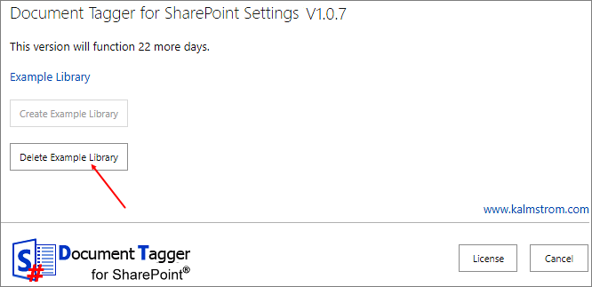
Another way to remove the example library is to open its library settings. Then click on ‘Delete this document library’.
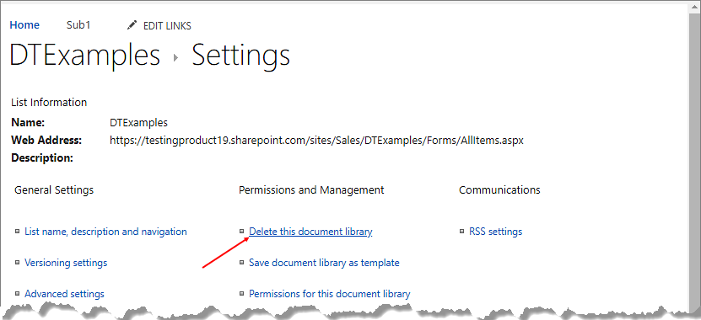

How to Tag and Use Tags
With Document Tagger, you can tag newly uploaded documents as well as existing documents.

Tag a Document
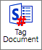
Select a document in a SharePoint document library and click on the ‘Tag Document’ button. Depending on the interface and tagging method a new window or a pop-up window with tagging suggestions will open. Document Tagger will make a semantic analysis of the document you have selected and suggest the top 15 keywords based on the text of the selected document.
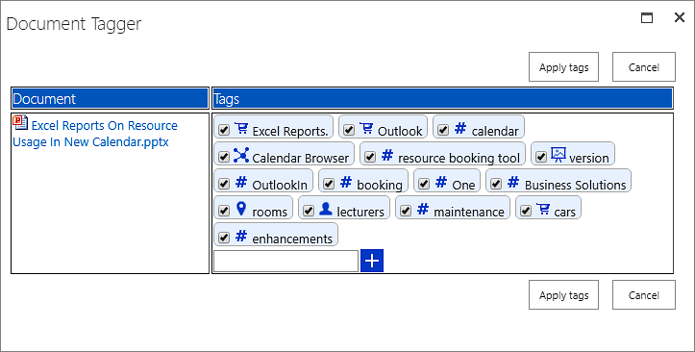
You can uncheck the boxes for the tags you find irrelevant.
If you want to add another tag, write in your keyword in the field at the plus sign. Click on the plus sign, or press Enter, to add the keyword to the document tags. Write in another keyword, if necessary, and click on plus or press Enter. When you are finished, click on ‘Apply tags’ to save the tags.
The tags will be displayed in the ‘Enterprise Keywords’ column in the document library.
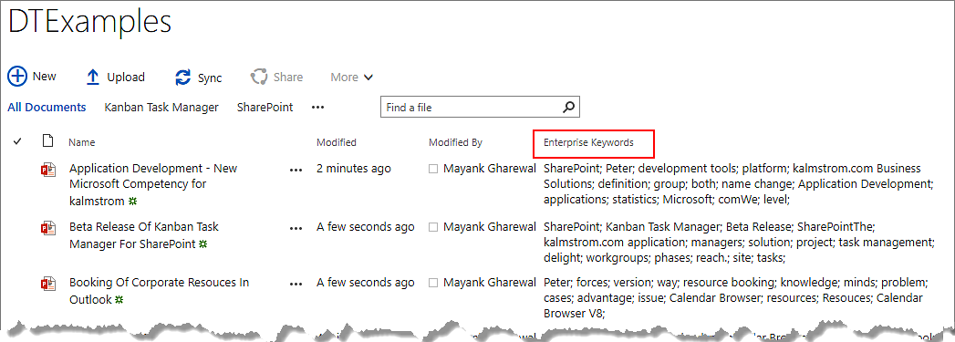

Tagging in the Modern Interface
In the modern interface, tagging can be done in two ways:
- Select a document and click on the ‘Tag Document’ button in the command bar.
- Select a document, click on the vertical ellipsis and then on ‘Tag Document’.

Tagging in the Classic Interface
In the classic interface, tagging can be done in two ways:
- Select a document and click on the ‘Tag Document’ button, under the ‘Files’ tab in the ribbon.
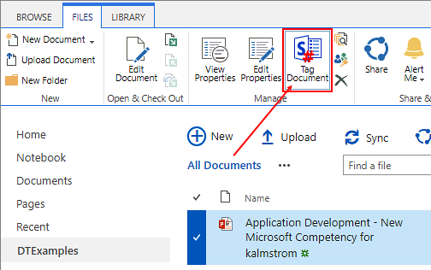
- Select a document and click on the horizontal ellipsis. Again click on the horizontal ellipsis, go to ‘Advanced’ and select ‘Tag Document’.
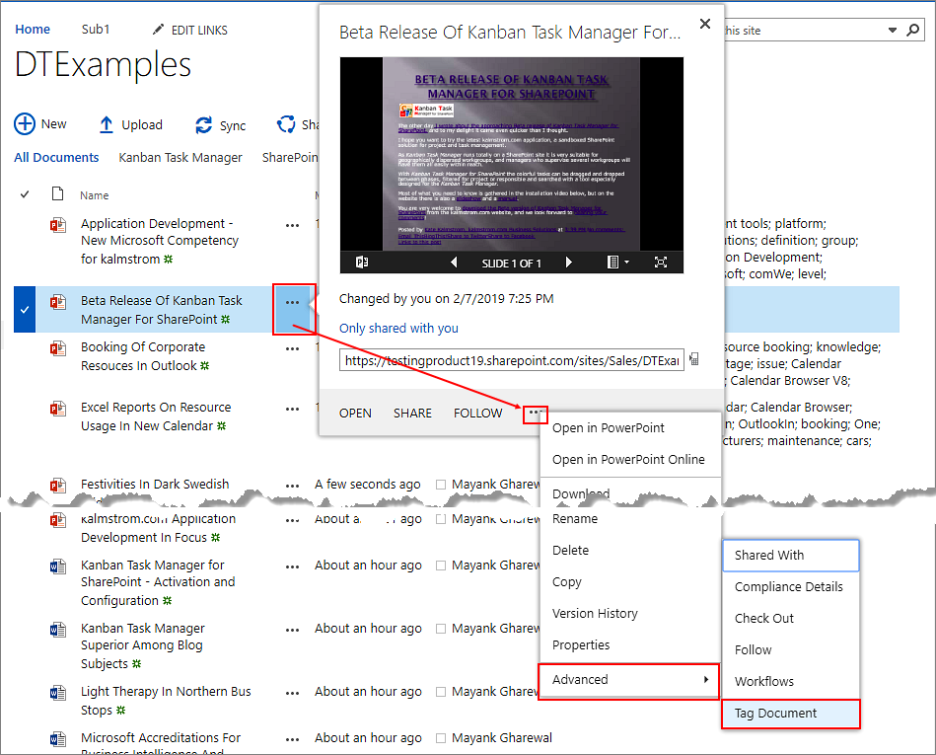

Tag Multiple Documents
With Document Tagger, you can tag multiple documents at a time. To tag multiple documents, select the documents and click on the ‘Tag Document’ button in the command bar or ribbon.
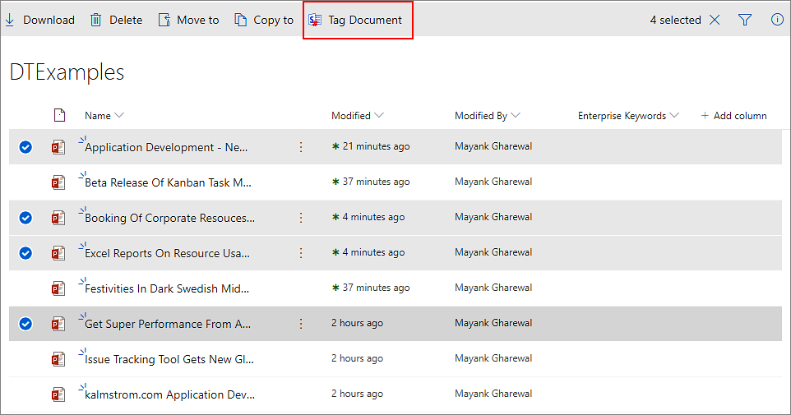
When you tag multiple documents, Document Tagger will analyze the documents and suggest top 15 keywords for each of them.
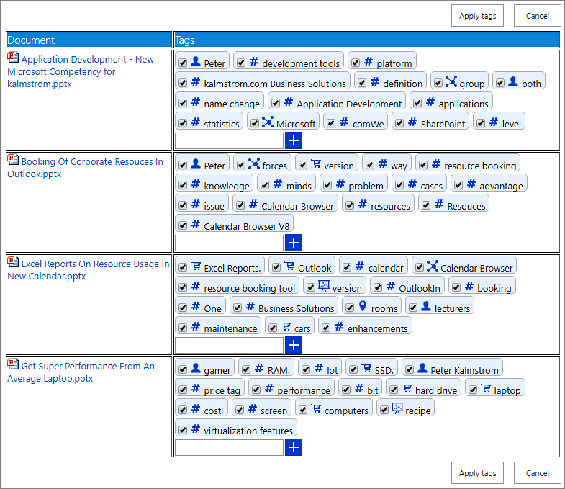
You can uncheck the boxes for keywords you find irrelevant. If you want, you may also add a keyword by writing it in the field at the plus sign and click ‘+’ or press Enter.
Then click on ‘Apply tags’ to save.

Filter by Tag
You may filter the Enterprise Keywords column by one or several tags.

Filter Icon In The Modern Interface
To filter documents in the modern interface, click on the accordion to the right of the ‘Enterprise Keywords’ column and select ‘Filter by’. A filter pane opens to the right, displaying all the keywords by which you can filter the column.
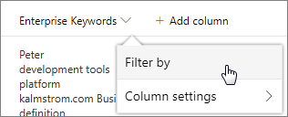
In the modern interface you can also filter any column in the right pane. Click on the filter icon at the top right corner of the command bar and a filter pane opens where you will see the columns that you could apply filter on.
Under ‘Enterprise Keywords’ click on ‘See all’ to view all the keywords. Check the box for the keywords as per your needs. When you click on ‘Apply’, all the documents that have the selected keywords will be displayed.
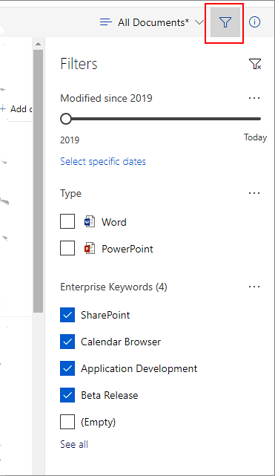
To remove the filter, click on the clear filter icon at the top right corner of the filter pane.

Filter In The Classic Interface
In the classic interface, move the cursor over the ‘Enterprise Keywords’ column and expand the accordion. You can check the boxes for the keywords as per your needs. As you start checking the boxes, the documents start getting filtered according to the keywords.
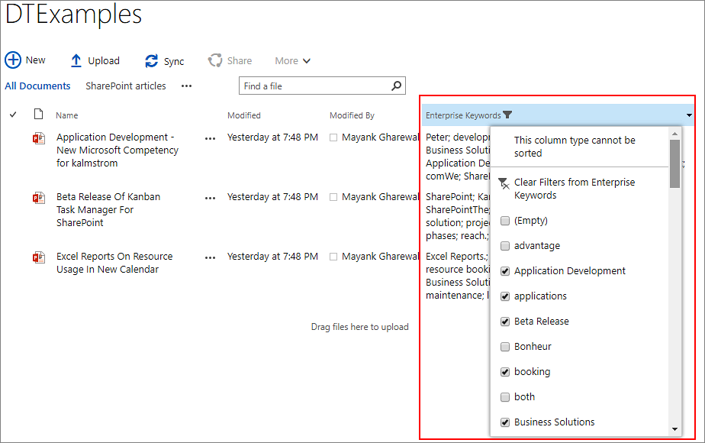
To remove the filter, click on the ‘Clear Filters from Enterprise Keywords’ option in the dropdown.

View by Tag
You may create views where you see all documents that have one or more specified tag(s). This is especially useful if you want to keep track of any new documents added about a certain subject.
To create a view by tag, follow the steps below:
- In the SharePoint library, go to ‘Library settings’.
Modern interface:
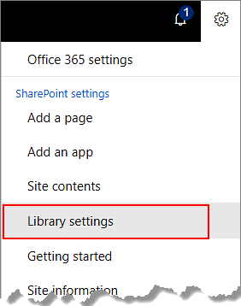
Classic interface: Go to the SharePoint document library, then click on the ‘Library Settings’ button under the ‘Library’ tab in the ribbon.
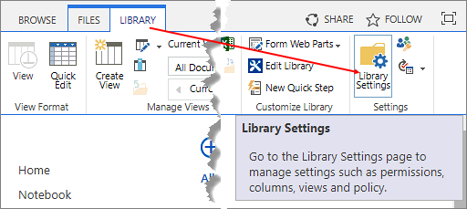
- Click on ‘Create View’.
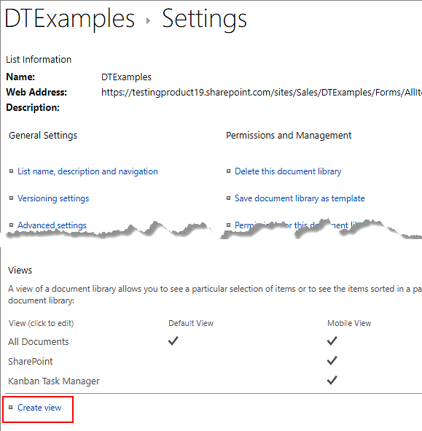

- Select ‘Standard View’.
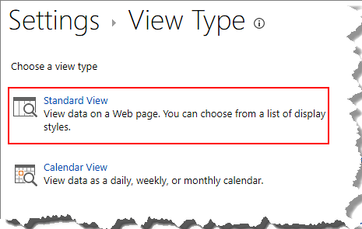
- Name the view, for example "SharePoint articles". Under ‘Filter’, at ‘Show the items when column’, select ‘Enterprise Keywords’ from the dropdown. Keep ‘is equal to’ and write the keyword in the last box: ‘SharePoint’. Then click ‘OK’.
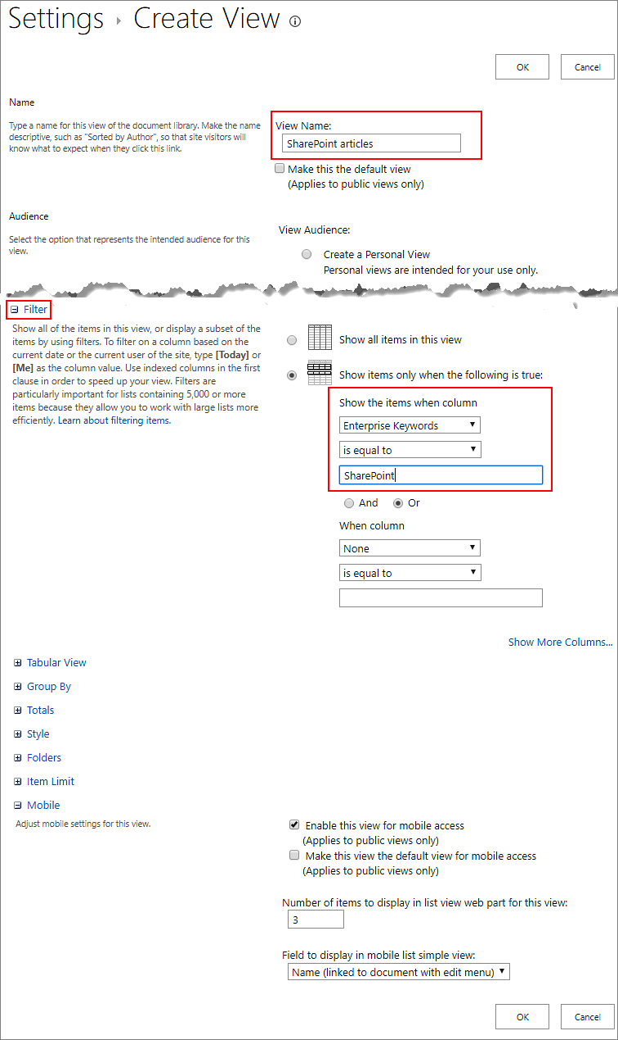
- Now when you select the “SharePoint articles” view, all the documents having the tag ‘SharePoint’ will be displayed .
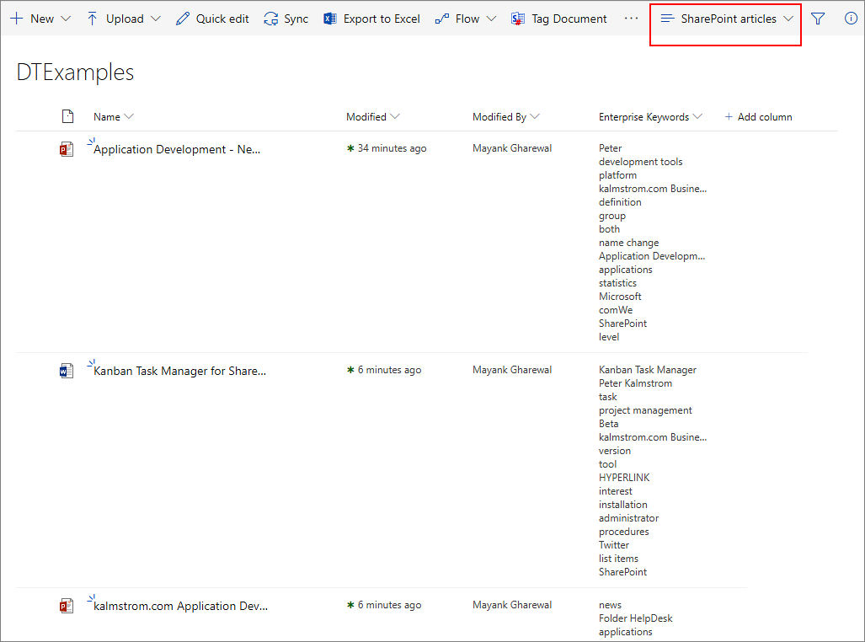
You can also create views for more than one tag, by adding more tags under the first one. Select ‘And’ or ‘Or’, select the Enterprise Keywords column again and write in the next tag.

Upgrade
Subscribers who do not use a Premium copy should download the new version from the kalmstrom.com Upgrade page. Premium Subscribers will get a message from kalmstrom.com when their setup file has been updated.
To upgrade Document Tagger, deactivate the solution from the site collection and replace the old DocumentTaggerSP.wsp file with the new version of the file. After this, you need to re-activate the site feature on each site where Document Tagger is used.
This is the upgrade process:
- Deactivate Document Tagger on all sites where it is activated.
- Deactivate the old DocumentTagger.wsp file under Site settings >Solutions.
- Delete the old DocumentTagger.wsp file.
- Upload the new DocumentTagger.wsp file to the Solutions gallery.
- Activate the new DocumentTagger.wsp file for the site collection.
- Activate Document Tagger on each site where it is used.
A PowerShell script for the whole process can be provided on request. The script is free for Premium subscribers.

Registration
You may evaluate Document Tagger without cost and with full functionality for 30 days.
When the 30 days evaluation period has expired, you must either order a register free Premium copy or register Document Tagger.
To register, go to the Document Tagger Settings page from the Site settings.
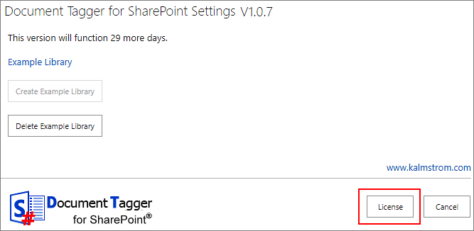
Click on the ‘License’ button, and a registration dialog will open.
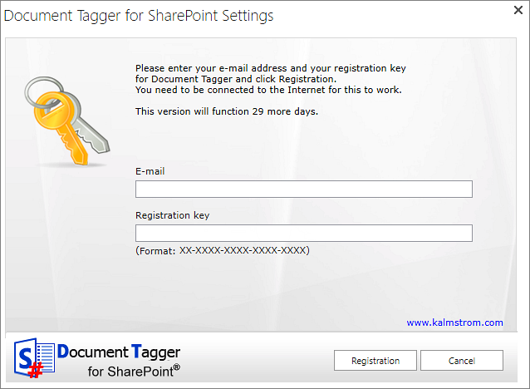
Enter an e-mail address with your company domain and the registration key you have received from kalmstrom.com. Then click on ‘Registration’.

Contact
If you have any kind of problem or questions about Document Tagger, there are several ways of contacting us:
E-mail | support@kalmstrom.com – Technical issues
 | sales@kalmstrom.com – General issues
Telephone | +46 739 206 106

Removal and Deactivation
Should Document Tagger not be used in a site anymore, there are two ways to remove it.
- Deactivate Document Tagger: Site settings >Site Actions >Manage site features.
This removes the functionality from the site, but as long as the solution is available in the site collection it may be activated again.
- Remove the Document Tagger WSP file from the site collection root file: Site settings >Site Actions >Solutions. This removes Document Tagger from all sites in the site collection, and the solution can no longer be used or activated.

More SharePoint Tips
You surely have noticed that Document Tagger uses what is best in SharePoint. For tips on SharePoint usage in general, please refer to the kalmstrom.com Tips section.

