Document Tagger SharePoint Add-in ‒ Manual

1 Introduction 2
1.1 Language processing service 2
1.1.1 Relevance 2
1.1.2 Security 2
1.2 Languages 2
1.3 Requirements 3
1.4 Formats 3
2 Installation of Document Tagger SharePoint Add-in 4
2.1 Get from SharePoint Store 4
2.2 Download from kalmstrom.com 5
2.3 Permissions 5
2.3.1 Users 5
2.3.2 Administrator 5
2.3.3 Add-in 5
2.3.4 Visitors 5
2.4 Add as Web Part 5
2.5 Term Store 8
3 First Time Usage 9
3.1 Example Library 9
3.2 Remove Example Library 10
4 How to Tag and Use Tags 12
4.1 Tag a Document 12
4.1.1 Tagging in the Modern Inerface 13
4.1.2 Tagging in the Classic Interface 13
4.2 Tag Multiple Documents 15
4.3 Filter by Tag 16
4.3.1 Filter Icon In The Modern Interface 16
4.3.2 Filter In The Classic Interface 17
4.4 View by Tag 18
5 Upgrade 23
6 Registration 24
7 Contact 25
8 Remove Document Tagger 25
9 More SharePoint Tips 25

Introduction
Document Tagger SharePoint Add-in tags documents in SharePoint document libraries with keywords, which helps organizations to take full advantage of their site's metadata driven SharePoint Search. But better search is just one advantage. You can also filter by tag and create SharePoint views for certain tags.
Document Tagger sends your document to a language processing engine, Google Cloud Natural Language, which quickly analyzes it and sends back the top 15 suitable keywords. Review the suggestions, remove those that are not relevant and add more keywords if needed. Then click on the ‘Apply tags’ button, to apply the tagging.
This way the addition of SharePoint metadata is much quicker than adding each word manually. You can find a detailed description of the possibilities Document Tagger gives in chapter 4 of this manual.
Documents are tagged in different ways depending on which interface you work with: classic or modern. Most of the images in the manual are taken from the modern interface, but when there are significant differences we show both interfaces.

Language processing service
Document Tagger uses the Google Cloud Natural Language for the text analysis. As Google Cloud Natural Language supports document of the size less than 1MB, the current version of Document Tagger only reads the first 1MB of documents that are bigger than 1MB.

Relevance
Systems for text analysis are continuously improved, but semantic word processing is still a young science and you will probably have some suggestions you don’t want to use. For best result, you should therefore always review the keyword suggestions and uncheck the ones you find irrelevant. Document Tagger still makes the process of tagging documents much easier and quicker than manual tagging.

Security
As Document Tagger sends documents to Google Cloud Natural Language for text analysis, Google Cloud's security model ensures that your organization's information is secure.
The content is purged immediately after the successful extraction of metadata. Also refer to the Google Cloud Natural Language security policy.

Languages
The language of Document Tagger is automatically set to the same as on the SharePoint site. The supported languages are: Danish, Dutch, English, French, German, Italian, Norwegian, Portuguese, Spanish and Swedish. When the SharePoint site has another language, Document Tagger will be in English.
For document analysis, as we use Google Cloud Natural Language, the languages that are supported for tagging are: English, Chinese, French, German, Italian, Japanese, Korean, Spanish and Portuguese: [https://cloud.google.com/natural-language/docs/languages]
When Google Cloud Natural Language starts supporting more languages in the future, Document Tagger will automatically support the analysis in those languages also.

Requirements
To use Document Tagger you need to have SharePoint 2013 or above (in-house or hosted) or Office 365 SharePoint Online.
Supported browsers are Microsoft Edge, Internet Explorer 9 and higher and the latest version of Google Chrome or Mozilla Firefox.

Formats
Document Tagger supports DOCX, PDF, PPTX, TXT and XLSX files.

Installation of Document Tagger SharePoint Add-in
Document Tagger is available on SharePoint Store and can also be downloaded from the kalmstrom.com website. The person who installs Document Tagger must have administrator permission on the site collection.

Get from SharePoint Store
Go to the SharePoint site where you want to use Document Tagger and click on Site contents.
In the Site contents, click on ‘New’ and ‘App’.
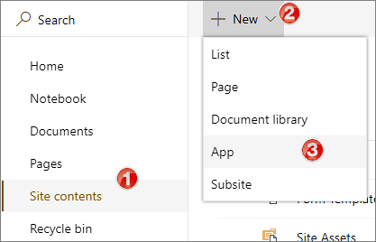
Click on SharePoint Store in the left pane and select ‘Document Tagger SharePoint Add-in’.
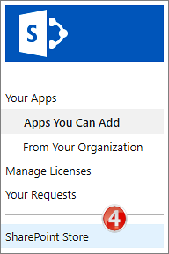

Download from kalmstrom.com
You can download Document Tagger directly from the kalmstrom.com website to your PC and then upload the add-in to the farm’s or tenant’s Add-in/App Catalog.
When this is done, you can install Document Tagger on any site by going into Site contents and add an app as described under Get from SharePoint Store. Select ‘Apps You Can Add’ and choose Document Tagger.

Permissions
Standard SharePoint permissions are used for Document Tagger. The permission for the Add-in itself is set automatically when the download is trusted.

Users
People who should work with tagging documents must have at least Contribute permission over the document library/libraries where they need to tag documents,, in the SharePoint site where Document tagger is installed.

Administrator
The Document Tagger administrator must have Full control over the site where Document Tagger is installed.
At first time use, refer to chapter 3 below, the admin must have Full control over the site collection.

Add-in
Document Tagger has Manage permission on the SharePoint site where it is installed. Thanks to this permission restriction, Document Tagger cannot make any other changes on the SharePoint site than the ones needed for the add-in to work, no matter what permission the user has.
Document Tagger sets the required add-in permission when you have clicked on the Trust-it button during the installation.

Visitors
For people who just need to see the documents, it is sufficient with Read permission over document library. Visitors will not be able to tag documents or remove tags, but they will be able to use the keywords to find documents and to view the tagged documents.

Add as Web Part
Document Tagger can also be used when a SharePoint library is added as a classic web part or app part:
- Go to the SharePoint site where Document Tagger is installed.
- Click on ‘Edit’ on the top right of the SharePoint page where you want to add the web/app part. The page will open in Edit mode.
- Open the INSERT tab and click on ‘Web Part’ or ‘App Part’.
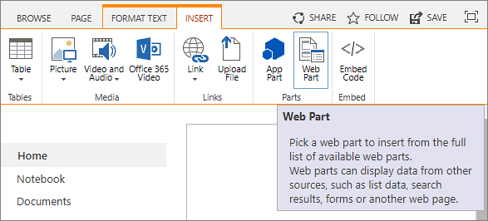
- Select the SharePoint library you wish to add, here 'DTExamples'.
- Click on ‘Add’.
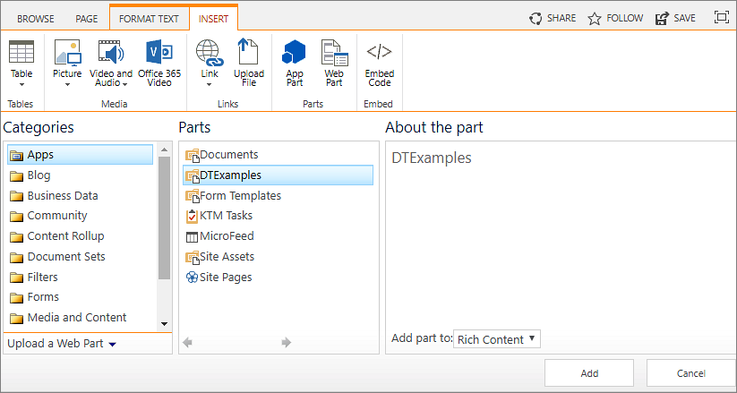
- Click on ‘Save’.
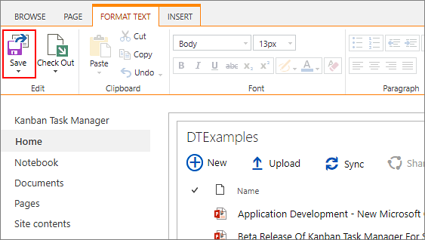
- Now the SharePoint library is added as a web part to the page.

When a SharePoint library has been added to a page, you can tag the documents in the same two ways as you tag them in the classic interface, refer to 4.1.2

Term Store
All Document Tagger keywords are added to the Enterprise Keywords folksonomy, which is stored in the SharePoint Admin center Term Store and available across the farm or tenant. The concept of tagging is well-known from social media, and usually this freedom of suggesting keywords, or tags, works in SharePoint too.
If you still need to edit the keywords, for example to remove wrongly spelled or inappropriate words, this is done in the Term Store. You need to be a SharePoint admin to perform this action.
- In the SharePoint Admin center, click on the 'term store' link in the left pane.
- (The first time this is done, add yourself as Administrator of the Term Store.)
- Open the Keywords accordion and move or delete keywords.

First Time Usage
When Document Tagger has been installed in a site, a “Get Started” page will be shown when you click on “Document Tagger SharePoint Add-in” in the Site contents.
From the “Get Started” page, you can generate an example library if you don't want to try Document tagger with your own files. You can also reach the Manual web page, to download this manual.
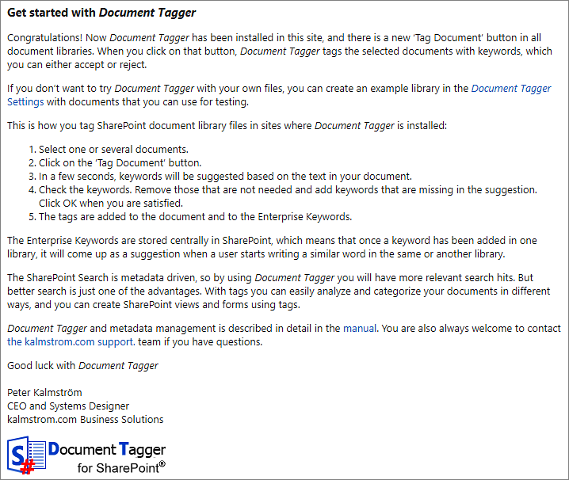

Example Library
If you choose to first generate an example library for the evaluation, click on the ‘Document Tagger Settings’ link in the “Get Started” page. Then click on ‘Create Example Library’ to create an Example library called ‘DTExamples’ with different file formats.
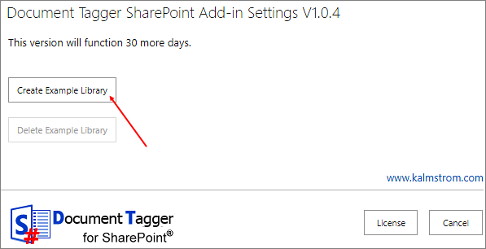

Remove Example Library
To remove the example library, go to the Document Tagger Settings from the ‘Document Tagger’ link under Site contents. You can also reach the settings from the Document Tagger link in the Quick Launch.
Then click on ‘Delete Example Library’, and your example library will be deleted.
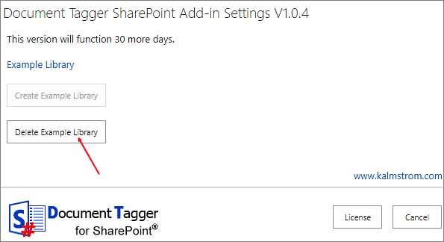
Another way to remove the example library is to open its library settings. Then click on ‘Delete this document library’.
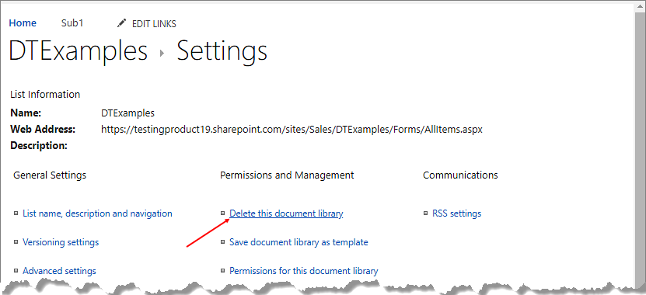

How to Tag and Use Tags
With Document Tagger, you can tag newly uploaded documents as well as existing documents.

Tag a Document
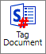
Select a document in a SharePoint document library and click on the ‘Tag Document’ button. Document Tagger will make a semantic analysis of the document you have selected and suggest the top 15 keywords based on the text of the selected document.
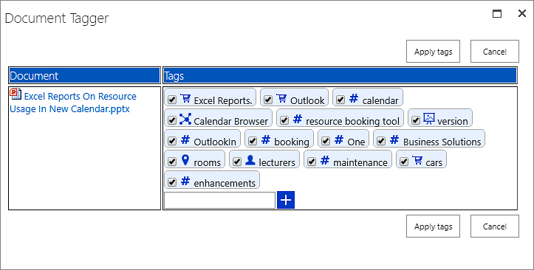
You can uncheck the boxes for the tags you find irrelevant. If you want to add another tag, write in your keyword in the field at the plus sign. Click on the plus sign or press Enter to add the keyword to the document tags. Write in another keyword, if necessary, and click on plus or press Enter. When you are finished, click on ‘Apply tags’ to save the tags.
The tags will be displayed in the ‘Enterprise Keywords’ column in the document library.
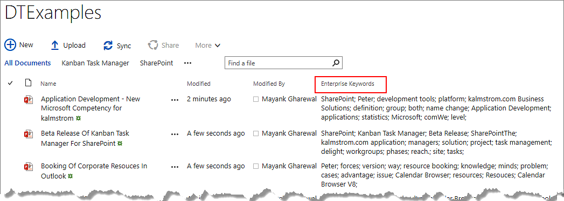

Tagging in the Modern Inerface
In the modern interface, tagging can be done in two ways:
- Select a document and click on the ‘Tag Document’ button in the command bar.
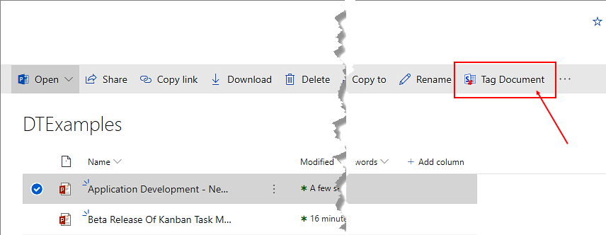
- Select a document, click on the vertical ellipsis and then on ‘Tag Document’.
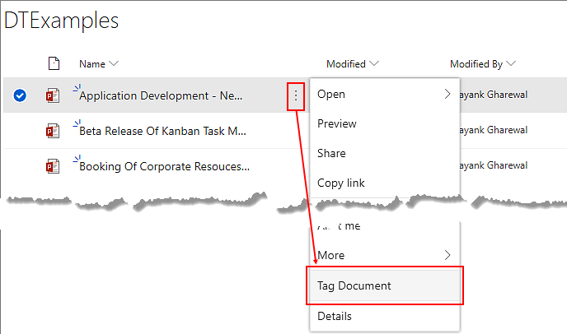

Tagging in the Classic Interface
In the classic interface, tagging can be done in two ways:
- Select a document and click on the ‘Tag Document’ button, under the ‘Files’ tab in the ribbon.
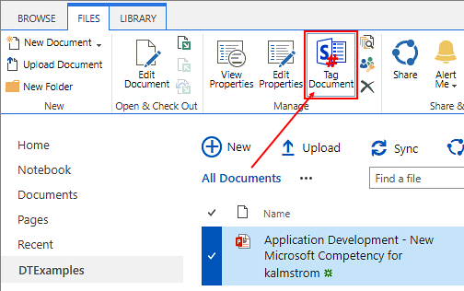
- Select a document and click on the horizontal ellipsis. Again click on the horizontal ellipsis, go to ‘Advanced’ and select ‘Tag Document’.
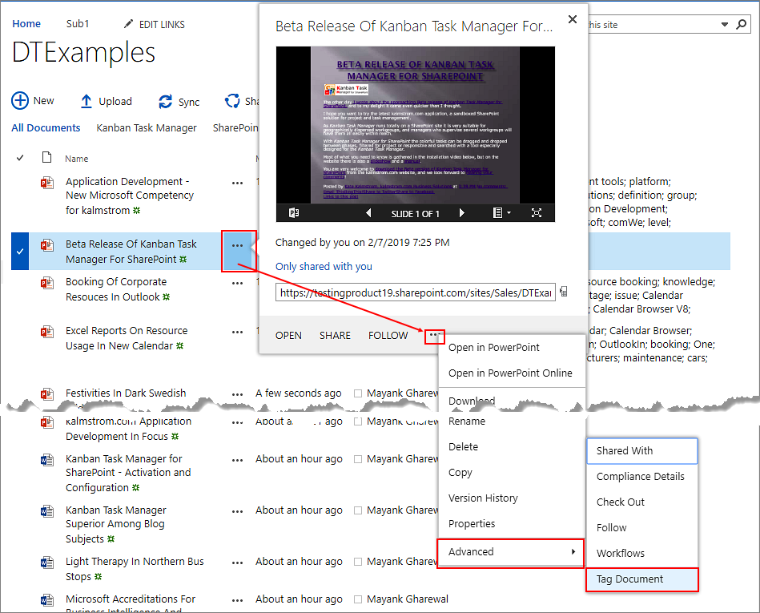

Tag Multiple Documents
With Document Tagger, you can tag multiple documents at a time. To tag multiple documents, select the documents and click on the ‘Tag Document’ button in the command bar or ribbon.
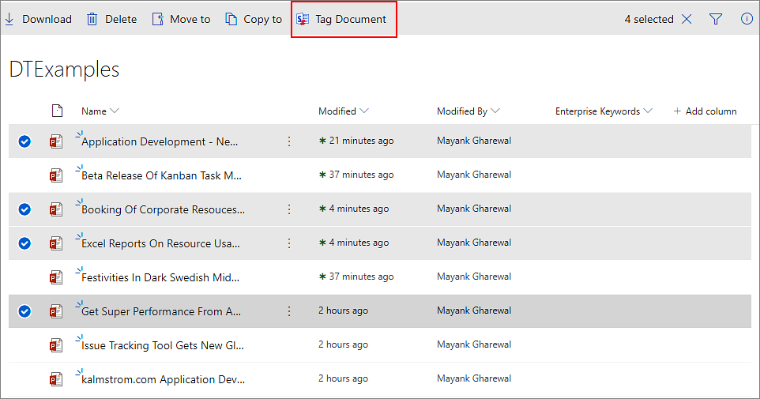
When you tag multiple documents, Document Tagger will analyze the documents and suggest top 15 keywords for each of them.
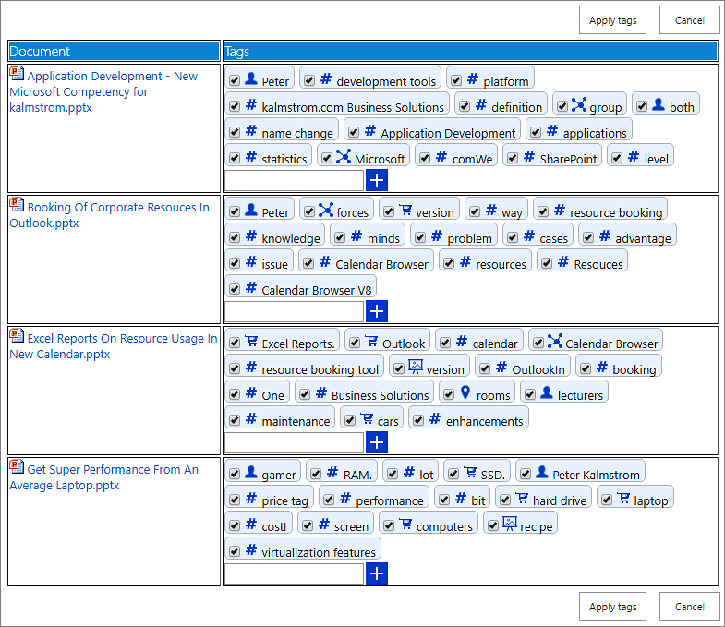
You can uncheck the boxes for keywords you find irrelevant. If you want, you may also add a keyword by writing it in the field at the plus sign and click ‘+’ or press Enter.
Then click on ‘Apply tags’ to save.

Filter by Tag
You may filter the Enterprise Keywords column by one or several tags.

Filter Icon In The Modern Interface
To filter documents in the modern interface, click on the accordion to the right of the ‘Enterprise Keywords’ column and select ‘Filter by’. A filter pane opens to the right, displaying all the keywords by which you can filter the column.
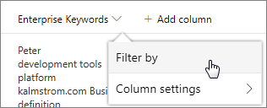
In the modern interface you can also filter any column in the right pane. Click on the filter icon at the top right corner of the command bar and a filter pane opens where you will see the columns that you could apply filter on.
Under ‘Enterprise Keywords’ click on ‘See all’ to view all the keywords. Check the box for the keywords as per your needs. When you click on ‘Apply’, all the documents that have the selected keywords will be displayed.
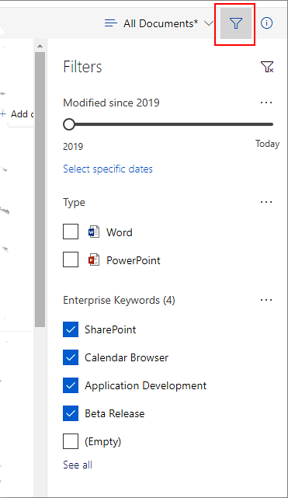
To remove the filter, click on the clear filter icon at the top right corner of the filter pane.

Filter In The Classic Interface
In the classic interface, move the cursor over the ‘Enterprise Keywords’ column and expand the accordion. You can check the boxes for the keywords as per your needs. As you start checking the boxes, the documents start getting filtered according to the keywords.
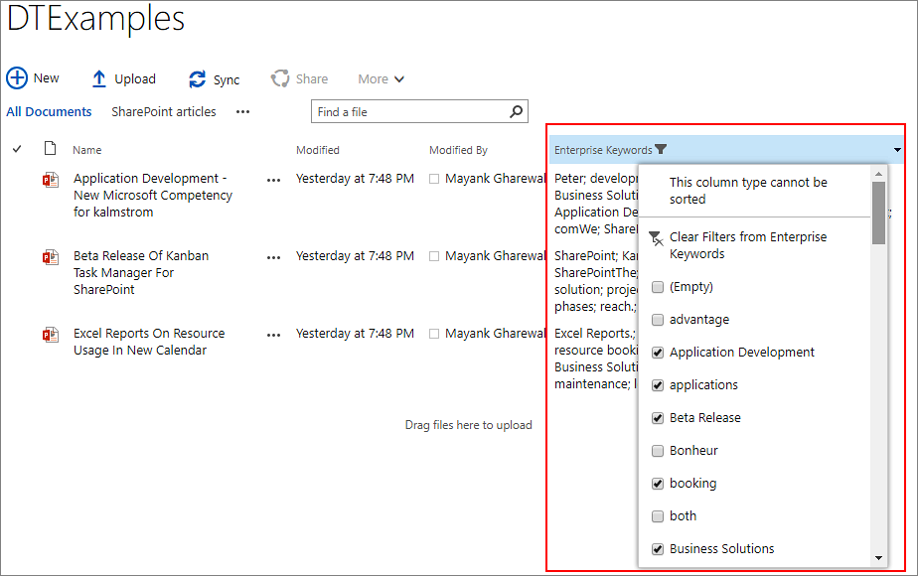
To remove the filter, click on the ‘Clear Filters from Enterprise Keywords’ option in the dropdown.

View by Tag
You may create views where you see all documents that have one or more specified tag(s). This is especially useful if you want to keep track of any new documents added about a certain subject.
To create a view by tag, follow the steps below:
- In the SharePoint library, go to ‘Library settings’.
Modern interface:
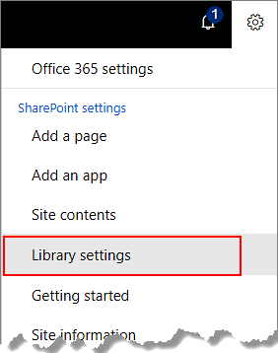
Classic interface: Go to the SharePoint document library, then click on the ‘Library Settings’ button under the ‘LIBRARY’ tab in the ribbon.
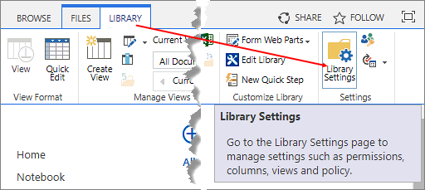
- Click on ‘Create View’.
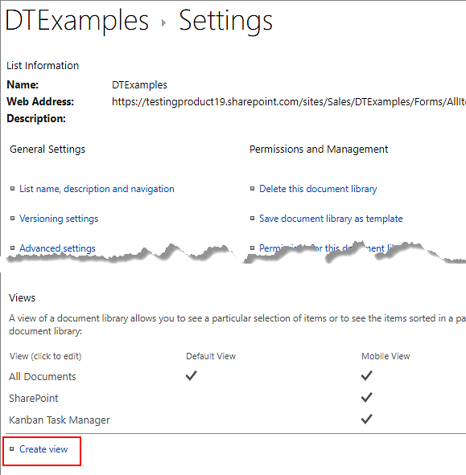
- Select ‘Standard View’.
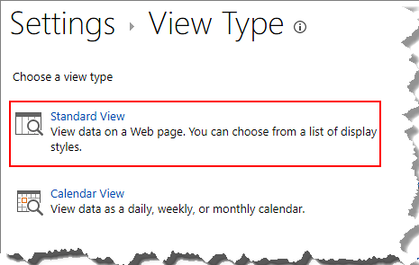
- Name the view, for example "SharePoint articles". Under ‘Filter’, at ‘Show the items when column’, select ‘Enterprise Keywords’ from the dropdown. Keep ‘is equal to’ and write the keyword in the last box: ‘SharePoint’. Then click ‘OK’.
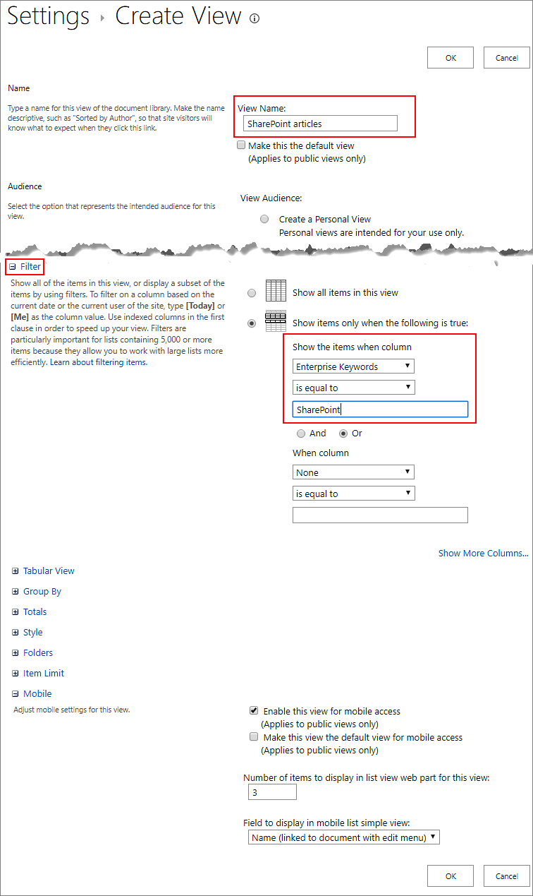
- Now when you select the “SharePoint articles” view, all the documents having the tag ‘SharePoint’ will be displayed .
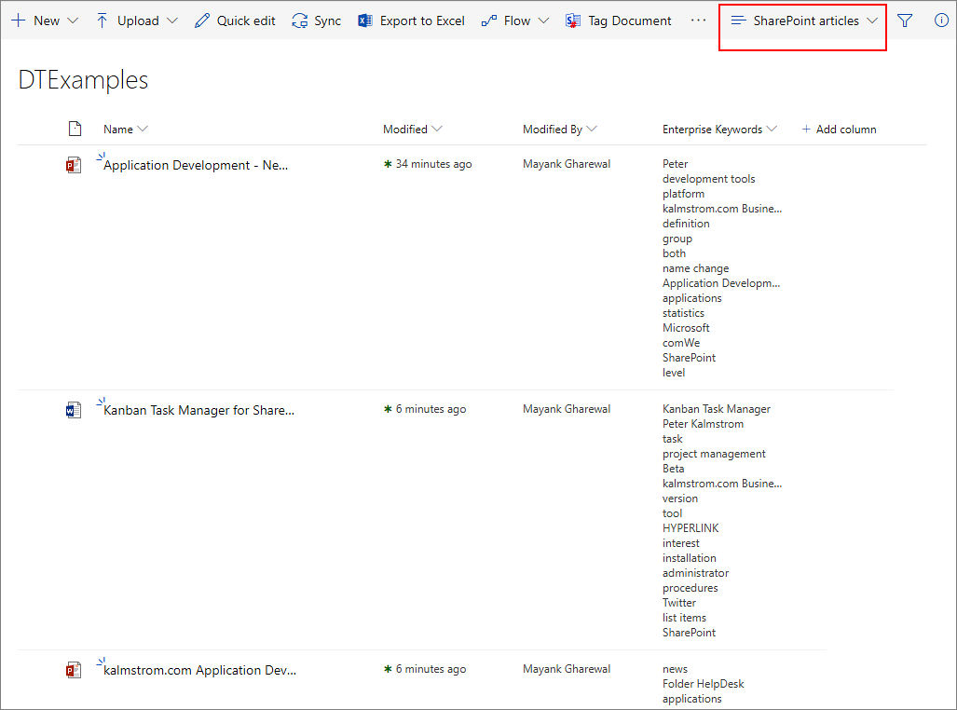
You can also create views for more than one tag, by adding more tags under the first one. Select ‘And’ or ‘Or’, select the Enterprise Keywords column again and write in the next tag.

Upgrade
Subscribers who do not use a Premium copy should download the new version from the kalmstrom.com Upgrade page or get it from the SharePoint Store, depending on where you first got Document Tagger from.
Premium Subscribers will get a message from kalmstrom.com when their setup file has been updated.
If you got your current version of Document Tagger from the SharePoint Store, you will get the message at step 3 below automatically.
If you have downloaded the current version of Document Tagger from the kalmstrom.com website you must first update the .app file in the App Catalog, refer to steps 1 and 2 below.
- Download the ZIP file and extract it.
- Upload the Document Tagger APP file to the App Catalog of your SharePoint farm or tenant. The older version will be overwritten.
- On each site where Document Tagger is installed, you will now get a message in the Site contents about the new version.
- Click on the GET IT button and then on Trust It.
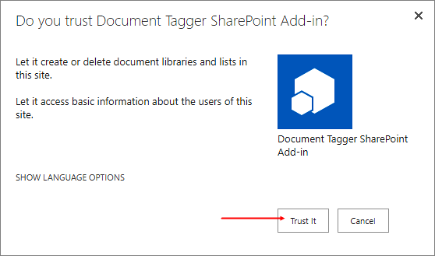
- The Site contents page will open again with the notice ‘We are updating your app’ on the Docment Tagger tile.
Should you not get the message in the Site contents, remove the older app from the Site contents and add a new Document Tagger "From your organization".
A PowerShell script for the whole process can be provided on request. The script is free for Premium subscribers.

Registration
You may evaluate Document Tagger without cost and with full functionality for 30 days.
When the 30 days evaluation period has expired, you must either order a register free Premium copy or register Document Tagger.
To register, go to the Document Tagger Settings page from the Site settings.
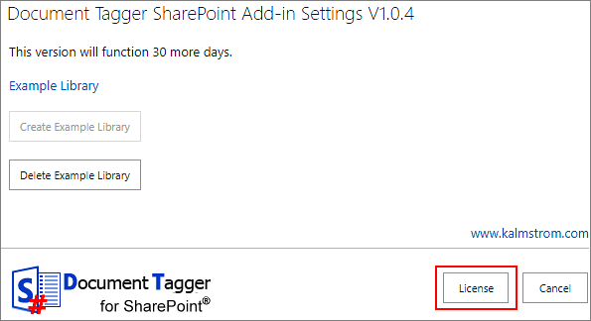
Click on the ‘License’ button, and a registration dialog will open.
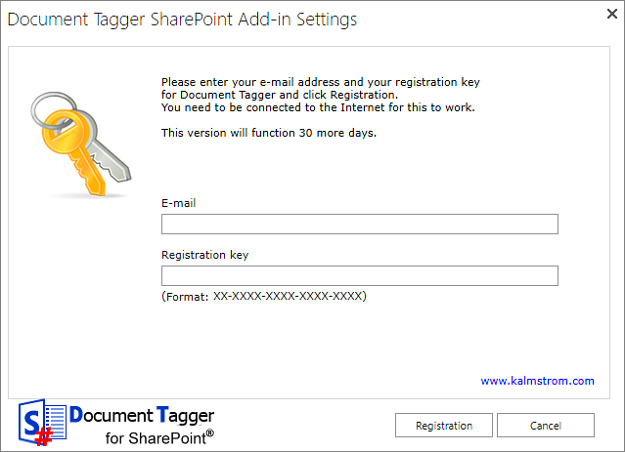
Enter an e-mail address with your company domain and the registration key you have received from kalmstrom.com. Then click on ‘Registration’.

Contact
If you have any kind of problem or questions about Document Tagger, there are several ways of contacting us:
E-mail | support@kalmstrom.com – Technical issues
 | sales@kalmstrom.com – General issues
Telephone | +46 739 206 106

Remove Document Tagger
Should Document Tagger not be used anymore, you can remove it. Currently Microsoft has not added a Remove option in the modern Site contents interface, so you must use the classic experience to remove Document Tagger.
To remove, go to the Site contents and find Document Tagger SharePoint Add-in. Click on the ellipses (…) and select REMOVE from the context menu.
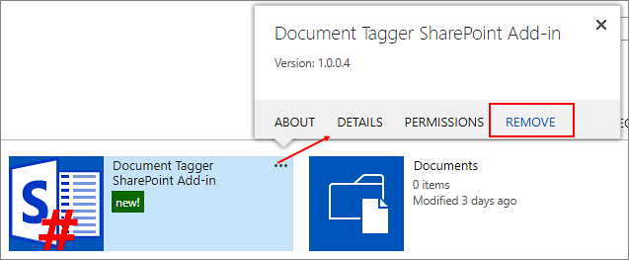

More SharePoint Tips
You surely have noticed that Document Tagger uses what is best in SharePoint. For tips on SharePoint usage in general, please refer to the kalmstrom.com Tips section.

