Calendar Browser for SharePoint User manual

Contents
1 Introduction 2
2 The Calendar Browser Page 2
2.1 The Calendar View 2
2.2 The Control Panel Buttons 2
2.3 Browsing Resources 3
2.4 Views 3
2.5 See Descriptions of Resources 3
2.6 Book a Resource 4
2.6.1 Book Supplies 5
2.6.2 Project 6
2.6.3 Extra Booking Information 6
2.7 Search for Resources 7
2.8 Cancel a Booking 9
3 The Calendar Browser Overview 9
3.1 Choose Date and Period 10
3.2 Print 11
3.3 Book in the Overview 11
4 Support 11

Introduction
Use Calendar Browser for SharePoint when you want to book any kind of resource within your organization. It could be rooms, cars, machines or even people. If you are a SharePoint user already, you don’t have to learn a new program to make the bookings.
In Calendar Browser each resource has its own calendar, and when you book a resource you make an event in that calendar.
For simplicity we talk about booking rooms in this manual. Your organization might use Calendar Browser for booking of other resources, but the principles are the same.
All screenshots in this manual come from Office 365 SharePoint, English version.

The Calendar Browser Page

The Calendar View
In the calendar view you will find the resource calendars and the Control Panel buttons.
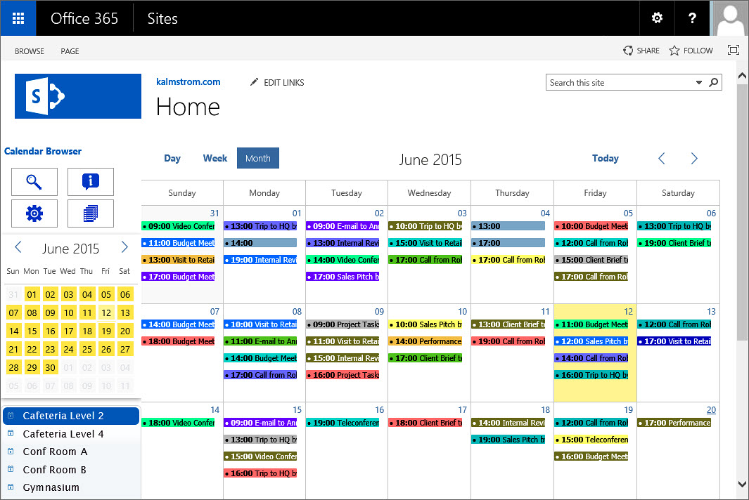

The Control Panel Buttons
When you go to the Calendar Browser home page, you will see the Control Panel buttons on top left. How many buttons you see depends on the administrator settings. You may see four, three or only two Calendar Browser buttons.
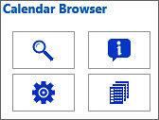 | 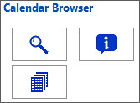 | 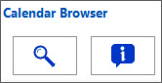
The default Calendar Browser control panel. | The Calendar Browser control panel when the Manage button is hidden. | The Calendar Browser control panel when the Manage and Overview buttons are hidden.

Browsing Resources
With Calendar Browser you can easily browse among your organization’s resources to find the most suitable one among those who are free at the time when you want to book.
To see a resource calendar, select the calendar you wish to see from the list to the left.

Views
You can choose between different views, day, week or month, just like you do in any SharePoint calendar. Select a resource calendar in the list and click on the desired view.

See Descriptions of Resources
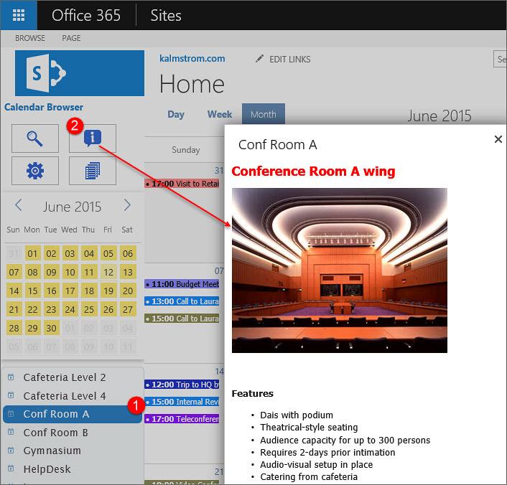
Which one of the free resources is best for your needs? To decide this, you can look at the descriptions of the resources.
Select a resource and then click the Description button in the Control Panel. Now the description comes up.

Book a Resource
You can book a resource by selecting its calendar in SharePoint and creating an event. Create the event as usual, by clicking on an empty space in the resource calendar. A SharePoint calendar event opens, and you can fill out time and other booking information.
The event has an extra tab named ‘Calendar Browser’ see the image below. Under this tab, you can select project or another parameter specified for your organization. You may also book additional services or supplies. When you are finished, click on Save.
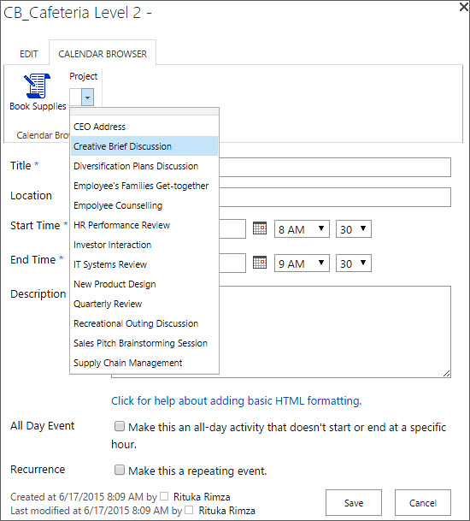

Book Supplies
At the same time as booking a room you can book supplies for the meeting by clicking the button Book Supplies under the Calendar Browser tab.  You will then be presented with a dialog where you can select what you need in addition to the resource you are booking. Enter another number than the default 0, and the item will be booked. | 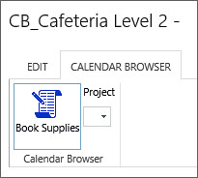
Your name and the date will be filled out automatically. If you so wish, you can comment on your order. You might also be able to select among place settings defined by the administrator.
It might be mandatory to specify Cost Center. This is also defined by the administrator. If Cost Center is mandatory, you cannot save the booking without filling it out.
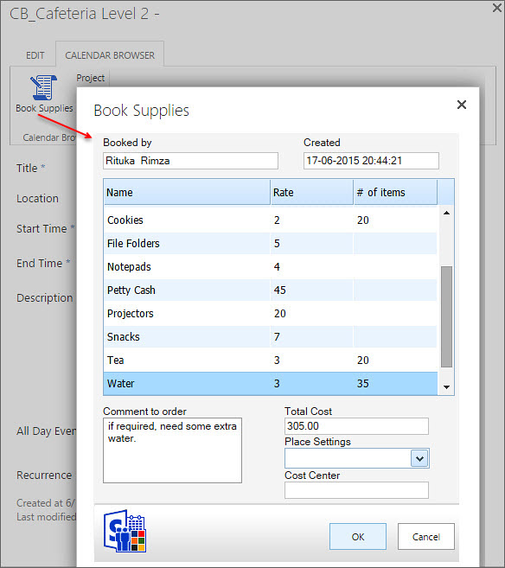

Project
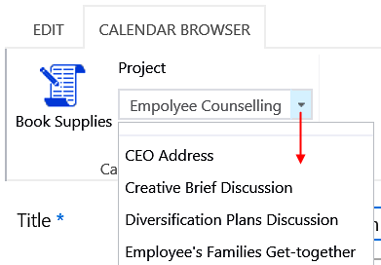
The administrator may have predefined projects that each booking should be connected to.
Click on the arrow to see the project list and select the project you will make the event for.
The administrator can change the caption “Project” to something else, so in your Calendar Browser maybe something else than a project can be selected.

Extra Booking Information
The Calendar Browser administrator might enable Extra booking information. In that case each booking event has an additional task pane where you can select extra data. By default the extra info is about host and attendees, but in your organization the terms may be other than “Host” and “Attendees”.
The “Host” is selected from a dropdown, and if you create the event you will be added by default.
The “Attendees” are written in, but you only have to write the first letter. Then you will get suggestions and can select the correct name. Click on Add, and continue with the next person.
The additional information (e-mail address, company or department) is filled out automatically, just like the number of attendees
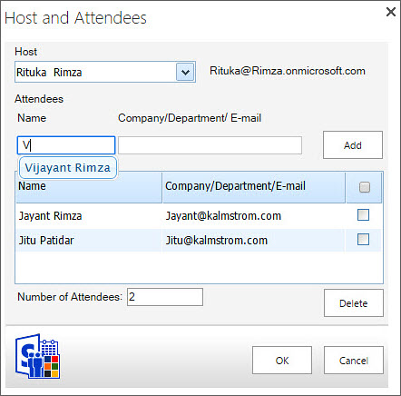

Search for Resources
You can search for resources that are free at specific dates and times and have as many seats as you need (if applicable).
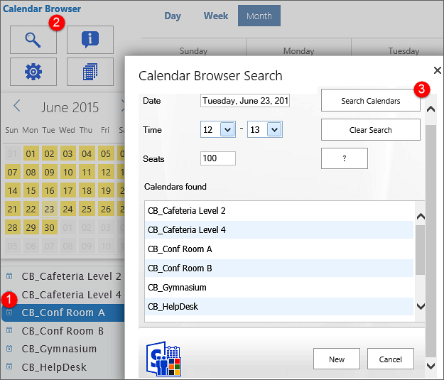
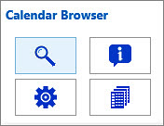
Click on the Search button in the Control Panel, and the Search dialog will be shown. Specify date and time and maybe how many seats you need.
Then all the free resources on your specified date and time, with the desired number of seats or more, are shown in the ‘Calendars found’ list.
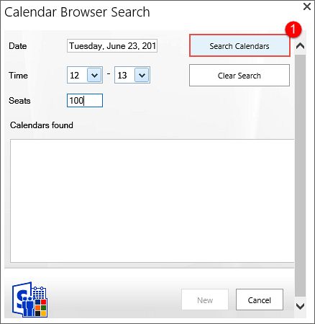 | 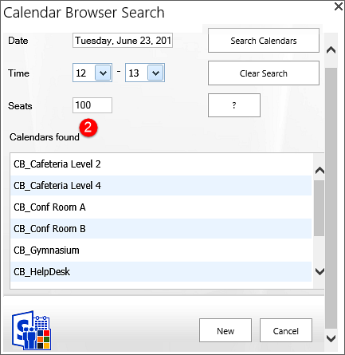
Click on the question mark (‘?’) to see a description of the selected resource.
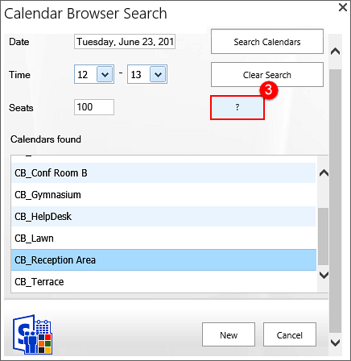 | 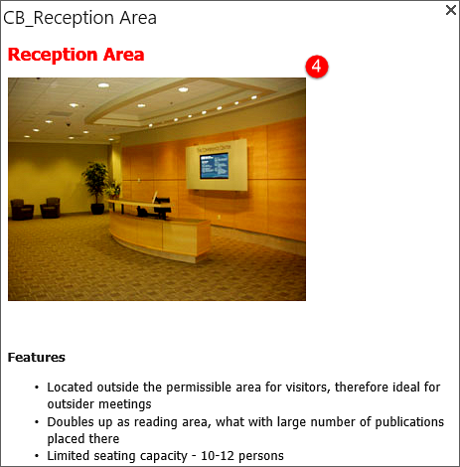

To book a resource directly from the Search dialog, select one of the resource calendars and press the ‘New’ button. An event for the selected time and resource will open.
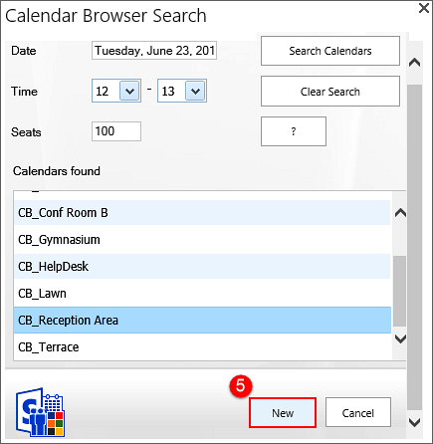 | 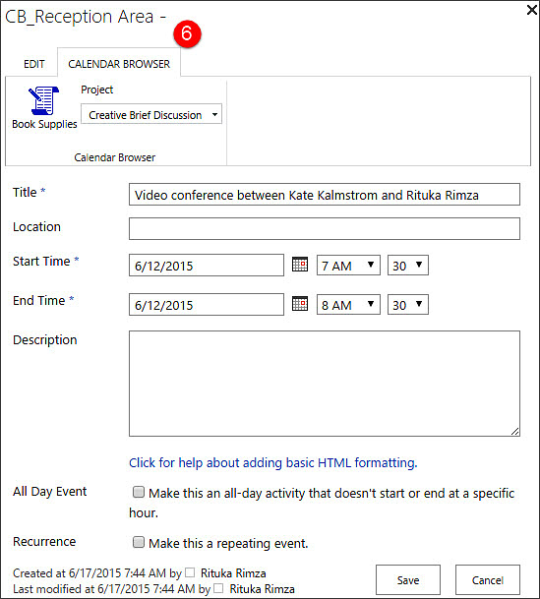

Cancel a Booking
If you want to cancel a booking, open the event that you want to cancel and select the Delete option from the Ribbon.
If you have ordered any supplies with your booking, that order will also be cancelled automatically.
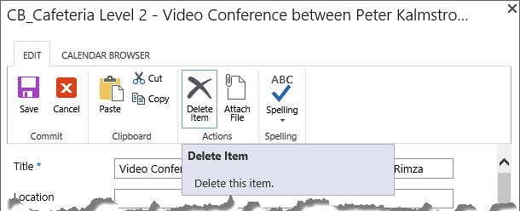

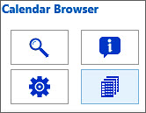
The Calendar Browser Overview
Through the Overview button, you can reach an overview over future bookings. The orders for each room and meeting are also listed here.
The administrator can hide the Overview button, so you might not see it. In that case you cannot use the Overview.

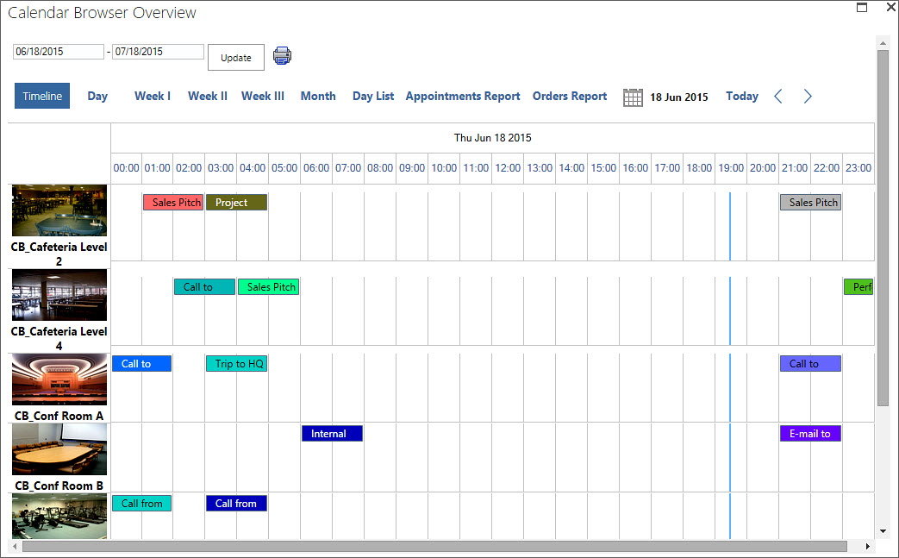

The bookings shown in the overview may be handled in different ways:
- Move the mouse cursor over the event and info about the booking is shown in a popup.
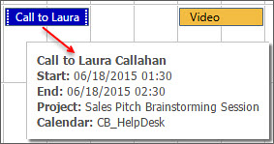
- Select the event and more info about the booking is shown at the bottom of the screen.
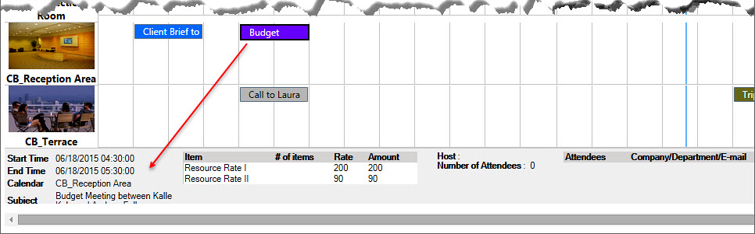
- Double-click the event to open it.

Choose Date and Period
Specify what date you are interested in and choose period, see the image below. The current day is shown by default.
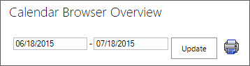
If enabled by the administrator, you can also see the resource booking done by a particular “host”. Instead of “host” you may have something else to filter on. Refer to Extra Booking Information.
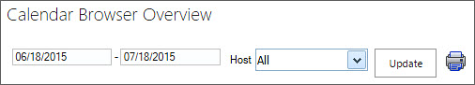

Print
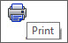
You may print an Overview view, something that is especially useful for the Appointments and Orders reports and for the Booking summaries.
When you want to print the Timeline, Day, Week I, Week II, Day List, or Month view, open the desired view and press the Print button.
A PDF file will be downloaded to your PC. Open it and print it.
When you want to print Week III, Events Report, Order Report or Booking Summaries, a window will open asking you to select a printer. Select it and click the Print button.
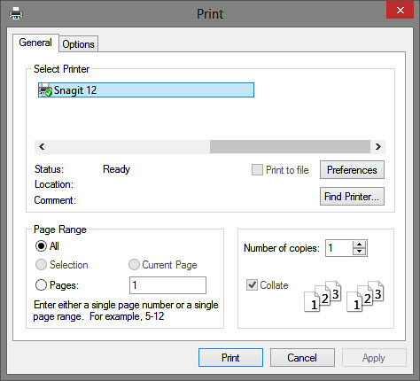

Book in the Overview
When you click in an empty cell in the Overview, an event for that time and resource calendar will open. That way you can book resources directly from within the Overview, with supplies and project, just as you do from the calendar.
You must update the Overview with the Update button to see the new event.

Support
If you get problems with Calendar Browser, you are welcome to contact the kalmstrom.com Support. However, we recommend you to first inform your Calendar Browser administrator about the issue.

