Calendar Browser for SharePoint Administrator manual
Content
1 Introduction 3
2 Requirements 3
3 Calendar Browser Features 4
3.1 Book 4
3.1.1 Order Supplies 4
3.2 Projects 5
3.3 Descriptions 6
3.1 Search 6
3.2 The Calendar Browser Overview 8
4 Installation of Calendar Browser 9
4.1 Introduction 9
4.2 Install And Activate For Site Collection 9
4.3 Activate For Site 10
4.4 Site Settings Link 10
4.5 Get Started 11
4.6 Example Data 11
4.6.1 Load Example Data 11
4.6.2 Remove Example Data 12
4.1 Permissions 12
4.1.1 Users 12
4.1.2 Administrator 12
4.1.3 Visitors 12
5 The Calendar Browser Settings 13
5.1 Configure 13
5.1.1 Prevent Double Bookings or Recurrence 14
5.1.2 Panel Settings 14
5.1.1 Overview Settings 14
5.1.2 Auto–Update Data In Calendar Browser Overview 14
5.1.3 Show Calendar Images in Overview 14
5.1.4 Extra Booking Information 15
5.2 Calendars 16
5.2.1 Add Calendars 17
5.2.2 Remove Calendar 17
5.2.3 Rename Calendar 17
5.2.4 Descriptions 17
5.2.5 Overview Images 18
5.3 Project 18
5.4 Supplies 19
5.4.1 Remove supply items without disturbing existing bookings 20
5.5 Place Settings 20
5.6 New Events 22
5.6.1 Overview Settings 22
5.6.2 AUTO–Update Data In Calendar Browser Overview 22
5.6.3 SHOW Calendar Images in Overview 22
6 The Calendar Browser Overview 23
6.1 See More Info 24
6.2 Search the Overview 25
6.2.1 Auto–Update Data In Calendar Browser Overview Error! Bookmark not defined.
6.2.2 Show Calendar Images in Overview Error! Bookmark not defined.
6.3 Overview Images 25
6.4 THe Overview Views 26
6.4.1 Day View 26
6.4.2 Week Views 26
6.4.3 Month View with Calendar Filter 26
6.4.4 Day List View 27
6.4.5 Appointments and Orders Reports 28
6.4.6 Booking Summaries 29
6.5 Print 29
7 Clean-up 30
7.1 Upgrade 30
8 Register 30
9 Support 32
9.1 Contact 32
10 Remove Calendar Browser 32
11 More SharePoint Tips 32

Introduction
Calendar Browser is an application for booking resources within an organization. It is totally integrated in SharePoint.
In Calendar Browser each resource has its own calendar, and to book a resource the user simply creates an event in the calendar of that resource.
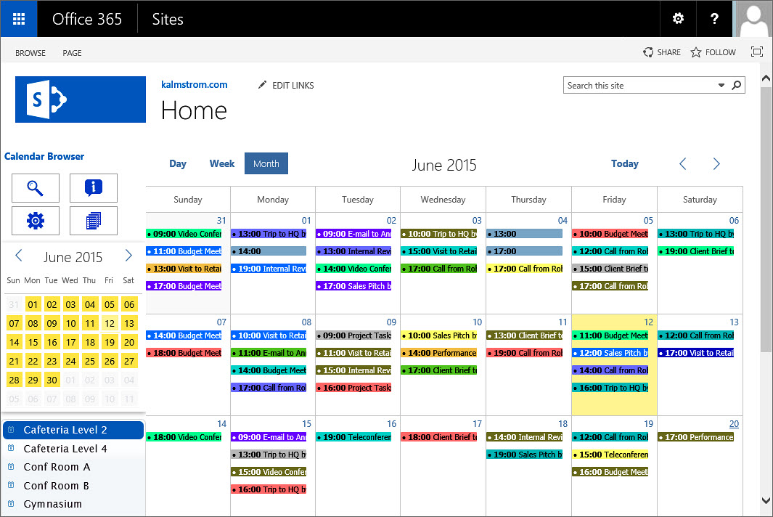
The screenshots in this manual come from a Calendar Browser installation in Office 365 SharePoint, English version, where the Calendar Browser example data has been loaded.
The example data shows room bookings, and for simplicity we have also chosen to talk about booking rooms in the manual. However, anything that is bookable within an organization – cars, equipment, personnel – can of course be booked through Calendar Browser.
The SharePoint language will be automatically used for Calendar Browser. The supported languages are Danish, Dutch, English, French, Italian, Norwegian, Portuguese, Spanish and Swedish. If the SharePoint language is not supported, English will be used instead.

Requirements
To use Calendar Browser for SharePoint, you need to have SharePoint 2010 or 2013 (in-house or hosted) or Office 365 SharePoint.
Supported browsers are Internet Explorer 9 and higher, Google Chrome and Mozilla Firefox (the latest version).
The SharePoint Sandboxed Code Services must be activated. Please refer to the kalmstrom.com Tips section, which has a demo how to active the Sandboxed Code Services.

Calendar Browser Features
Here we will give just a short description of the Calendar Browser features. For more extended explanations of each feature, refer to the Calendar Browser User Manual.

Book
The main Calendar Browser feature is of course the possibility to book resources without having to use separate software. For users already familiar with SharePoint, it is very easy to learn how to book resources with Calendar Browser.
Create an event in the selected resource calendar by clicking on an empty space in the resource calendar, just as when you create a standard SharePoint event.
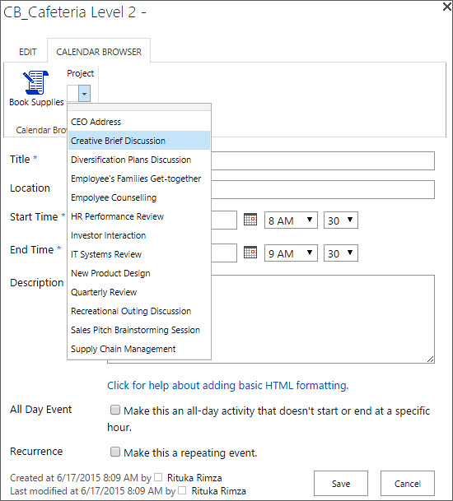
When the event opens, all the SharePoint calendar features can be used. Users can not only book the resource, but under the Calendar Browser tab in the event they can also order supplies and specify the project (or a custom parameter) for which the resource is booked.

Order Supplies
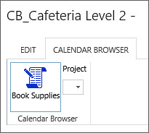
By clicking on the Book Supplies button under the Calendar Browser tab in the event, users can reach a dialog and order supplies for the resource booking.
See Supplies on how to fill out the Supplies form in the Admin Settings. Specifying Cost Center can be set to mandatory.
The Book Supplies dialog inside the event can give the following
info:
- Booked by: The SharePoint user name is filled out automatically.
- Created time: This is also filled out automatically.
- Number of items: Here the user can specify the number of items of each supply item that is booked. The user selects the supplies by entering a value for the number of items ordered. The currency will automatically be the one specified by the system.
- Comment to order: Allows the user to specify any instructions for the supplies order.
- Total cost: This will be automatically calculated by Calendar Browser, based on the number of items ordered and their costs.
- Place settings: Allows the user to select the type of place setting arrangement needed for that particular event. The place settings to select from are specified in the Settings.
- Cost Center: This information can be numeric or free text. The administrator specifies the format in the Settings.
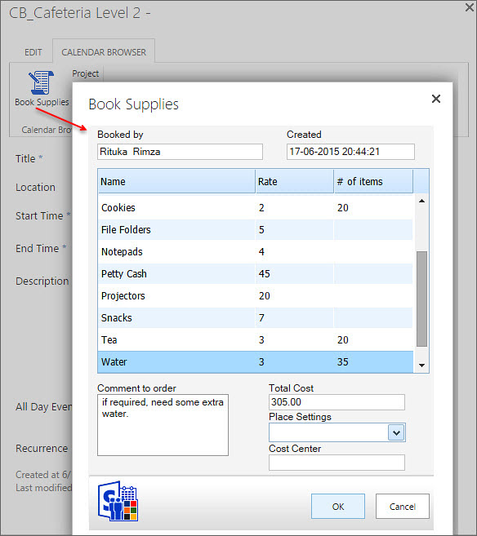

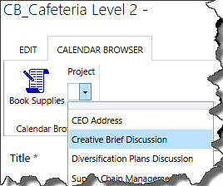
Projects
Bookings may be attached to specific projects. It is possible to change the caption “Project” in the settings, so you can give this parameter any name that suits your organization.

Descriptions
To facilitate an adequate choice among the free resources, Calendar Browser gives the users a possibility to see descriptions of them.
To reach a description follow these steps:
- Select the resource you wish to see info about in the resource calendar list.
- Click on the Description button in the Control Panel.
- A new dialog with a description of the resource will open.
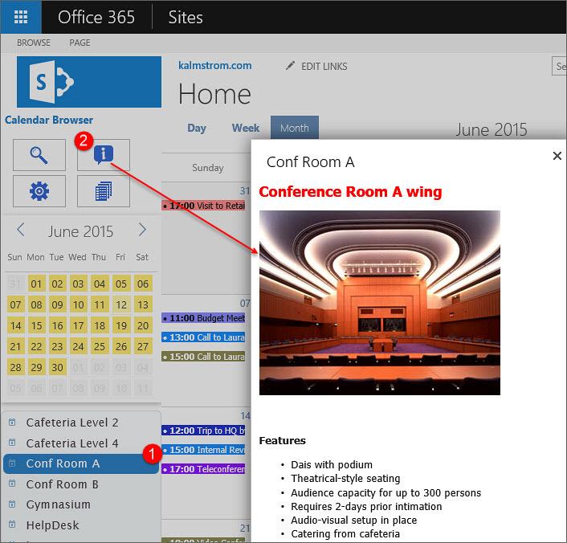

Search
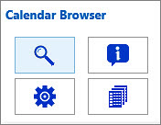
Users can search for resources that are free at specific times
and have the desired number of seats or more. Resource descriptions may be seen from the Search dialog, and the preferred resource may be booked directly from within the dialog.
Select Date, hour and seats if applicable, and then press the button “Search Calendars”. Now all free resources for that time will be shown.
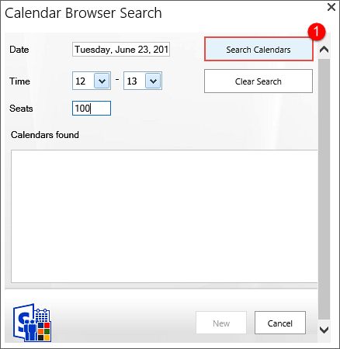 | 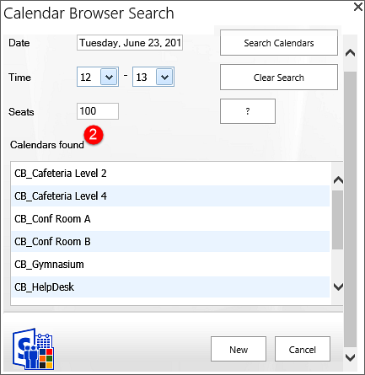
To see a description, select a resource and press the question mark (“?”) button to the right.
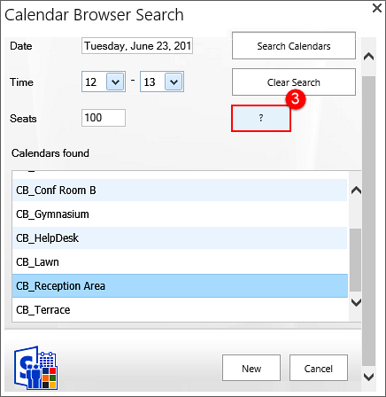 | 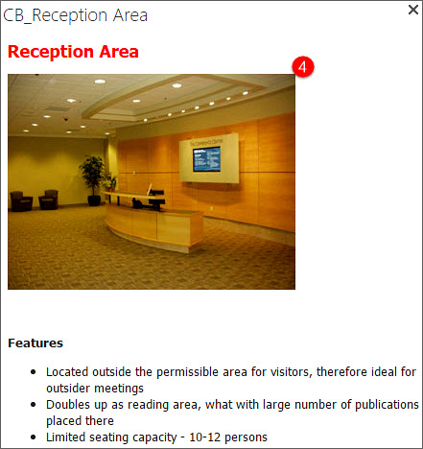
To book a resource directly from the Search dialog, select one of the resource calendars and press the New button. An event for the selected time and resource will open.
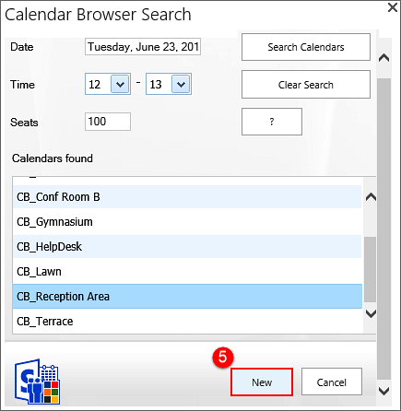 | 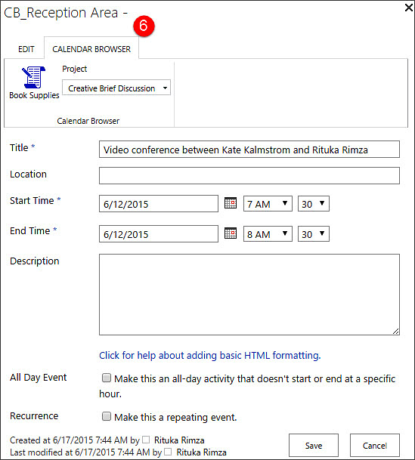

The Calendar Browser Overview
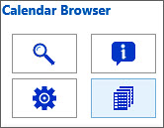
The Overview gives a summary of bookings of all resources. The orders for each resource and meeting are also listed here, and all activities and costs for a specified time are shown.
It is also possible to book resources from within the Overview.
For more info, see The Calendar Browser Overview.

Installation of Calendar Browser

Introduction
Calendar Browser is installed as a SharePoint Solution in a site collection, and it needs to be activated for each site where it will be used.

Install And Activate For Site Collection
 | Download the file CalendarBrowserSP.wsp from the kalmstrom.com website to any folder on your computer.  Then go to the root site of the SharePoint site collection where you want to use Calendar Browser. Click on the Settings icon at the top right and select the Site settings option.  If you don’t see this option, most likely you don’t have the appropriate permissions. You need to be the site collection Administrator to install solutions.  Under Galleries, select “Solutions”.  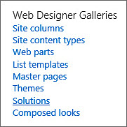 | 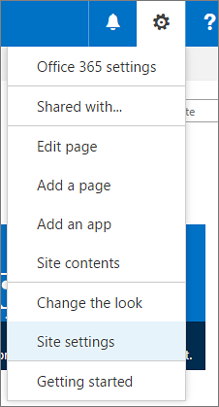
Next step is to upload the Solution – which is the .wsp file you downloaded from the kalmstrom.com website.  Click on the SOLUTIONS tab if the Upload Solution button is not visible. Then browse to the file CalendarBrowserSP.wsp on your computer.  When the file is uploaded, you will be shown a dialog where you can activate the solution.  Don’t worry if you get a warning message. Calendar Browser is intended for moderate modification of data, but the solution will do what you tell it to do, nothing more. |  |  | 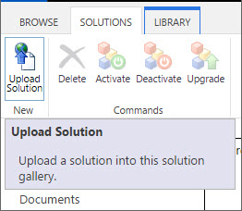

When this upload and actiivation is done, Calendar Browser is available for all sites in this site collection. However, to use the solution on a site you also need to activate it there.

Activate For Site
When Calendar Browser has been installed in the site collection, you need to activate the solution for each site and subsite where it should be used.
You may very well have Calendar Browser installed on several sites, if you want to group the resources. This makes it easier for users to overview the resource calendars.
You can for example have one site for cars, another one for rooms and a third one for resource persons. A common top navigation makes it easy to move between the Calendar Browser sites.
Go to the site where you want to activate Calendar Browser and once again select Site Settings.
Then select “Manage site features” under Site Actions. (If you don’t see this option, most likely you don’t have the appropriate permissions. You need to be a site owner or site designer to manage site features.)  NOTE that you have to activate Calendar Browser this way, if you want to use the solution on the root site of the site collection, even though you activated it for the site collection when you uploaded the Calendar Browser .wsp file. | 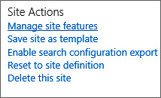
Click on the Activate button at the Calendar Browser entry. During the activation the Calendar Browser SharePoint lists, libraries and pages will be created, and there will also be a link to Calendar Browser in the Quick Launch.
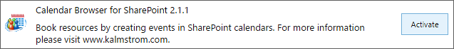

Site Settings Link
When Calendar Browser has been activated for a site, there is a Calendar Browser link in the site settings, under the Web Designer Galleries heading.
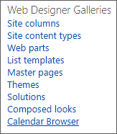
When you click on the Site settings link Calendar Browser creates lists, libraries and pages and adds a Calendar Browser link in the Quick Launch.
When this is done, a “Get Started” page will be displayed. Refer to Get Started.
Get Started
NOTE that you have to activate Calendar Browser this way if you want to use the solution on the root site of the site collection, even though you activated it when you uploaded.

Get Started
When the installation is finished and you click on the Calendar Browser link in the Quick Launch for the first time, a Get started page will be shown. From this page you can create Example Data or add your own resource calendars to Calendar Browser.
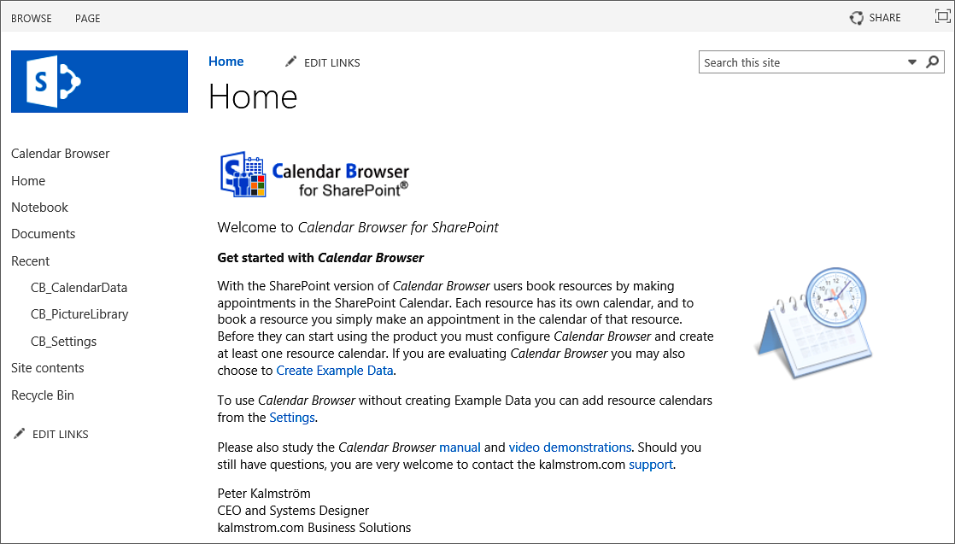

Example Data
If the solution is new to you, it might be a good idea to load the example data. It gives you an opportunity to see how Calendar Browser works when you have a lot of data in it, what performance you can expect and so on.
(When you select to not install example data, click on the Settings link instead, to add your owh resource calendars to Calendar Browser.)

Load Example Data
You will have a choice to load example data when you click on the Calendar Browser link in the Quick Launch for the first time. In the Get started page that opens, click on the ‘Create Example Data’ link. It will take you to the Example Data page. Select Month Past and Month Ahead and click ok, and the example data will start loading.
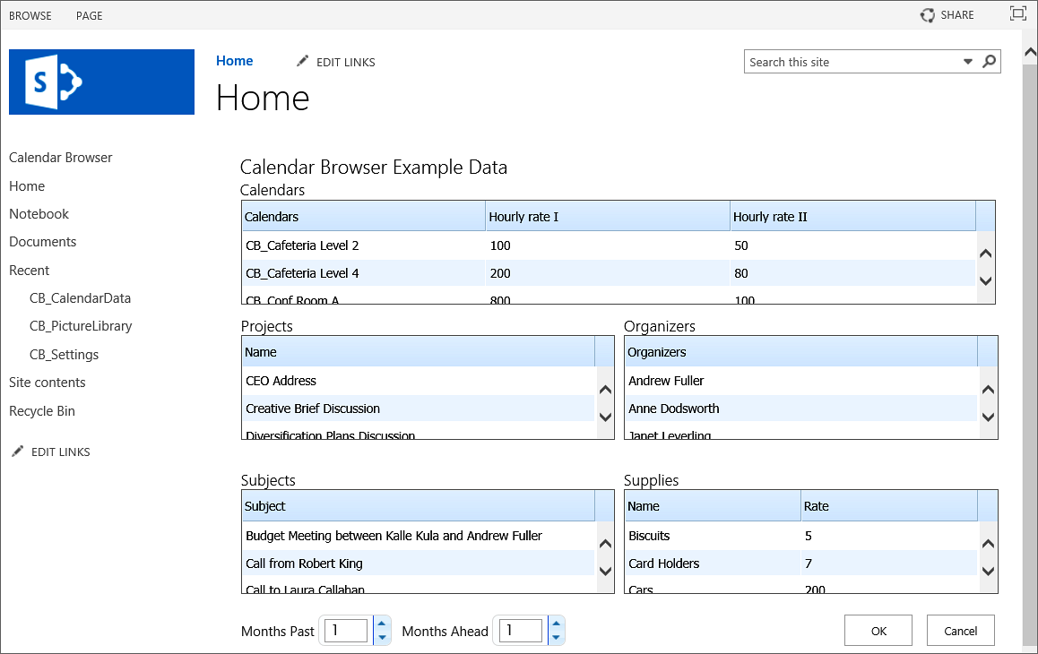

Remove Example Data
Remove the example data through the Administrator settings, Calendars tab. Refer to Remove Calendar.

Permissions
Standard SharePoint permissions are used for Calendar Browser.

Users
People who should book resources must have at least Contribute permission over the Calendar Browser lists.

Administrator
The Calendar Browser administrator must have Full control over the site where Calendar Browser is activated.

Visitors
For people who just need to see bookings, the SharePoint administrator must provide Read permission over the Calendar Browser lists. Visitors will not be able to modify, delete or add events.

The Calendar Browser Settings
The Calendar Browser settings are reached via the Manage button in the Calendar Browser control panel. (The Manage button can be hidden from users, refer to Panel Settings below.)  When no resource calendars have been added to Calendar Browser, you will be asked if you want to add calendars when you open Calendar Browser. If you click on Yes, the Administrator settings will open. | 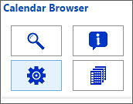
The configuration is organized under tabs, as described below. If your organization does not need some of the features, leave the corresponding checkbox unchecked and/or do not fill out any information under the corresponding Settings tab.

Configure
This is the default dialog. Check the options you want to use and uncheck the ones you don’t want to use.
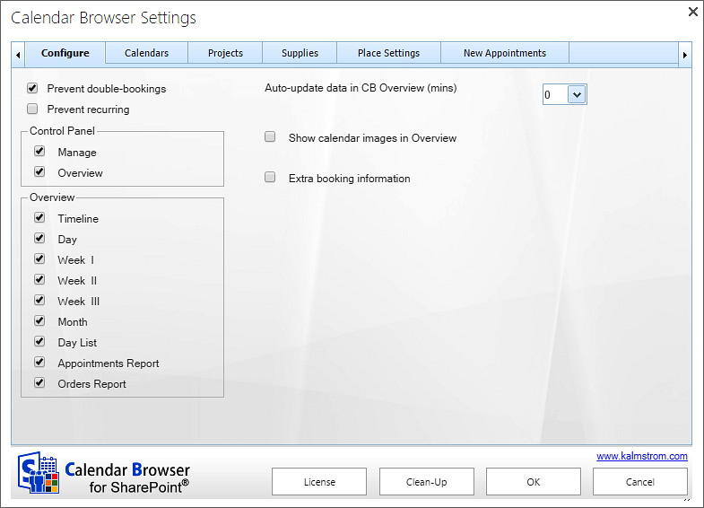

Prevent Double Bookings or Recurrence
Via checkboxes in the Administrator Settings both double bookings and recurring events can be prevented.  If recurring events are allowed and users create them in Calendar Browser, an icon is shown on the event in the Overview. | 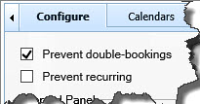

Panel Settings
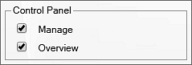
By unchecking the checkboxes for Manage and Overview, you can hide these buttons for all users who don't have site collection administrator permission.
The images below show how the different options will look for other users than the site collection administrator(s).
Site collection administrators will always see all four buttons.
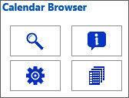 | 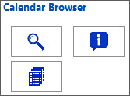 | 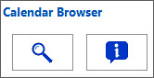
The default Calendar Browser control panel.  The Manage and Overview checkboxes are checked. | The Calendar Browser control panel when the Manage button is hidden.  The Manage checkbox is unchecked. | The Calendar Browser control panel when the Manage and Overview buttons are hidden.  The Manage and Overview checkboxes are unchecked.

Overview Settings
In the Overview settings you can select which views should be displayed in the Overview.

Auto–Update Data In Calendar Browser Overview
In the ‘Auto-update data’ box you can select the number of minutes between the automatic updates of data in the Calendar Browser Overview. The default value is zero, which means that the Overview is never updated automatically.

Show Calendar Images in Overview
Check this box if you want to show resource images in the Overview. These images have to be added under the Configure tab, refer to Overview Images.

Extra Booking Information
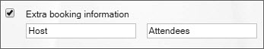
Check the box for Extra booking information if you want the users to be able to select Host and Attendees in each booking event.
The captions “Host” and “Attendees” may be changed into something else. Just write the terms you want to use in the fields under the checkbox.
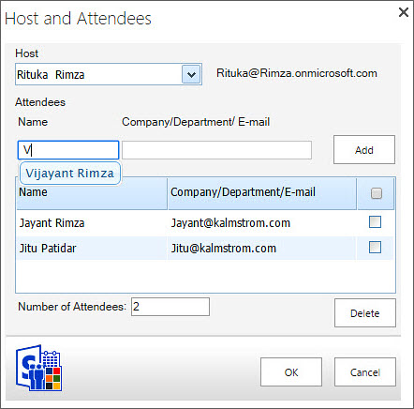
The image to the right shows the Extra Booking Information pane in the event.
“Host” will be selected from a dropdown, and the logged in user is shown by default.
The “Attendees” are written in, but users only have to write the first letter for each person. Then alternatives are shown and the correct one can be selected.
The company, department or e-mail information will be shown automatically in the event when the name has been selected. The number of “Attendees” will also be filled out automatically.
When the Extra booking information box is checked, two new tabs will open in the Settings. They will be called Hosts and Attendees – or your own terms, if you have changed the default ones.
Here you can fill out or paste names to be selected in the events and also their company, department or e-mail address.
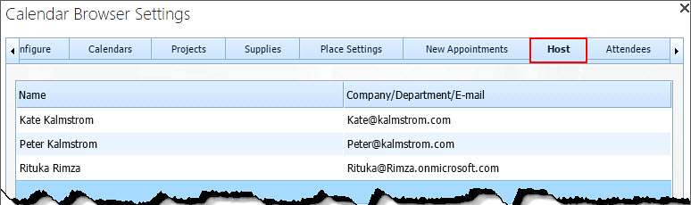

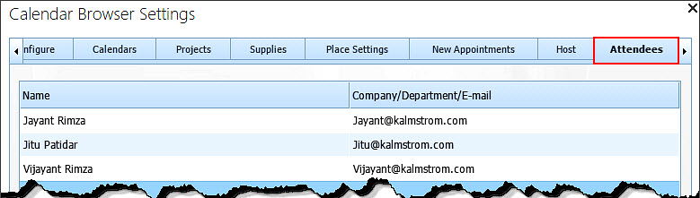
When the Extra booking information box is checked, another option will be shown for the Overview: Booking Summaries. The Booking Summaries report gives information about “Hosts” and “Attendees" for all meetings during a specified day, refer to Booking Summaries.
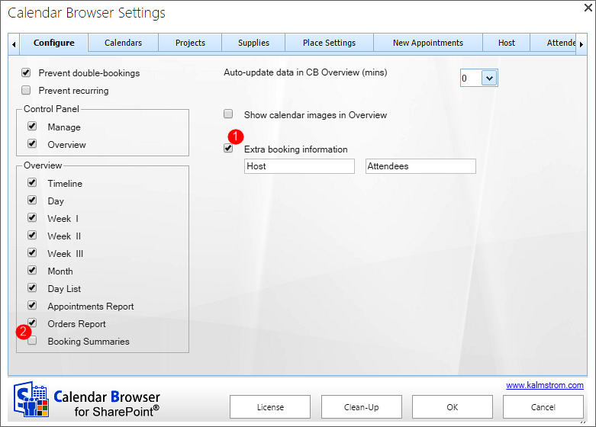

Calendars
Under the tab Calendars, you can add and remove resource calendars and give each resource a description.
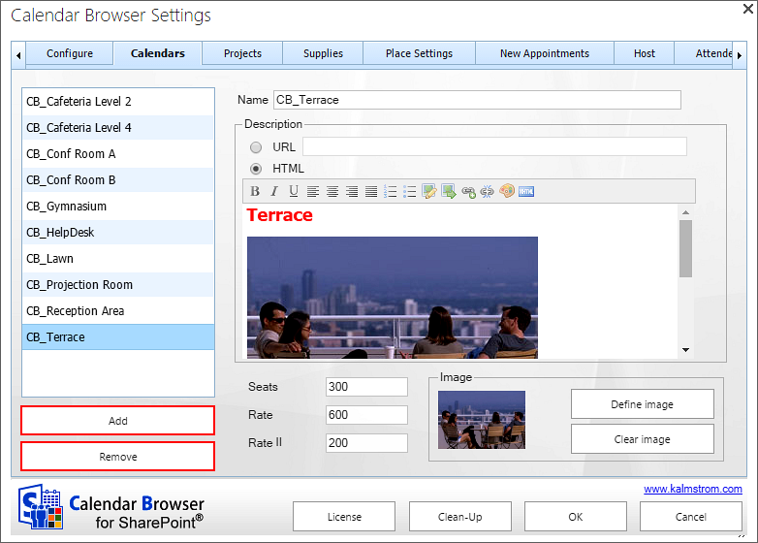

Add Calendars
You may add a new calendar anytime by pressing the Add button under the Calendars tab.

Remove Calendar
Remove a calendar from Calendar Browser by selecting it and clicking Remove.

Rename Calendar
Rename calendars by selecting a calendar and entering a new Name for it.

Descriptions
Under the Calendars tab, each resource can be described with seats and two different rates. Write or paste in the digits.
NOTE: If a calendar is described as having 0 seats, it will always show up in the search, since there is no filter for zero.
The second rate can be used if you want to separate some part of the cost for the resource.
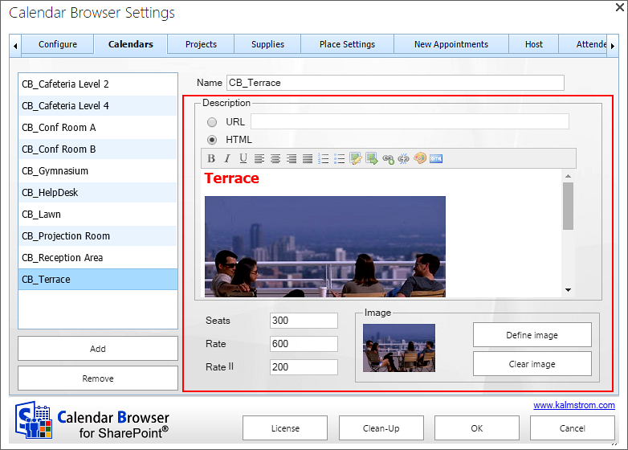
The resources can be described with words and images. When it comes to rooms, you can give the users information about each room’s features, such as type of room, air-condition, computers etc. The two methods for this are:
- URL: Here you can define a path to the description.
- HTML: Create a description directly in the .html description field to the right under the Calendars tab. The graphical WYSIWYG html editor makes it easy to create resource descriptions.
You can also click on the HTML icon in the editor and copy and paste .html code there.

Overview Images
If you want to use image headers in the Overview Timeline and Day views, define the image below the HTML editor. Valid formats are GIF, PNG, BMP and JPG. | 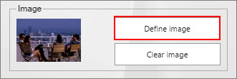
Note that you also have to check the box “Show calendar images in Overview” under the Configuration tab, for the images to be shown in the Overview. | 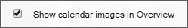

Project
The Project function might also be used for other factors than projects, because you can easily change the caption shown in the events to another word.
With different colors for different types of “projects” you will get a good overview over bookings in the Calendar Browser Overview. Write in the “project” name and select a color.
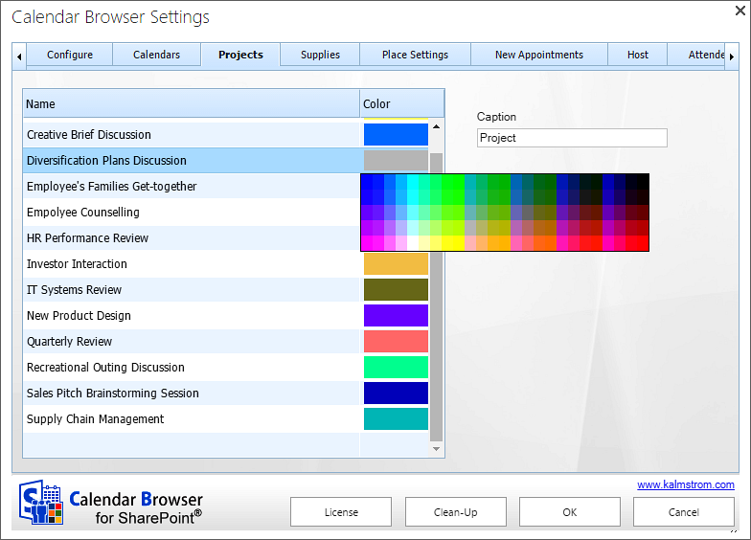

Supplies
In the supplies section you can specify all supplies that might be needed with the resource and the cost for each item. The currency will be the one already specified for your system.
You can also decide if information about Cost Center should be mandatory for each order, and Cost Center format can be specified.
There are two Cost Center formats:
- XXX-XXX ‒ in this format users may only insert numeric values
- Free text ‒ in this format all types of values may be inserted (numeric, characters etc.)
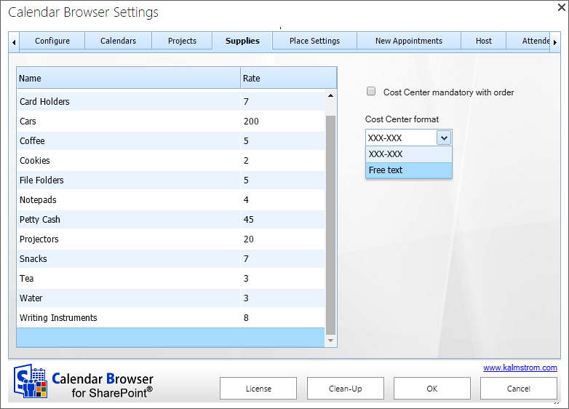

Remove supply items without disturbing existing bookings
When an item is removed from the Supplies items list, you will be asked if the item should be removed from existing bookings also. If you click No, the item will only be removed from the Supplies items list, so that it is not available for future bookings.
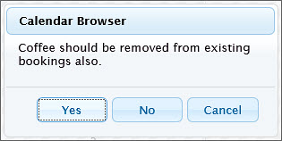

Place Settings
Under place settings you can give the users several different settings to choose from, like extra instructions on what tables should be used.
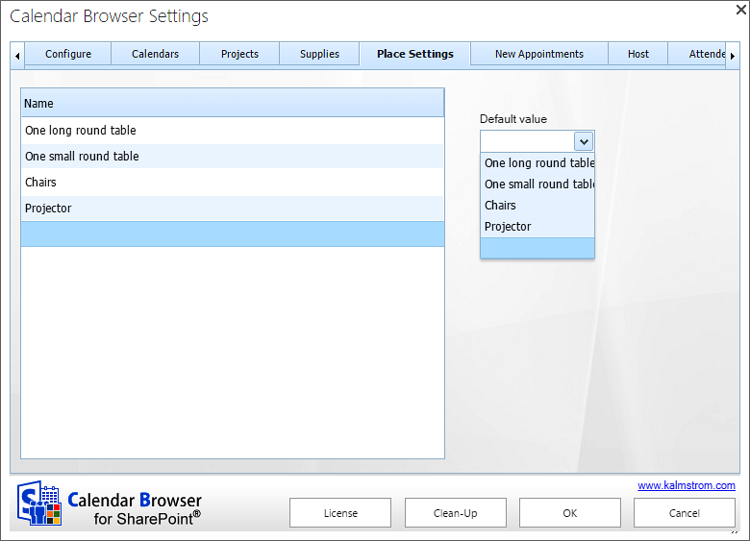
Another option is to use the Place settings for instructions on how the extra services ordered should be placed. For example:
On the side table
On the table
On a corner of the table
Or, if Calendar Browser is used to handle parties in a restaurant:
Blue china
Red china
White china etc.
Or you can use any other configurations of the resources that can be made available. This option is free text, so it can be used in any way appropriate to the organization – or not be used at all.  Enter a new Place Setting under the “Name” list. Click the Name list to add it to the list.  The users select the place settings in the supplies dialog of the event. | 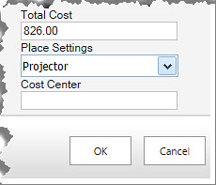

New Events
Here you can specify text that is to be filled into all new events. Use it if you, for example, want to give the end users a simple form to use when booking. The information is saved when you clicked OK. You can of course go back and edit the form if needed. (The information entered in such a form is not added to the overview reports. If you want that, use the overview settings.)

Overview Settings
In the Overview settings you can select which views should be displayed in the Overview.

AUTO–Update Data In Calendar Browser Overview
In the ‘Auto-update data’ box you can select the number of minutes between the automatic updates of data in the Calendar Browser Overview. The default value is zero, which means that the Overview is never updated automatically.

SHOW Calendar Images in Overview
Check this box if you want to show resource images in the Overview. These images have to be added under the Configure tab, refer to Overview Images.
When a new event is created in one of the resource calendars, the template text is copied into that event.
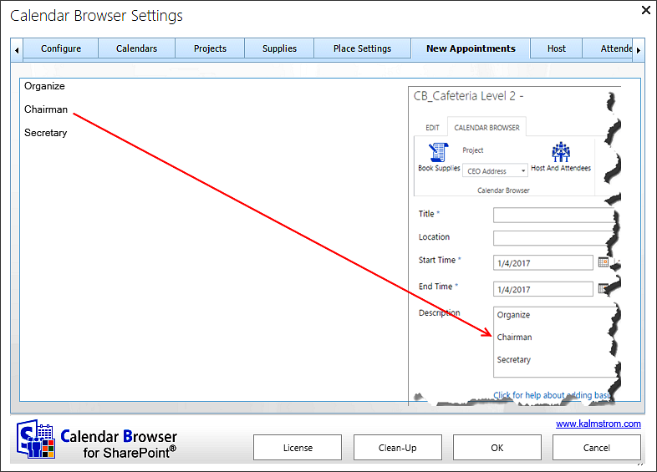

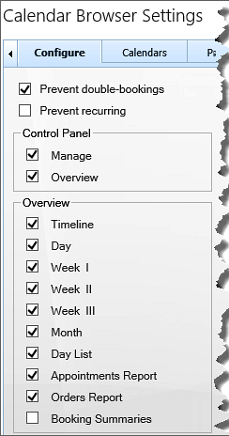
The Calendar Browser Overview
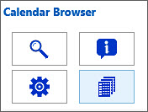
The Overview button gives access to different views of the resource bookings. These views can also be printed. (The Overview button can be hidden from users, refer to Panel Settings.)

What overview views the users will see depends on the Calendar Browser settings under the Configure tab, see image to the right.
Resources can be booked from within the overview by clicking an empty space in one of the views. Then an event will be opened for the selected resource and time.
To reach the Overview, click on the Overview button in the Calendar Browser control panel. Now a new Overview window with tabs for different views and reports will open.
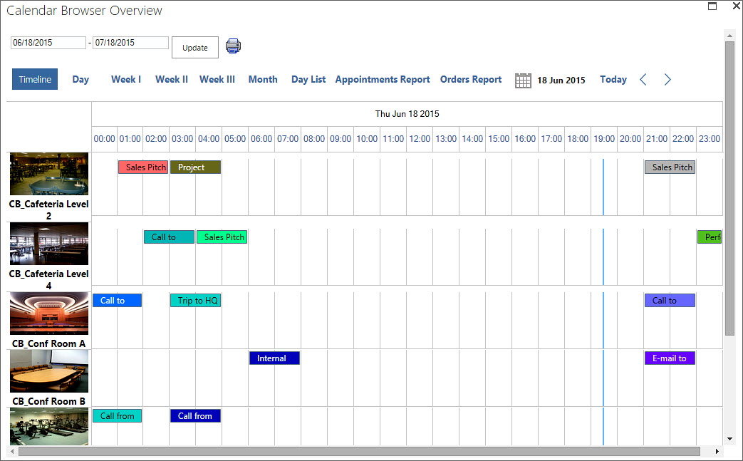

See More Info
The bookings shown in the Overview may be handled in different ways:
- Move the mouse cursor over an event and see info about the booking.
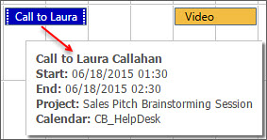
- Select the event to show more info at the bottom of the screen.
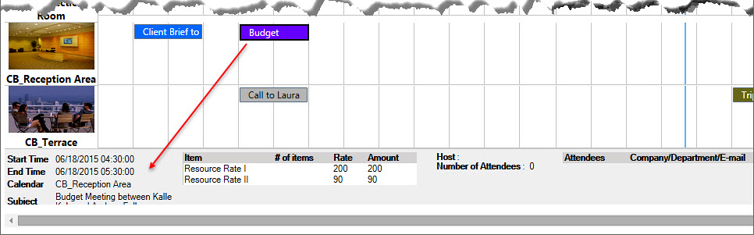
- Double-click the event to open it.

Search the Overview
You can search the Overview by a given date range.

When Extra booking information is activated, you can also search by a given date range sorted by Host (or any other term defined under the Configure tab in the Settings). When ‘All’ is selected, events from all hosts are shown, but if a particular host is selected, only events with that host will be visible. Note that Hosts are shown in the Overview only if the option “Extra booking information” is checked in the Calendar Browser settings, refer to Overview Settings
In the Overview settings you can select which views should be displayed in the Overview.

Auto–Update Data In Calendar Browser Overview
In the ‘Auto-update data’ box you can select the number of minutes between the automatic updates of data in the Calendar Browser Overview. The default value is zero, which means that the Overview is never updated automatically.

Show Calendar Images in Overview
Check this box if you want to show resource images in the Overview. These images have to be added under the Configure tab, refer to Overview Images.
Extra Booking Information.
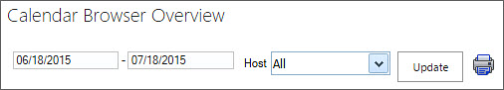
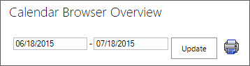
When “Extra booking information” is not checked in the Calendar Browser settings, you will get an Overview screen without host information.

The Update button is for refreshing the data from Calendar Browser. If you select a new date the information will be updated automatically.

Overview Images
The Timeline and Day views can show images. If you want to show images you must do two things in the Administrator Settings:
- Check the box under the Configure tab in the Calendar Browser settings.
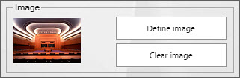
- Add the image under the Calendars tab in the Calendar Browser settings.

THe Overview Views
The Calendar Browser Overview has various views and reports. Under the Configure tab in the Calendar Browser settings you can select which of them should be shown to the users, refer to Overview Settings.
All views in the Overview except the Booking Summaries are shown by default and populated by the Calendar Browser example data.

Day View
In the Day view the bookings of each resource are shown for one day.
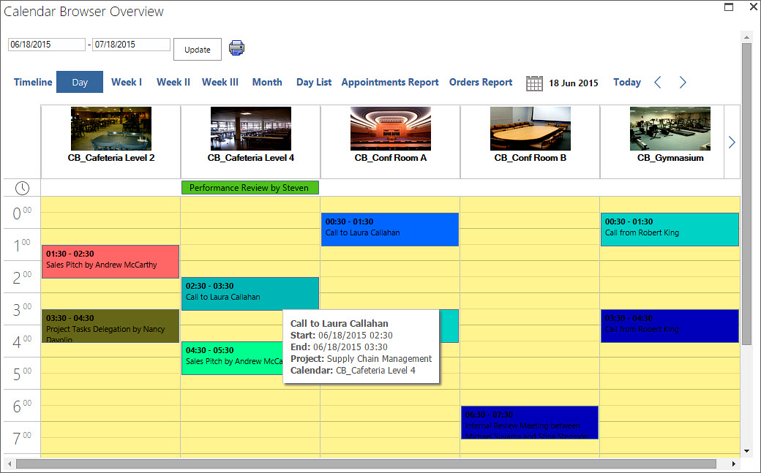

Week Views
There are three different week views:
- Week I, from Sunday to Saturday
- Week II, from Monday to Sunday
- Week III, from Monday to Friday

Month View with Calendar Filter
The Month view shows bookings for one month. By default all the resource calendars are shown, but you can filter the bookings by calendar. Select one calendar in the dropdown and only the bookings in that calendar will be shown.
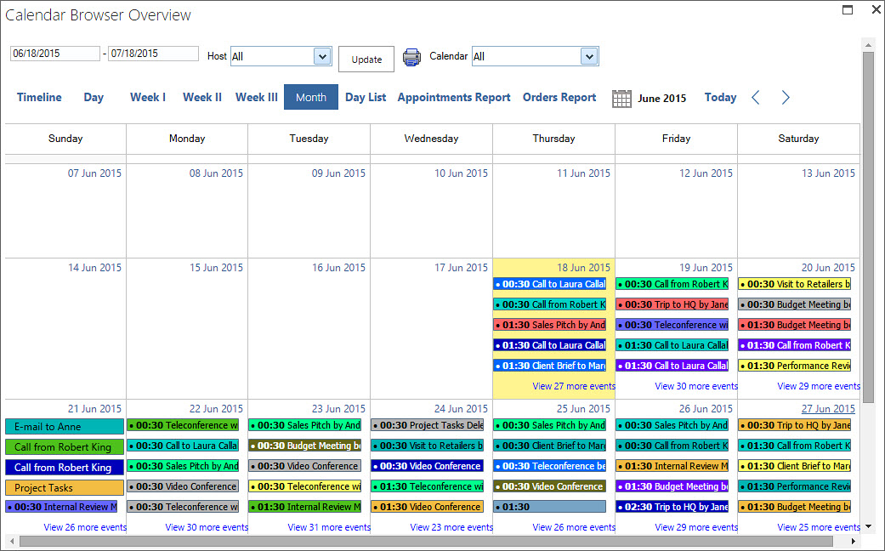

Day List View
Under the tab Day List you get information about the occupancy of and the activities in the separate resources on the date you choose. If you click on the plus sign to the left of the event in the list, you will get info about the supplies ordered for the booking.
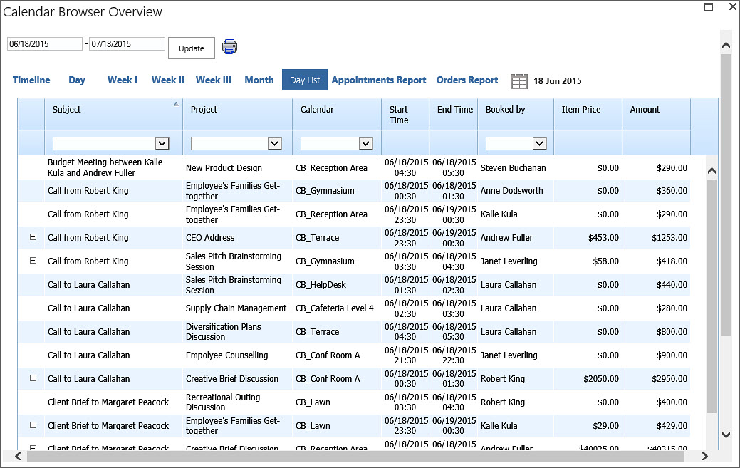

Appointments and Orders Reports
The Appointments report shows all the events and their orders for the day or date range you have chosen.
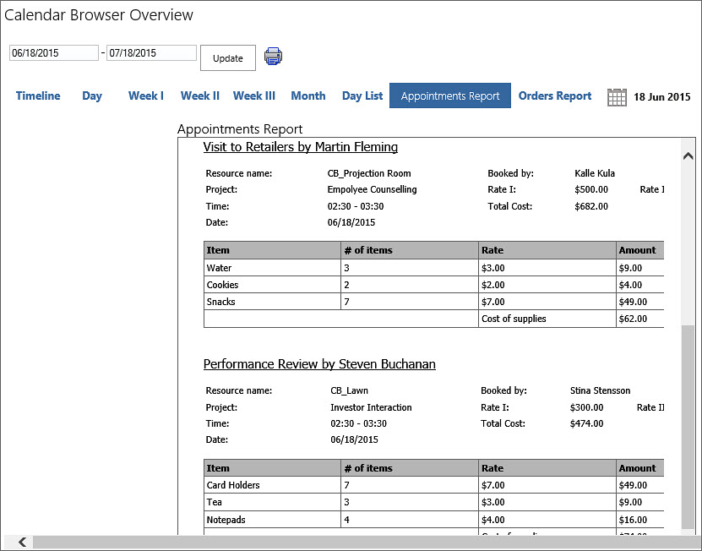
The Orders report is like the Appointments report, except that all events that don’t have any supplies booked are filtered out, so that only events with orders are shown.
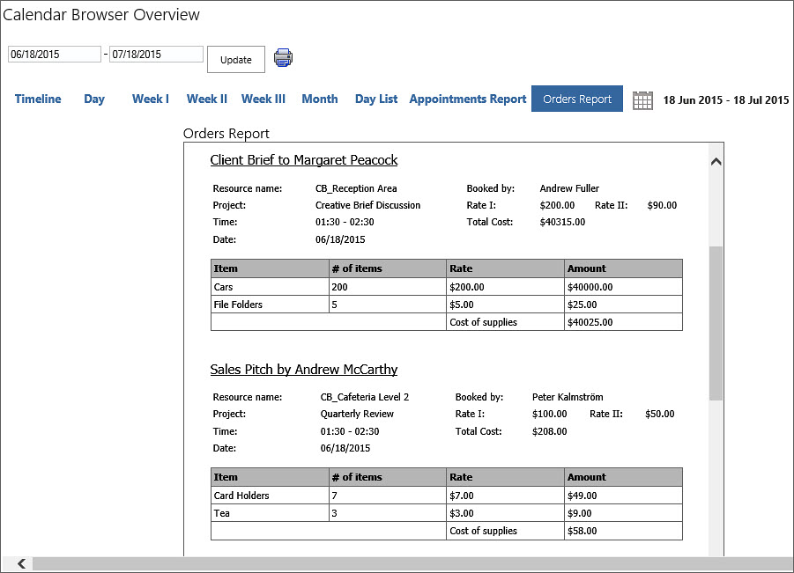

Booking Summaries
When you check the box for Extra booking information under the Configure tab in the Calendar Browser settings, you will get the possibility to use one more report, Booking Summaries. Refer to Extra Booking Information.
This report gives summaries of bookings for certain dates and include host name, a name list of the attendees and information on when the booking was made and when it was last edited. When other terms than “Host” and “Attendees” are defined under the Configure tab in the Calendar Browser settings, these terms will be used in the Booking Summaries too.
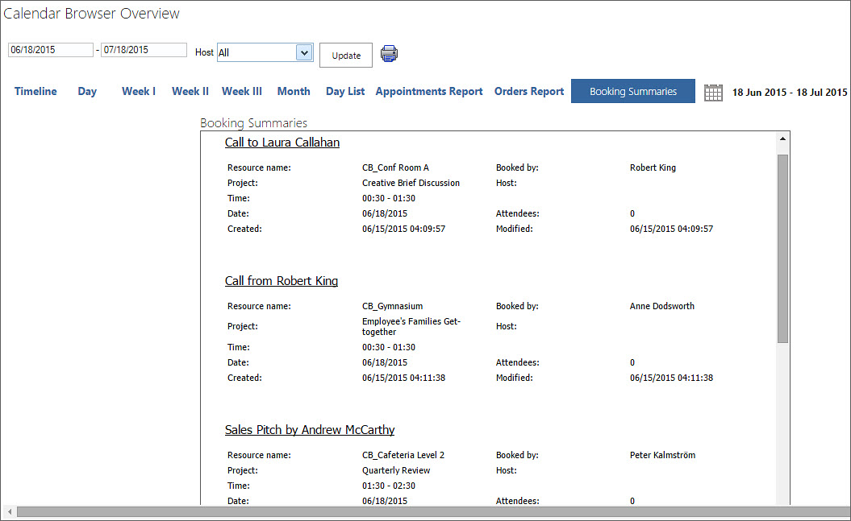

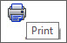
Print
You may print the Overview, something that is especially useful for the Appointments and Orders reports and for the Booking Summaries report.
When you want to print the Timeline, Day, Week I, Week II, Month or Day List view, open the desired view and press the Print button. Make sure that the PC is connected to the internet when you click on the Print button for these views. A PDF file will be downloaded to your PC. Open it and print it.
When you want to print Week III, Appointments Report, Orders Report or Booking Summaries, a simple window will open asking you to select a printer. Select it and click Print.

Clean-up
Use the Clean-up button in the Calendar Browser settings before deactivation. You will be asked to confirm the action, so click on ‘Yes’ to complete the clean-up.
After the clean-up you can deactivate Calendar Browser on the sites where Calendar Browser has been used, and you should also deactivate Calendar Browser in the Solutions gallery.

Upgrade
To upgrade Calendar Browser, replace the old CalendarBrowserSP.wsp file with a new version of the file. Subscribers who do not use a Premium copy should download the new version from the kalmstrom.com Upgrade page. Premium Subscribers will get a message from kalmstrom.com when their setup file has been updated.
This is the upgrade process:
- Clean Calendar Browser with the Clean-up button in the Settings page, refer to Clean-up above.
- Deactivate Calendar Browser on all sites where it is activated.
- Deactivate the old CalendarBrowserSP.wsp file under Site settings >Solutions.
- Delete the old CalendarBrowserSP.wsp file.
- Upload the new CalendarBrowserSP.wsp file to the Solutions gallery.
- Activate the new CalendarBrowserSP.wsp file for the site collection.
- Activate Calendar Browser on each site where it is is used.
- Click on the Calendar Browser link in the Site settings to recreate the Quick Launch link. Refresh the page to see the Quick Launch link.
A PowerShell script for the whole process can be provided to Premium subscribers on request.

Register
This information is only valid for organizations with a Standard Subscription. Premium Subscribers do not have to register their installations.
Register Calendar Browser by clicking the License button in the Administrator Settings (When you have registered Calendar Browser this button will be hidden.)
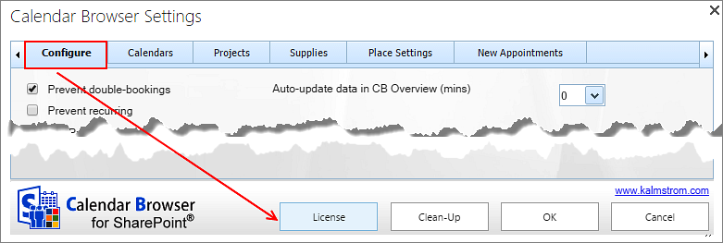
The person who registers Calendar Browser should have Owner or Designer permission on the site collection.
When you have clicked on the License button the register dialog is displayed. Add an e-mail address with the domain name of your company/organization and the registration key you have received from kalmstrom.com.
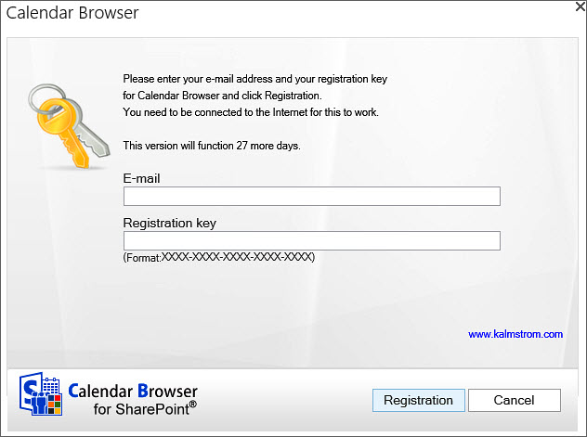

Support
To use Calendar Browser you must have a valid subscription. Free upgrades and the kalmstrom.com Support Services are included in all subscriptions.

Contact
The solutions of kalmstrom.com are designed to be very easy to deploy, use and manage. However, if you have any kind of problems or questions about our software, there are several ways of contacting us:
E-mail | support@kalmstrom.com | Technical issues
 | sales@kalmstrom.com | General and sales issues
 | finance@kalmstrom.com | Subscription issues
Teams | peter@kalmstrom.com
Telephone | +46 739 206 106

Remove Calendar Browser
Should Calendar Browser not be used, clean-up and deactivate Calendar Browser on all sites where it is used, refer to Upgrade. Then deactivate and remove the Calendar Browser WSP file from the root file of the site collection: Site Settings>Solutions. Now the solution can no longer be used or activated.

More SharePoint Tips
You surely have noticed that Calender Browser for SharePoint uses what is best in SharePoint. For tips on SharePoint usage in general, please refer to the Tips section of the kalmstrom.com website.

