Calendar Browser Manual
Contents
1 Introduction 3
1.1 Installation Tip 3
1.2 Language 4
1.3 Requirements 4
1.4 Editions 4
1.4.1 The SPFX edition 4
1.4.2 The Sandboxed Solution 4
1.5 Permissions 5
1.5.1 Use Calendar Browser 5
1.5.2 Install the SPFX edition 5
1.5.3 Install the Sandboxed Solution Manually 5
1.5.4 Install the Sandboxed Solution with a PowerShell Script 5
1.6 Third Party JavaScript Libraries 5
2 Calendar Browser Features 6
2.1 The Calendar Browser Overview 6
2.1.1 Views 6
2.2 Book 7
2.2.1 Orders 8
2.2.2 Cancel a Booking 9
2.3 Resource Descriptions 9
2.4 Make Homepage 9
3 Installation Details 11
3.1 The SPFX edition 11
3.1.1 SharePoint Online 11
3.1.1.1 Deploy in a Site 12
3.1.2 SharePoint On-Premises 13
3.1.3 Add the Web Part to a Page. 14
3.1.3.1 Add to Teams 14
3.2 Sandboxed Solution 15
3.2.1 Site Assets 15
3.2.2 Manual Installation 16
3.2.2.1 SharePoint Online 16
3.2.2.2 SharePoint On-Premises 16
3.2.2.3 Upload to a Solutions Gallery 16
3.2.2.4 Activate for a Site 17
3.2.3 PowerShell Package 17
3.3 Get Started 17
4 Example Calendars for Evaluators 19
4.1 Remove Example Data 19
5 The Calendar Browser Settings 20
5.1 Calendars 20
5.1.1 Descriptions 20
5.2 Categories 21
5.3 Supplies 21
5.4 Registration for Standard Subscribers 22
6 Upgrade and Removal 23
6.1 Upgrade 23
6.1.1 Upgrade the SPFX edition 23
6.1.2 Upgrade the Sandboxed Solution Manually 23
6.1.3 Upgrade with a PowerShell Script 24
6.2 Remove Calendar Browser 24
7 Support 25
7.1 Contact 25
7.2 More SharePoint Tips 25

Introduction
Calendar Browser for SharePoint is an application for booking resources within an organization. It is totally integrated in SharePoint and can be used both in the modern and the classic experience. Calendar Browser shows an overview of all calendars in a site and all events in them, and users can create and modify events directly from that overview.
For the best use of Calendar Browser, each resource should have its own calendar. To book a resource, users simply create an event in the calendar of the resource they wish to reserve. For users already familiar with SharePoint, it is very easy to learn how to book resources with Calendar Browser.
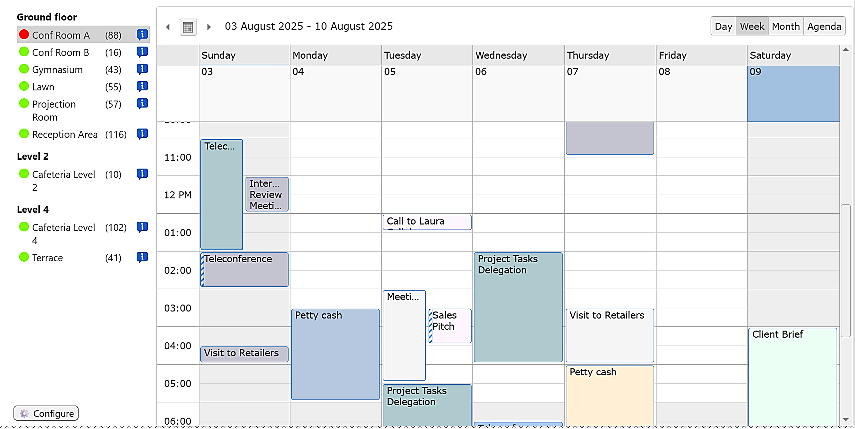
The screenshots in this manual show the Calendar Browser example data. We use room bookings as an example, but, anything that is bookable within an organization – cars, equipment, personnel – can of course be booked through Calendar Browser.
The second chapter of this manual is intended for all users. The rest of the manual is intended for people who will install and administer Calendar Browser.

Installation Tip
As Calendar Browser takes all calendars in the site, it is suitable to use a specific Calendar Browser site for the resource calendars and give all users who need to book resources Edit permission on that site.
In a small organization, it might be enough to have one installation. Different kinds of resources can be grouped in Calendar Browser overview.
Bigger organizations might need multiple Calendar Browser sites for different types of resources. This makes it easier for users to overview the resource calendars. You can for example have one site for cars, another one for rooms and a third one for resource persons. A common navigation makes it easy to move between the Calendar Browser sites.
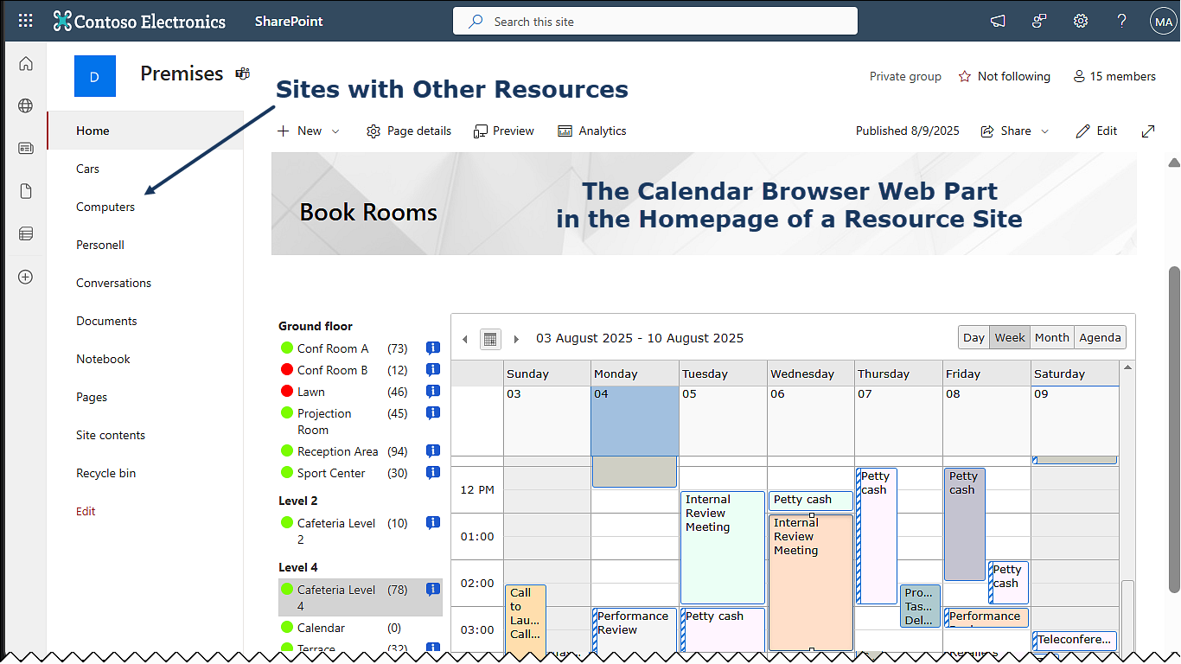

Language
The SharePoint language will automatically be used for Calendar Browser. The supported languages are Arabic, Danish, Dutch, English, French, Italian, Norwegian, Portuguese, Spanish and Swedish. If the SharePoint language is not supported, English will be used instead.

Requirements
To use Calendar Browser, you need to have SharePoint 2013 or above (in-house or hosted) or Microsoft/Office 365 SharePoint Online. Tested browsers are Microsoft Edge and the latest versions of Google Chrome and Mozilla Firefox.

Editions
Calendar Browser comes in two editions, SPFX edition and Sandboxed solution and three different packages. They are installed in different ways, but they have the same version numbers and features. One subscription is valid for all packages, so you can use any combination you wish.

The SPFX edition
The Calendar Browser SPFX edition supports SharePoint 2016, 2019, SE and Online.
The SPFX edition is very easy to install and upgrade, so we recommend that you use it when possible. It gives a web part that can be added to classic as well as modern SharePoint pages, and a modern page with the Calendar Browser web part can be added to Teams as a tab.

The Sandboxed Solution
The Calendar Browser Sandboxed SharePoint solution gives a Calendar Browser page in each site where it is installed. It supports SharePoint 2013, 2016, 2019, SE and Online and comes in two packages, a WSP file for manual installation and a PowerShell script.

Permissions
Standard SharePoint permissions are used for Calendar Browser.

Use Calendar Browser
Users must have at least Contribute permission on the list to book resources. In SharePoint Online, this generally means Edit permission. To view bookings, only Read permission is necessary.
To manage the Calendar Browser settings, you need to have Edit permission on the site where Calendar Browser is installed.
If you need more granular permissions on the calendars/events lists, you can do that in two ways:
- Create a separate SharePoint site for each group of resource calendars and set the permissions on that site (recommended).
- Set unique permissions on the calendars in the SharePoint site. Users will only see the calendars they have permissions on in the Calendar Browser overview.

Install the SPFX edition
To upload the Calendar Browser SPPKG file to an App catalog, you need to be a Global or SharePoint Admin of your tenant. Deployment to all sites can be done in the same process.
If Calendar Browser is not enabled for all sites in the upload process, it can be deployed in a single site by the Site owner.

Install the Sandboxed Solution Manually
To upload the Calendar Browser Sandboxed solution .wsp file to the Solutions gallery and activate it there, you need to be at least Site admin.
To activate the solution for the site you must be at least Site owner. Often – but not always – the same person has both these roles.

Install the Sandboxed Solution with a PowerShell Script
You need to be a SharePoint Admin of the farm or tenant to run the PowerShell script that installs Calendar Browser in all sites included in the script.

Third Party JavaScript Libraries
The kalmstrom.com team has modified and extended two third-party JavaScript libraries to create Calendar Browser: jQuery and jQuery Scheduler. No extra license is necessary to use these libraries in Calendar Browser.

Calendar Browser Features
This chapter contains information that all Calendar Browser users should be familiar with. If the Sandboxed solution is used, the Calendar Browser overview is displayed in a page created by Calendar Browser. The SPFX edition gives a web part that displays the same overview. The Calendar Browser web part can be added to any modern or classic SharePoint page.

The Calendar Browser Overview
In the Calendar Browser overview, you can find all the resource calendars you have access to, and you can see reserved time slots and book your own. Conference Room A is selected by default, but you can quickly switch resources by clicking on the resource names in the left panel.
To the left of the calendar names, green or red circles show if the resource is free (green) or busy (red) right now. The figure within parenthesis after the name shows the number of future events for that resource.
If the resource calendars are grouped, as they are in the example data, you can click on a group heading to collapse it.

Views
You can choose between different views for the resource calendars, just like you do in any SharePoint calendar. There is also an Agenda view. Select a resource calendar in the list and click on the desired view
By default, the calendar shows events for the current week, but you can easily change that in the area above the calendar events.
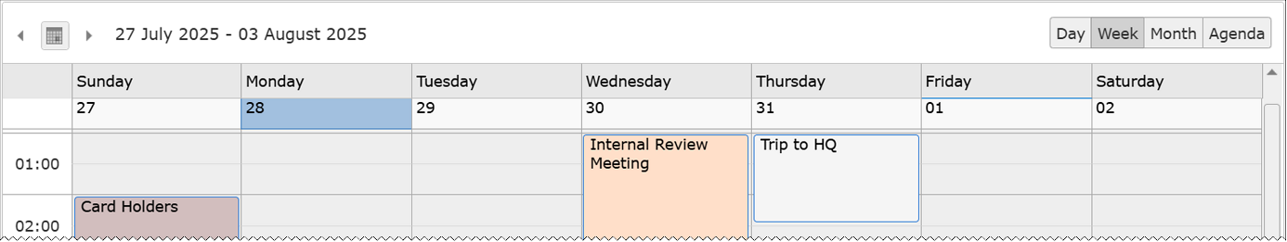
- Click on Day, Week or Month to the right to show these time periods. The Agenda option also displays one week.
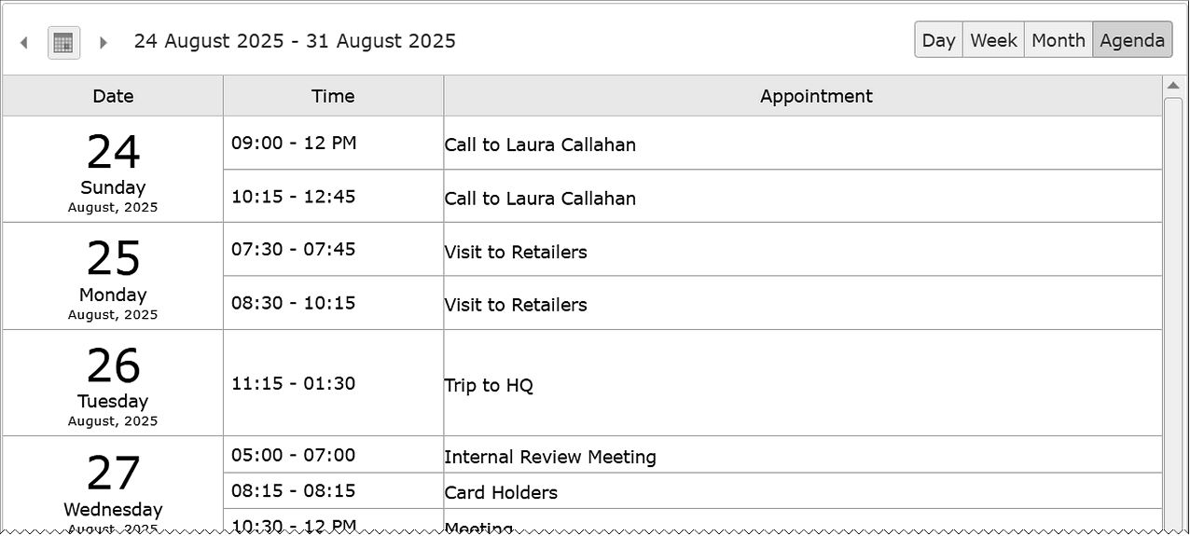
- Select a suitable day, week or month period by clicking on the calendar icon to the left. Or select the nearest previous or coming day, week or month by clicking on the arrows.
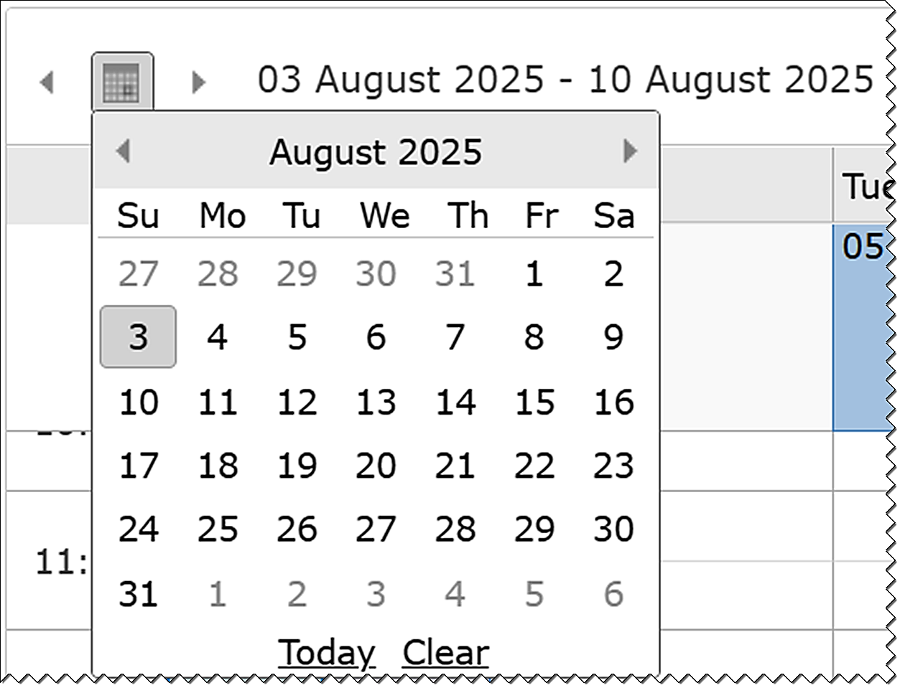

Book
You can book a resource by selecting its calendar in the SharePoint Calendar Browser page and creating an event. Create the event by double-clicking in an empty cell in the calendar overview to the right on the page.
An event dialog opens, and you can fill out time and other booking information. If the Calendar Browser admin has specified categories, you can also select a category for the event. Depending on the settings, this might give your event a specific color.
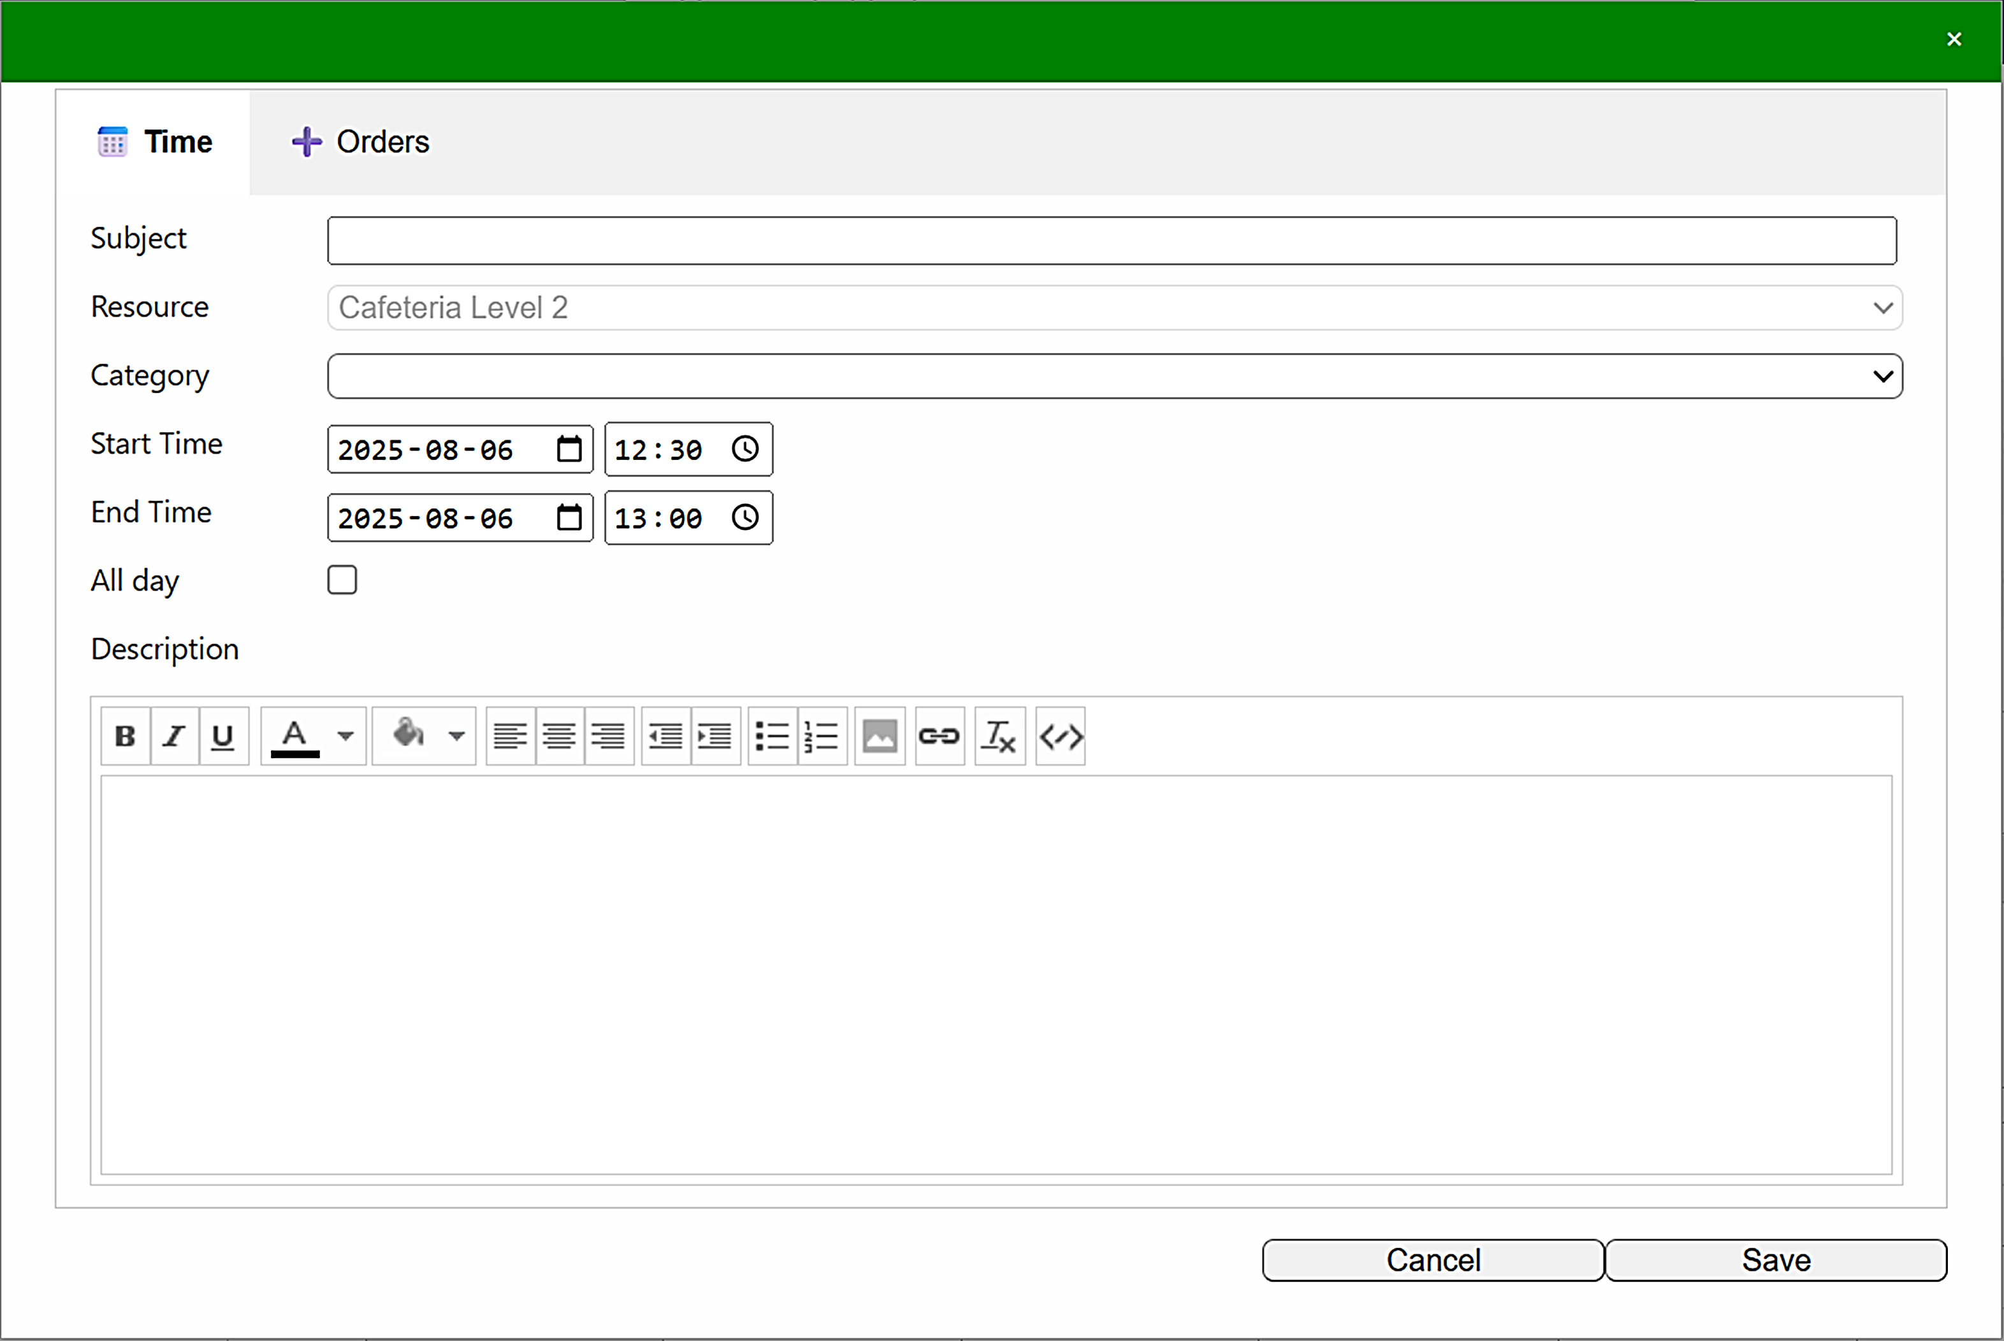
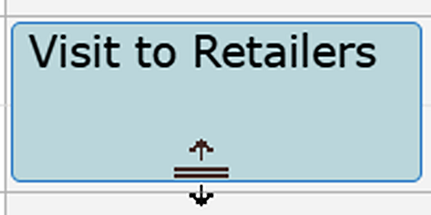
Events can be moved within a calendar by drag and drop, and you can extend or restrict the length of the event by dragging the handles that become visible when you hover over an event border on the overview.

Orders
The event dialog has an extra tab named 'Orders'. Here, you can book services or supplies that you want to use in the event. Click on one or more of the available supplies, and they will be added with their cost to the right of the supply buttons.
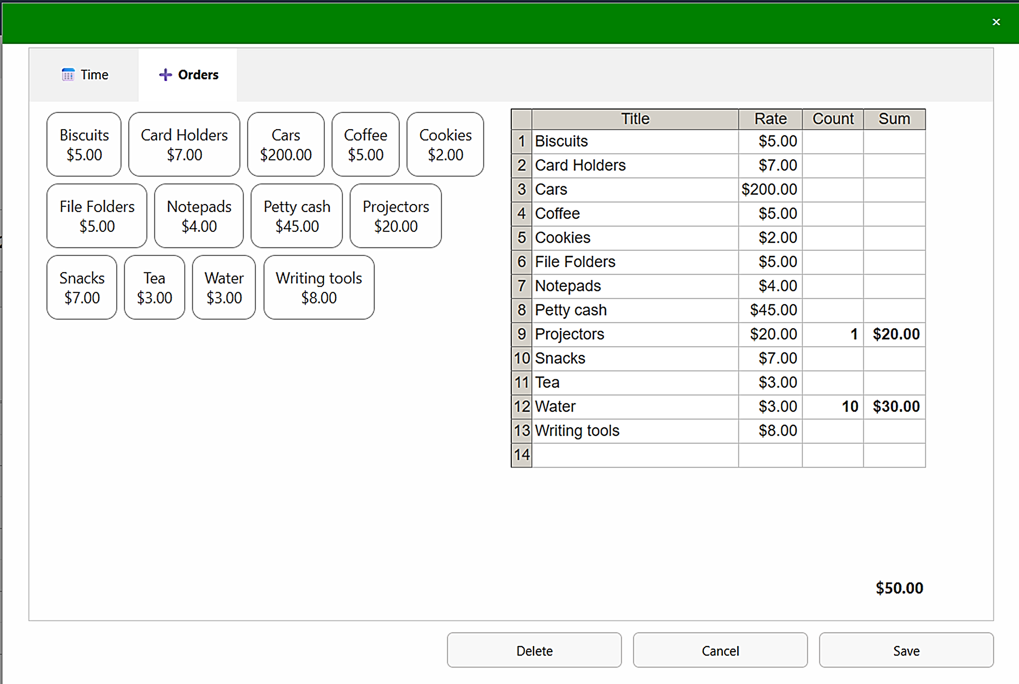
By default, only one of each item will be ordered. If you need more, click multiple times on the supply button or click in the cell with the number and type another figure.
The total cost will be automatically calculated by Calendar Browser, based on the number of items ordered and their rates.
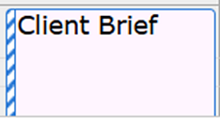
If you change your mind and don't want an item you have already clicked on, type 0 in the Count cell and move to another cell. Now your change will be saved, and the cost for the item will be deducted from the total. In the same way, you can change the number of items you have ordered.
On the overview, events with orders have a dashed border to the left.

Cancel a Booking
When you want to cancel a booking, open the event that you want to cancel and click on the Delete button in the bottom right corner. If you have ordered any supplies with your booking, that order will also be cancelled automatically.

Resource Descriptions
To facilitate an adequate choice among the free resources, Calendar Browser gives a possibility to create descriptions of them. If such descriptions are used, click on the information icon at the resource you wish to see information about. Now, a dialog with a description of the resource will open.
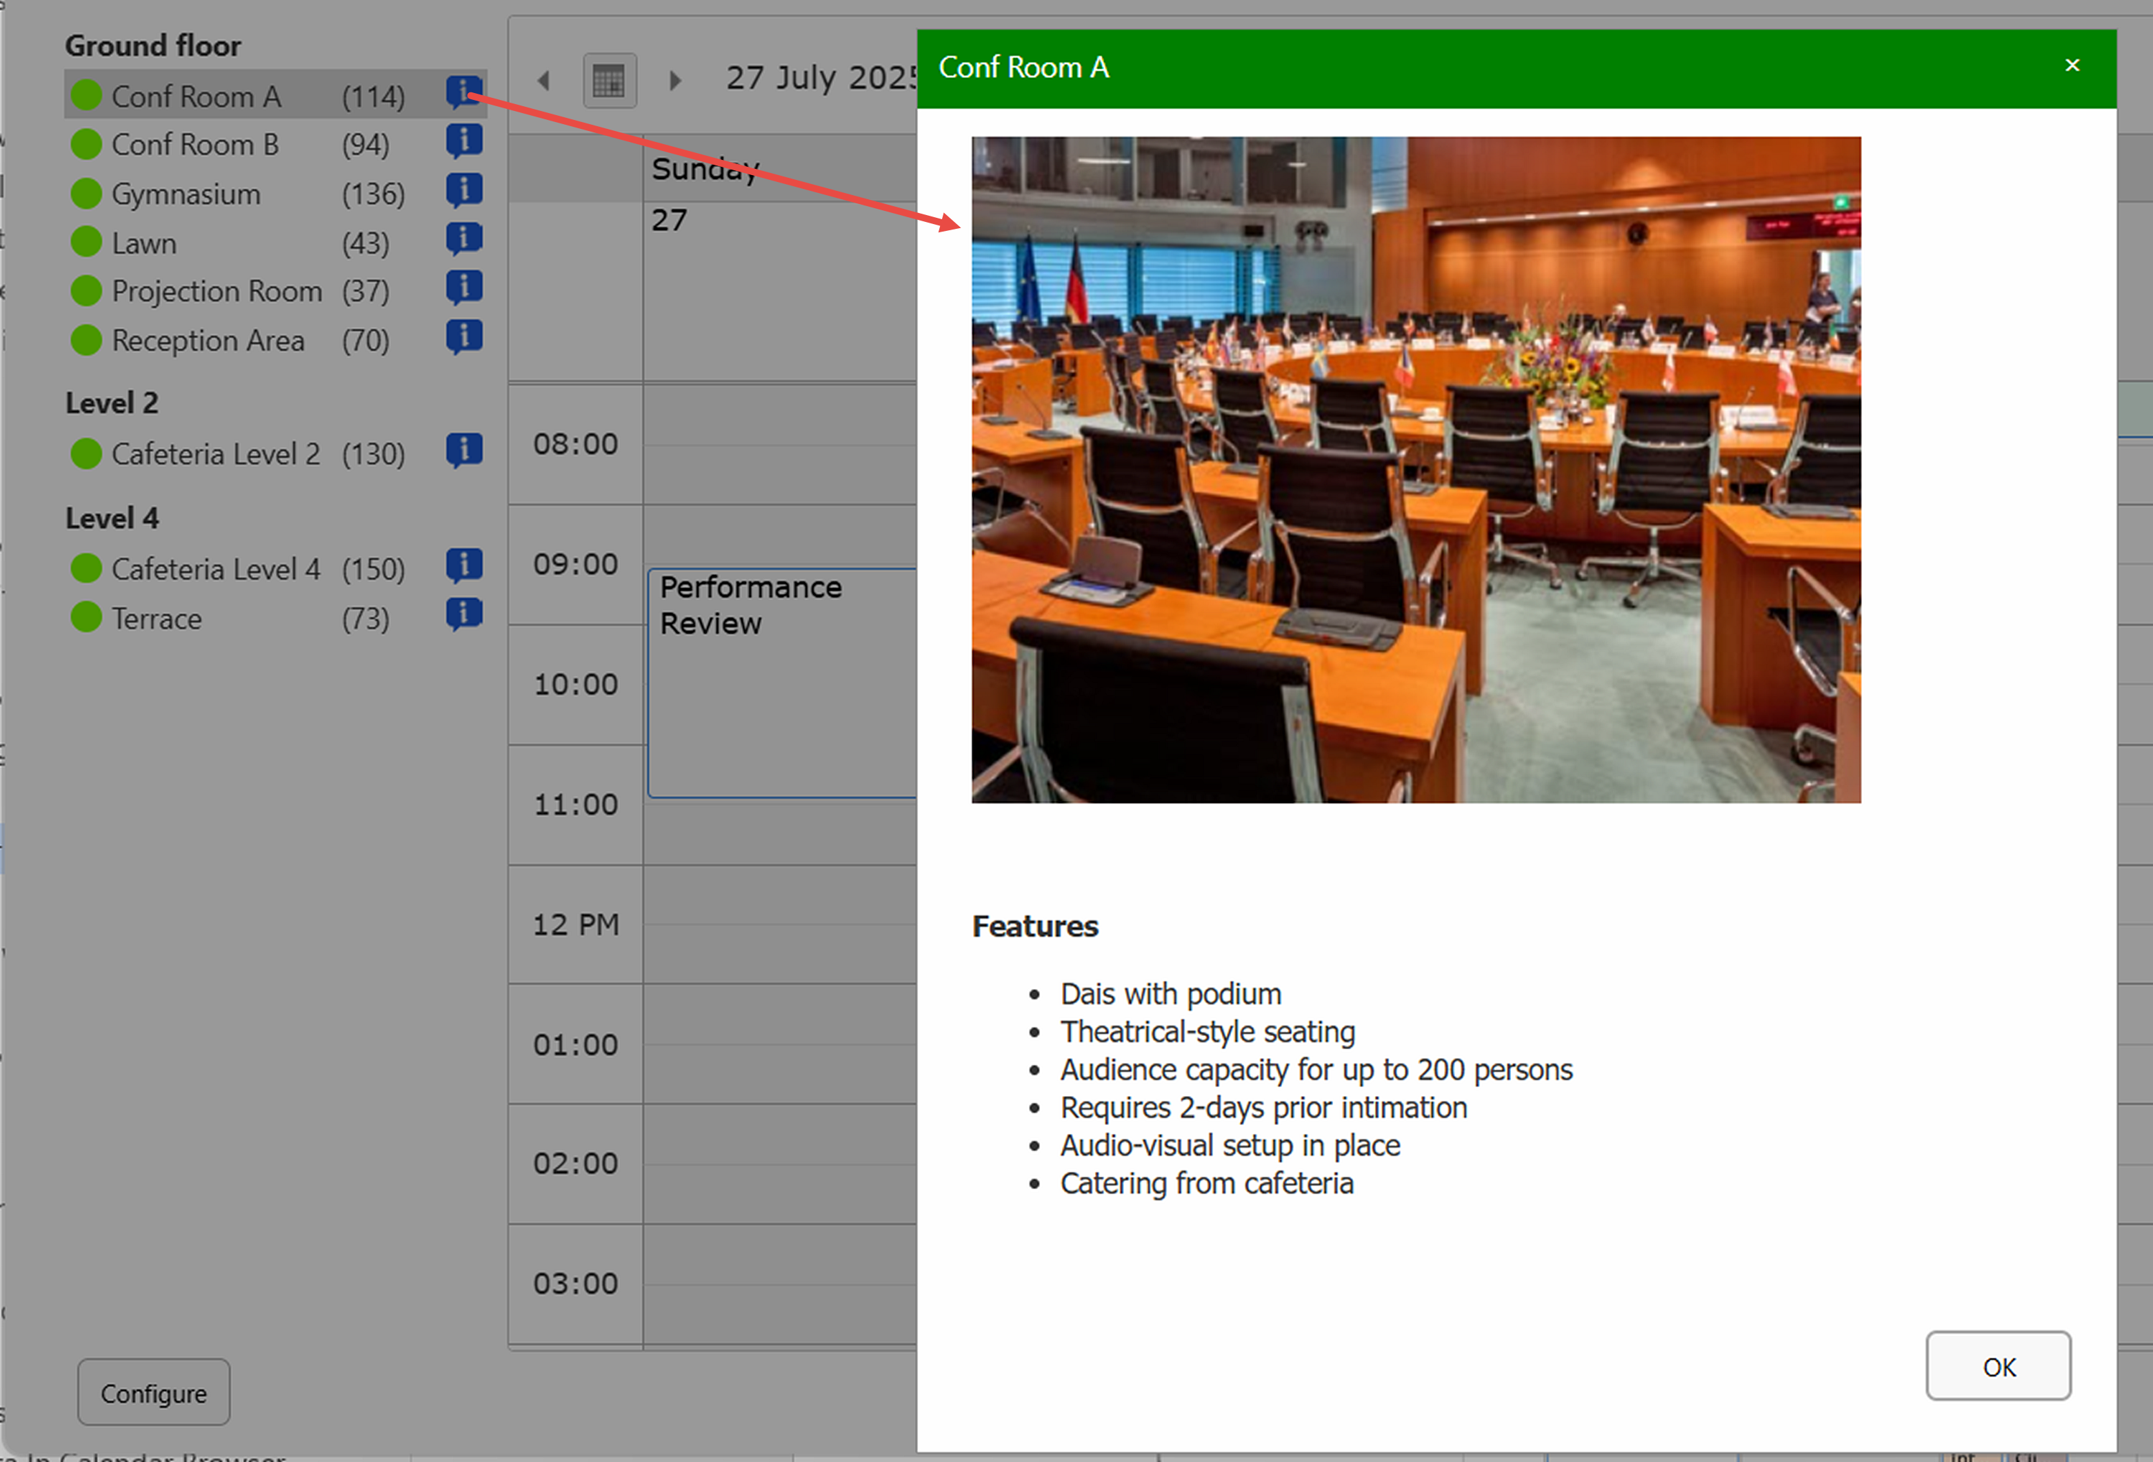

Make Homepage
If you want to use a dedicated site for resources and bookings, it is suitable to make the Calendar Browser page the homepage of that site.
To do that with the Sandboxed Solution, open the PAGE tab in the ribbon and click on the 'Make Homepage' button.
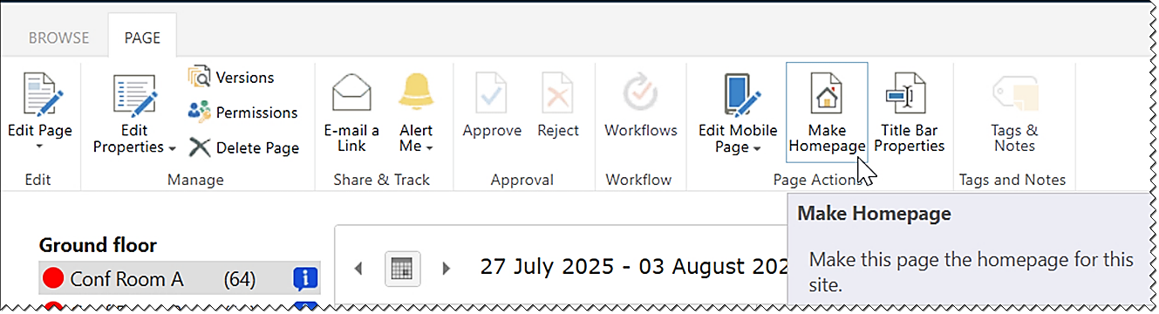
For the SPFX edition, open the Site contents >Site pages and find the page where you added the Calendar Browser web part. Select the page and right-click on the ellipsis and choose 'Make homepage'. The same command is also found under the ellipsis in the command bar.
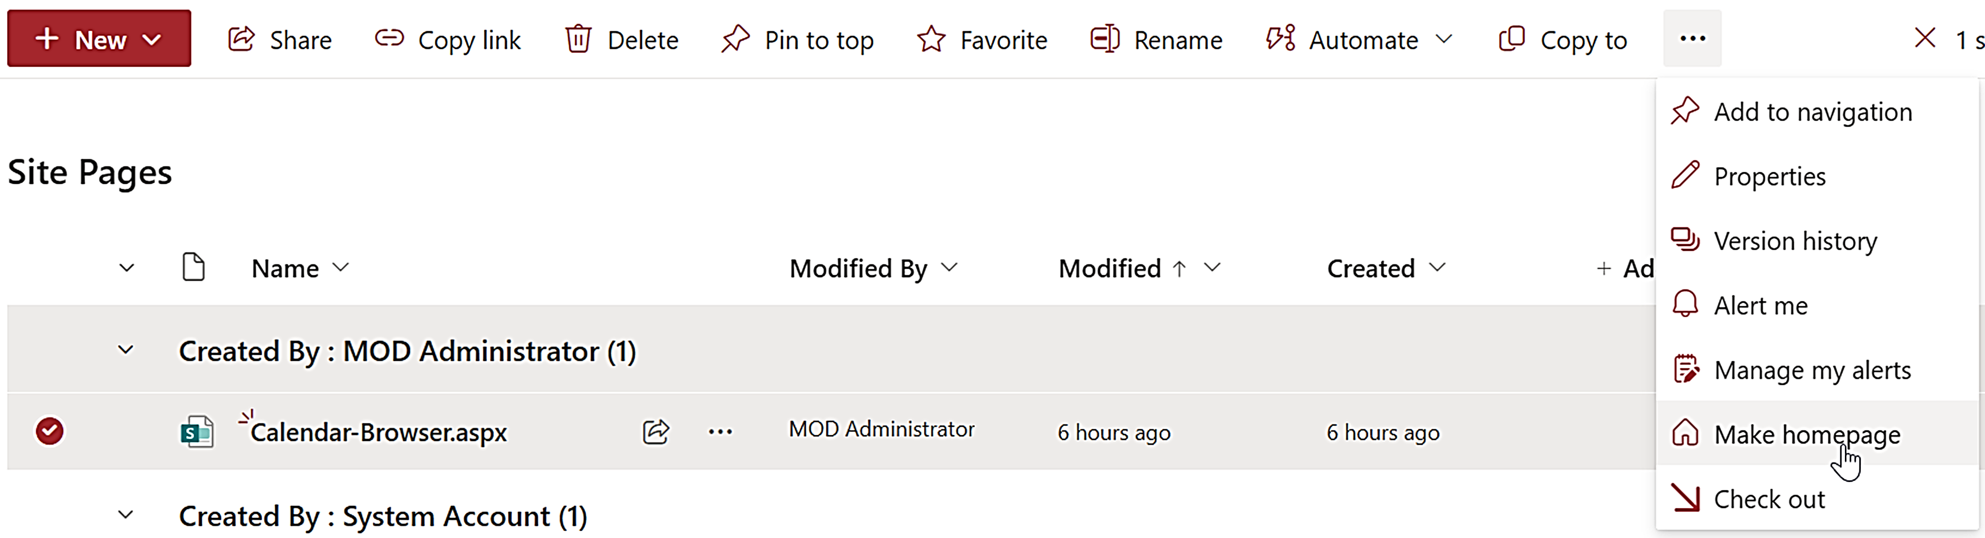
Another option for the SPFX edition is to add the Calendar Browser web part on the default homepage directly, or to add a page with the web part to a Teams tab.

Installation Details
Within Microsoft's limitations we have tried to make our products as easy as possible to install. The installation files can be downloaded from the kalmstrom.com website. Download pages for all packages can be reached from https://www.kalmstrom.com/products/CalendarBrowser/DownloadSP.htm. The download pages have videos that show the installation process.
You can also find all installation demonstrations on the Calendar Browser Demonstrations page at https://www.kalmstrom.com/products/CalendarBrowser/DemonstrationsSP.htm
Another option is to use the kalmstrom.com installation service, please refer to: https://www.kalmstrom.com/Services/Installation-Assistance.htm.

The SPFX edition
The Calendar Browser SPFX edition gives a modern client-side web part that can be added to modern as well as classic SharePoint pages. There are two download files, one for SharePoint Online and one for SharePoint On-Premises.

SharePoint Online
The SPFX edition comes as an SPPKG file that can be downloaded in .zip format from the kalmstrom.com website to your PC and then extracted and uploaded to the App catalog in the tenant or farm.
For SharePoint Online, the file can also be loaded from SharePoint Store directly to the App catalog/Apps site. In that case, use the SharePoint 'Add an app' command and select SharePoint Store. When the file has been loaded, you can go directly to step 3 below.
- Go to the tenant's App catalog/Apps site. (If you have not already created such a site, it will be created the first time you click on the 'Open' button in the SharePoint Admin center >More features >Apps.)
- Upload the SPPKG file. (If there is a warning message for add-ins, it can be ignored. It does not apply to SPPKG files.)
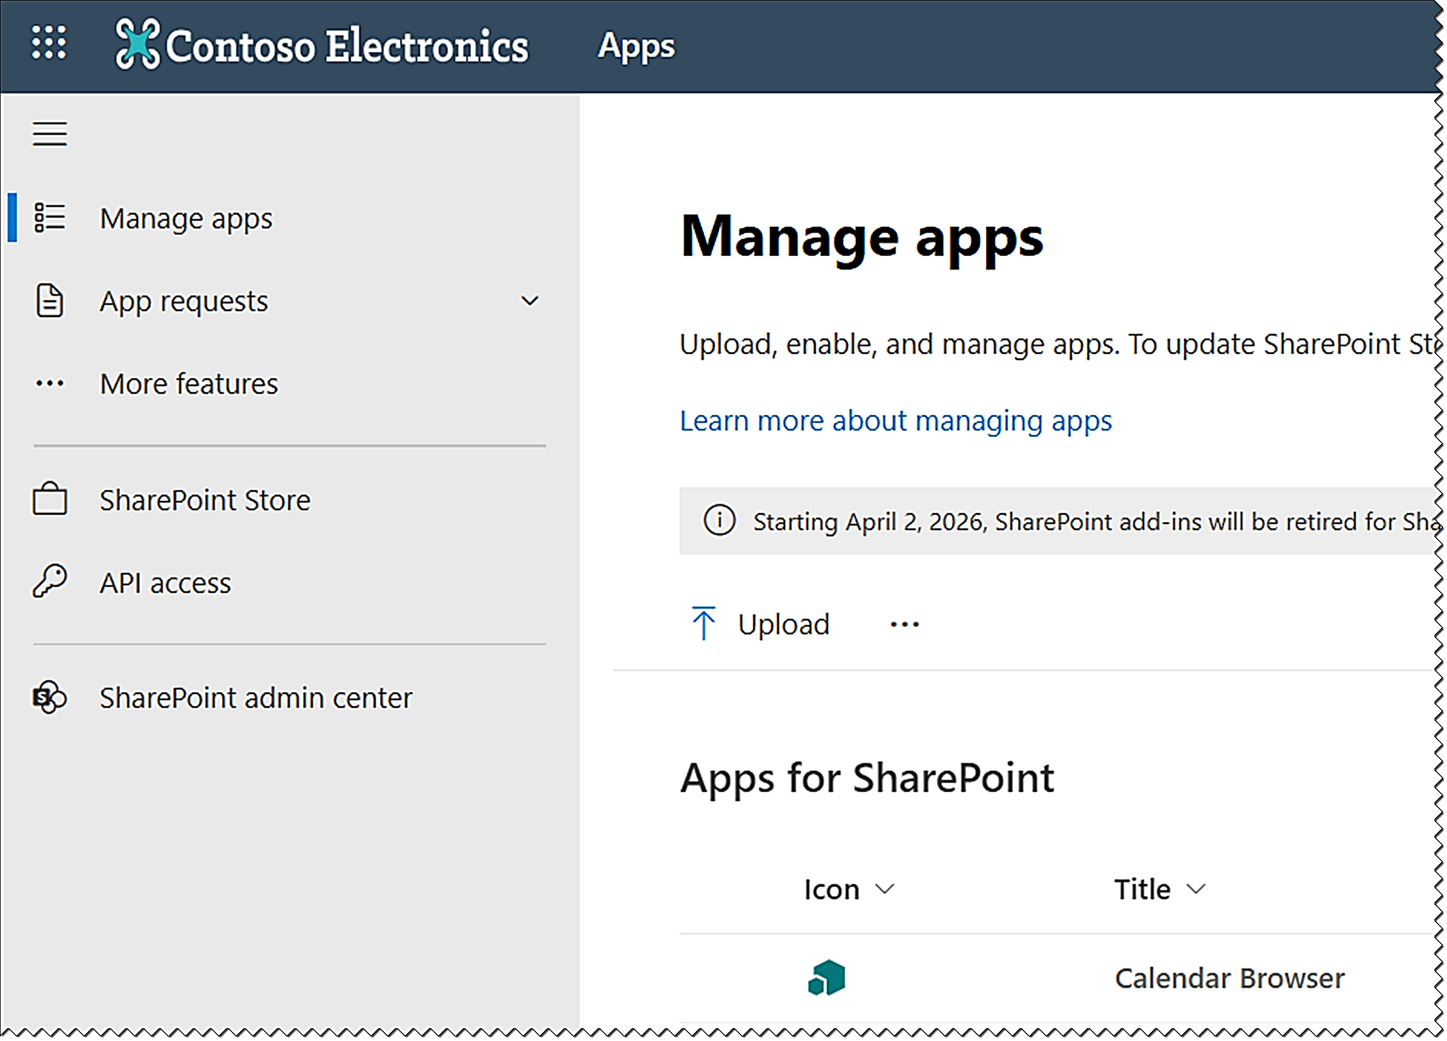
- A right Enable app pane opens. Select one of the options:
- Enable the file.
- Enable the file and add Calendar Browser to all sites. This option is default and makes it possible to use the Calendar Browser web part in pages in the whole tenant.
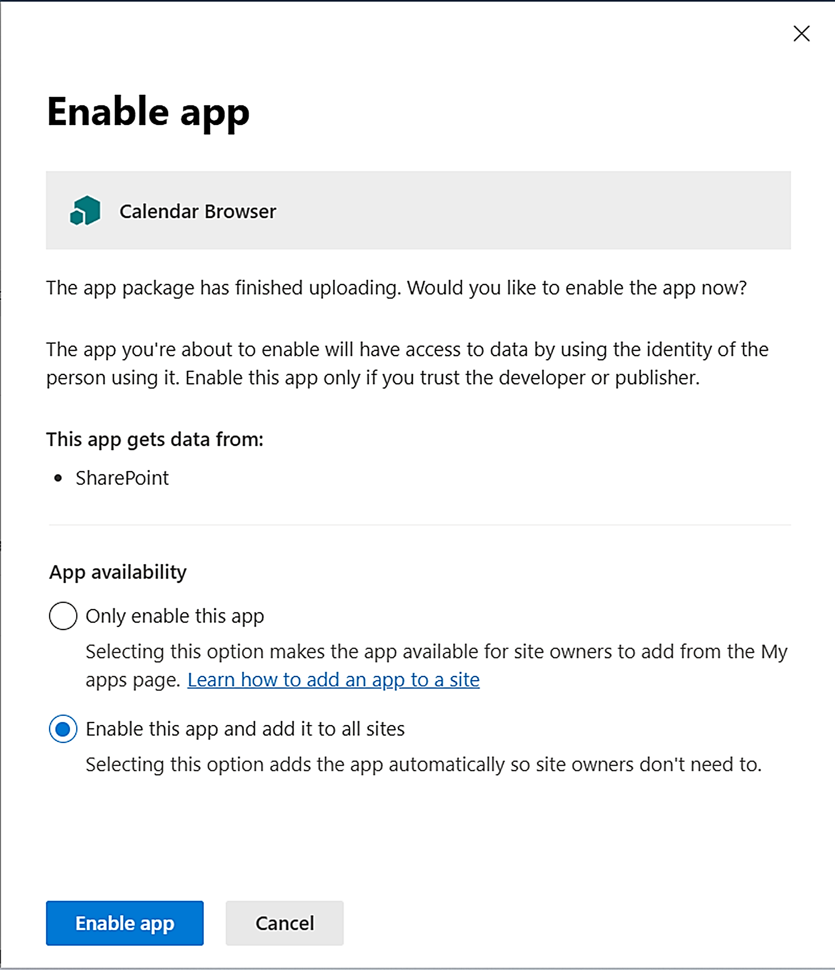
- Click on the 'Enable app' button.
- Close the right pane.

Deploy in a Site
If you have selected to only enable the file but not add it to all sites, Site owners must deploy Calendar Browser manually in each site where it should be used.
- In the site where you want to use Calendar Browser, click on + New >App in the modern homepage or Site contents, or click on the settings icon in the top navigation bar and select 'Add an app'.
- Select "All" or "From your organization" in the left menu.
- Click on the Calendar Browser tile.
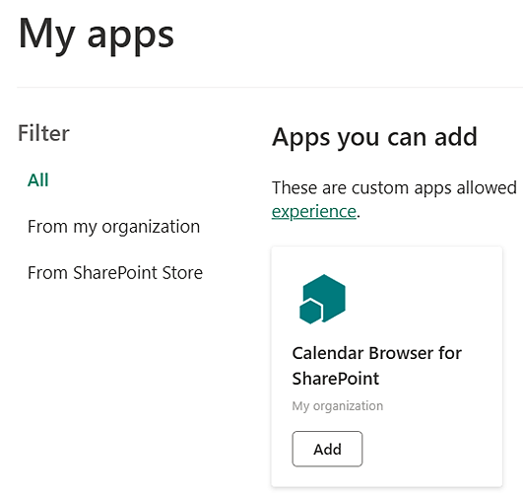
- Click on the 'Add' button.
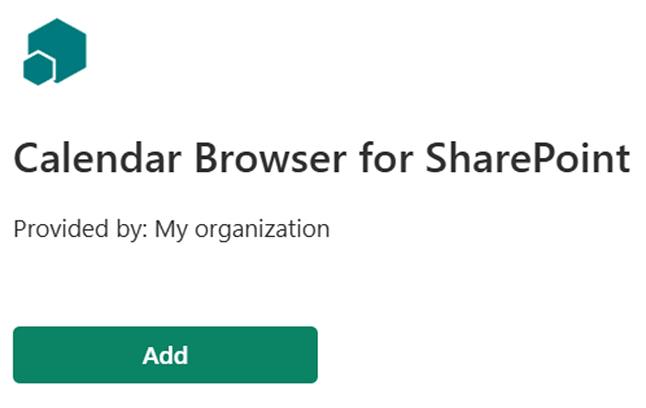
Now Calendar Browser will be installed in the current site, and the Calendar Browser web part can be added to pages in that site.
Repeat the process for each site where you want to use the Calendar Browser web part.

SharePoint On-Premises
Microsoft has created the SPFX edition for SharePoint Online, but the kalmstrom.com team has managed to get it to work for SharePoint On-Premises too.
We can however not change the text in Microsoft´s "Deploy" dialog, so it might look confusing for on-premises users to see "SharePoint Online" there, as in the image at step 3 below. Don't worry, you will get a Calendar Browser web part that works on all pages in SharePoint 2016, 2019 and SE.
- Go to the SharePoint farm's App catalog >Apps for SharePoint and upload the SPPKG file.
- A dialog opens. Check the box at 'Make this solution available to all sites in the organization.'
- Click on 'Deploy'.
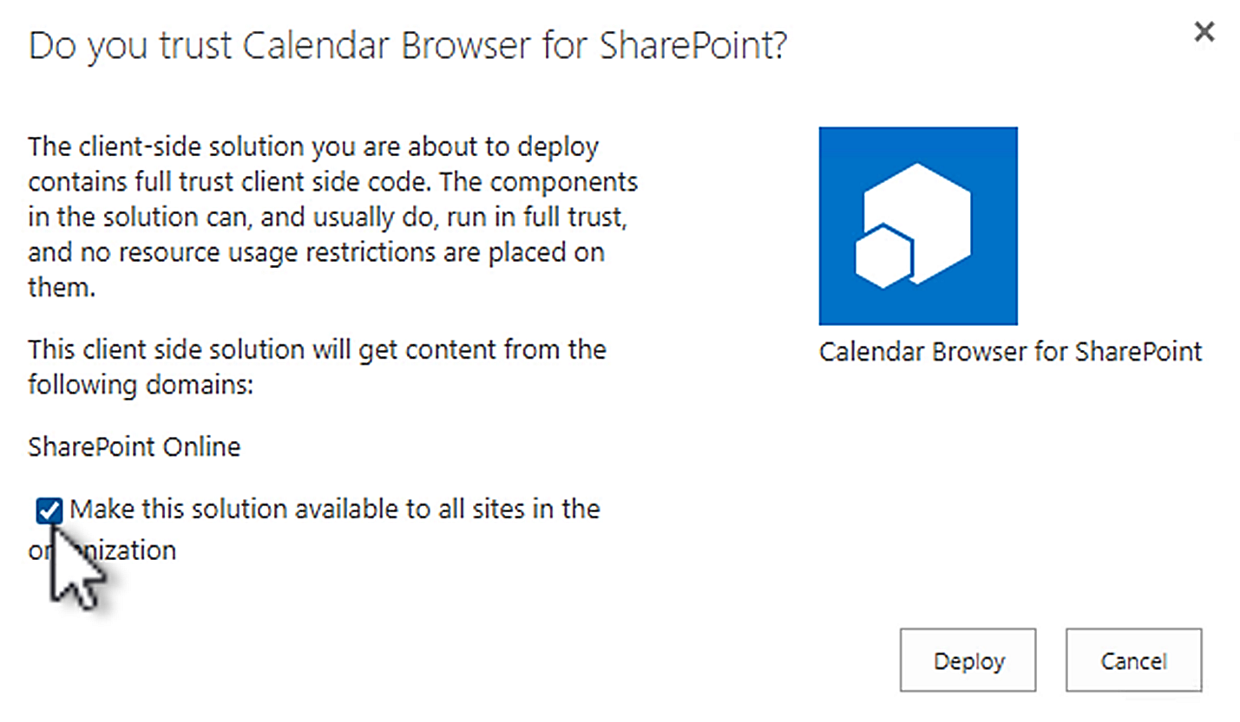
- Now the Calendar Browser web part is available in all pages in the farm.

Add the Web Part to a Page.
The Calendar Browser web part is found among the other web parts when you edit a page. In classic pages, Calendar Browser is found in the kalmstrom.com category. In modern pages, you can find it under Advanced or search for it.
We recommend that you use a one column section, remove the default comments section in modern pages and not add any additional web parts to this page.
The Calendar Browser overview will not be visible until you have published and refreshed the page. In a classic page, you might need to make a hard refresh with Ctrl+Shift+R to make it appear after publication.
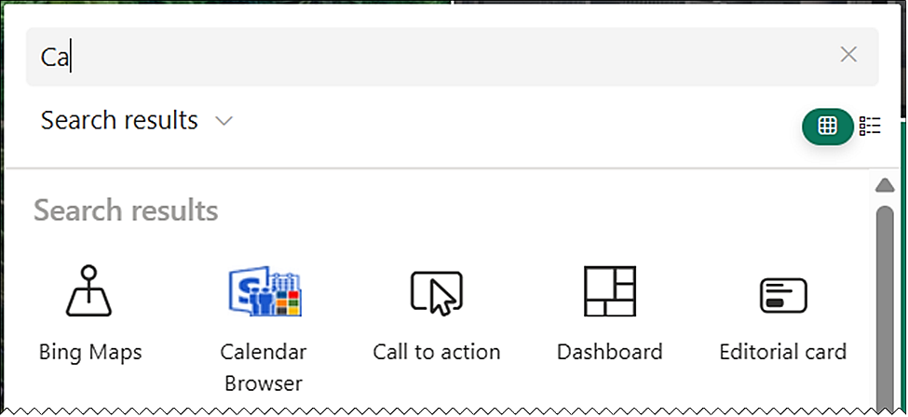

Add to Teams
To use Calendar Browser in Microsoft Teams, add a modern page with the Calendar Browser web part to a new Teams tab.
- Create a new modern page. You can start in SharePoint or open the Shared tab in the Teams channel you wish to use and go to SharePoint from the link under the ellipsis.
  - Give the page a name – it will be visible on the Teams tab.
  - Publish the page.
- Add a new SharePoint Page tab to the Teams channel.
- Select the page you created or paste the page link.
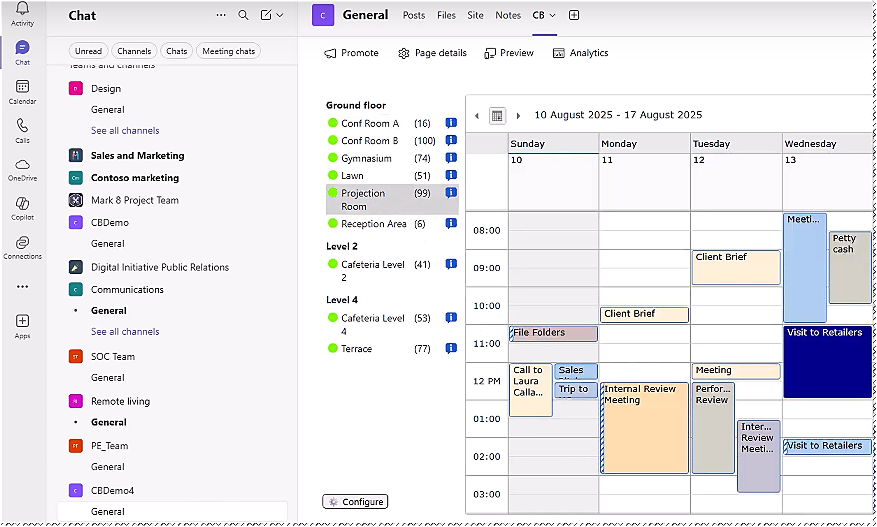
The process is described in a demo at https://www.kalmstrom.com/products/CalendarBrowser/DemonstrationsSP.htm.

Sandboxed Solution
The Calendar Browser Sandboxed solution is uploaded to a site's SharePoint Solutions gallery. It adds a site feature to the site, and this feature needs to be activated for the site and any subsites where it will be used. The upload and activation can be done manually or with a PowerShell script.
When the Calendar Browser feature has been activated, a Calendar Browser link will be added to the Web Designer Galleries group in the Site settings. Click on this link to get started, refer to 3.3.


Site Assets
When the Calendar Browser feature is activated for a site, two files will be created in the Site Assets library of that site: a JavaScript file, CB.js and a classic SharePoint page, CB.aspx. Another classic SharePoint page, CBSettings.aspx, will be created in the Site Assets the first time you save the configuration.
Before you start the installation, you must therefore make sure that the site really has a Site Assets library. If there is no such library, activate the Wiki Page Home Page feature under Site settings >Site actions >Manage site features, to create the library. (Your homepage will not be affected by this.)

Manual Installation
The manual installation of the Calendar Browser Sandboxed solution is performed with a WSP file that is downloaded from the kalmstrom.com website and then uploaded to a SharePoint Solutions gallery and activated there. After that, the Calendar Browser feature must be activated on the site, and on any subsites where it should be used, as described below.

SharePoint Online
If you want to use the Sandboxed solution in SharePoint Online, custom scripts must be allowed in the site during installation and upgrade. This is done in the SharePoint Admin center >Active sites >the sites Details pane >Settings, by a Global or SharePoint administrator.

SharePoint On-Premises
If you use SharePoint on-premises and have problems with the activation, please make sure that the Sandboxed code service is running on the SharePoint server.

Upload to a Solutions Gallery
- Go to the root site of the SharePoint site collection where you want to use Calendar Browser and click on the Settings icon in the top navigation bar.
- Select the Site settings option or select Site information and then Site settings.
- (If you don't see these options, most likely you don't have the appropriate permissions. You need to be Site admin to install solutions.)
- Under Web Designer Galleries, click on 'Solutions'.
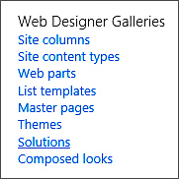
- Click on the 'Upload Solution' button and browse to the WSP file you downloaded from kalmstrom.com.
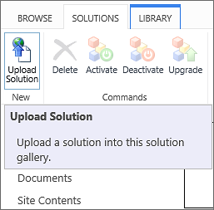
- When the file has been uploaded, you will be shown a dialog where you can activate the solution for the site collection and make Calendar Browser is available for the site and any subsites.

Activate for a Site
Before Calendar Browser can be used, the solution must be activated on each site or subsite where you want to add the Calendar Browser page. Note that you need to activate Calendar Browser this way if you want to use the solution on the root site of the site collection, even though you activated it when you uploaded.
- Click on the settings icon in the top navigation bar and click on 'Site settings'. You might need to first click on 'Site information'.
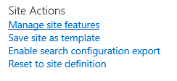
- Click on 'Manage site features' under the Site Actions heading. (If you don't see this option, most likely you don't have the appropriate permissions. You need to be at least Site owner to manage site features.)
- Find Calendar Browser in the list of Site features.
- Click on the 'Activate' button to activate the Calendar Browser feature.
- The activation adds a Calendar Browser link in the site settings.

PowerShell Package
The PowerShell script is most useful when you want to automate the process of installing Calendar Browser in multiple sites. This edition comes as a ZIP file that includes a PowerShell script, which must be modified for each organization before it is run. The PowerShell package works in both Online and On-premises SharePoint.
The changes that must be made for each organization are explained in the script, and the demos on the download page shows the process, but you should still have some experience of PowerShell to use this installation method.
It is the same script for all SharePoint editions, but note that SharePoint Online only supports PS7, which does not work with PowerShell ISE.
- Open PowerShell ISE or Visual Studio Code as an administrator.
- Open the .ps1 file included in the downloaded .zip file.
- Modify the script:
- Change to your SharePoint version if necessary.
- (For SharePoint Online, add your Client ID.)
- Include the sites where you want to install Calendar Browser.
- Connect to your farm or tenant.
- Run the script.
- Now the script installs Calendar Browser in each site that has been added to the script.

Get Started
The Calendar Browser Get started screen is displayed when the site where Calendar Browser has been installed has no calendar/events apps. From this page you can create example data or add your own resource calendars to Calendar Browser. There are also links to documentation on the kalmstrom.com website.
If the site has at least one events app/calendar, the Calendar Browser overview will be displayed instead.
The Sandboxed solution displays the Get started screen when it has been activated and you click on the Calendar Browser link in the Site settings.
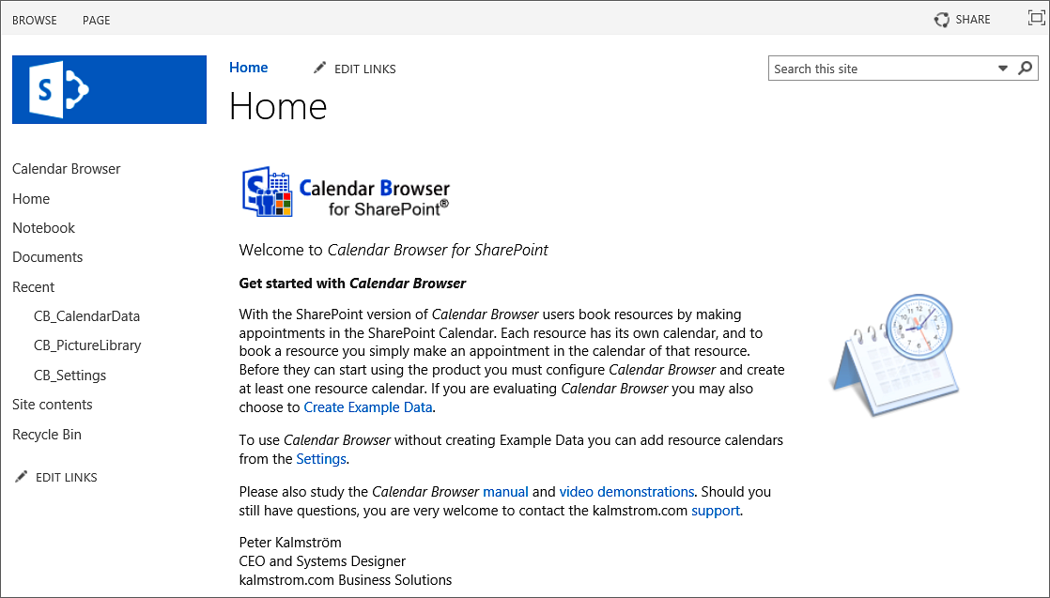
For the SPFX editions, the Get started information becomes visible when you add the Calendar Browser web part to a page and publish it.

Example Calendars for Evaluators
If you are new to Calendar Browser, it might be a good idea to load the example calendars with events. It gives you an opportunity to see how Calendar Browser works when you have a lot of data in it, what performance you can expect and so on.
(If you select not to install example data, you should instead add your own resource calendars to Calendar Browser, refer to chapter 5.)
Example data can be created in two ways:
- If the Get started screen opens, click on the 'Create Example Data' link.
- If Calendar Browser opens with the overview, click on the Configure button. Then open the Example data tab and click on Add.
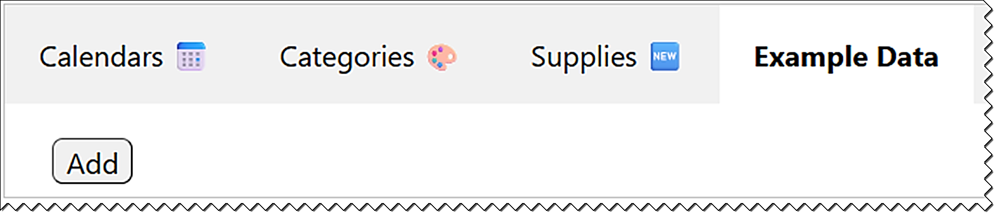
The example data creation will take a few minutes. In the example calendars we use business premises as resource examples, but Calendar Browser can be used for everything that needs to be booked within an organization.
The Calendar Browser overview opens when the example data has been created.
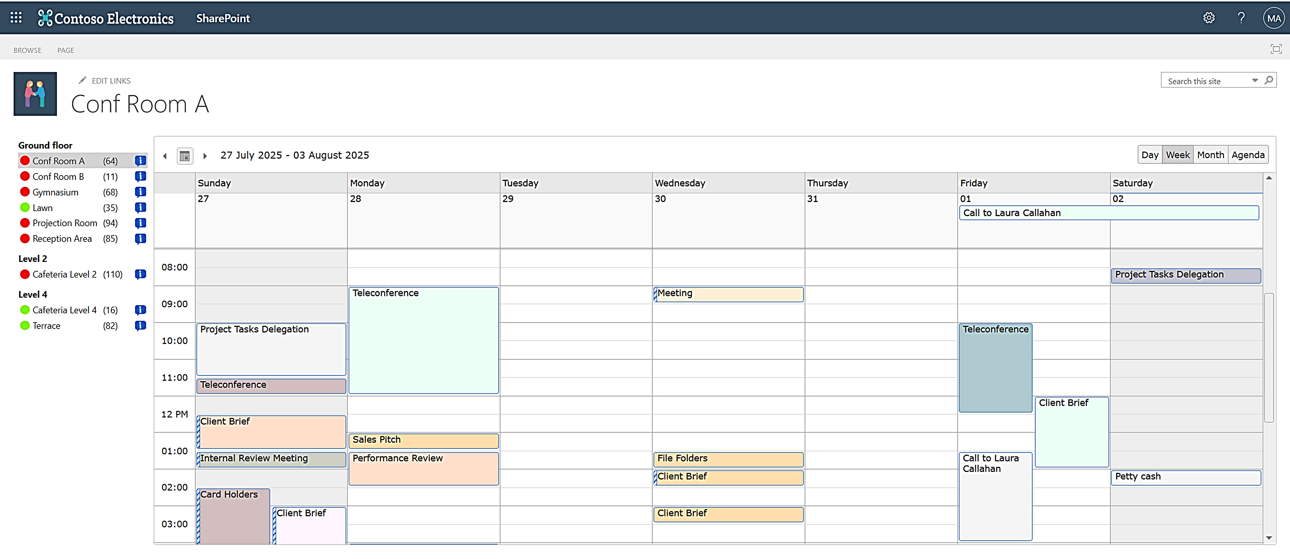

Remove Example Data
Remove the example calendars as you remove other SharePoint apps: open the Site contents, select a calendar and delete it.
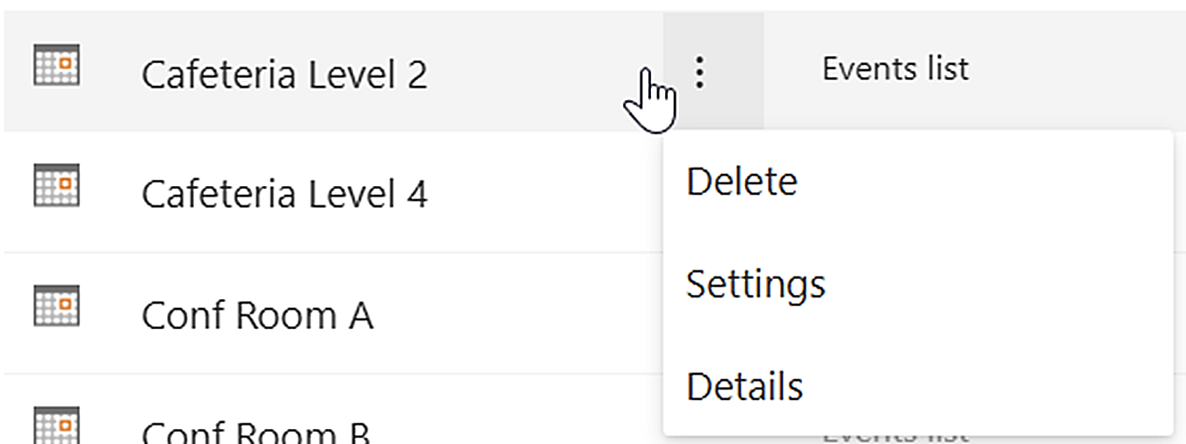

The Calendar Browser Settings
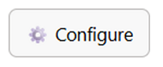
The Calendar Browser settings are reached via the Configure button below the calendar panel.
The configuration is organized under tabs, as described below. If your organization does not need some of the features, do not fill out any information under the corresponding Settings tab.
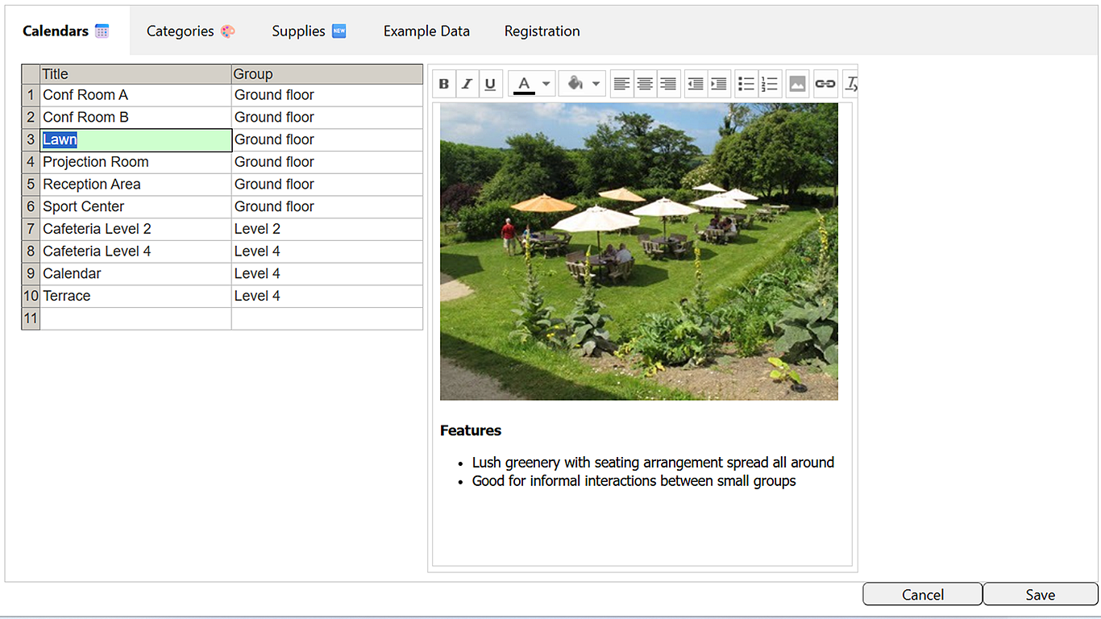

Calendars
Under the Calendars tab, you can add and group resource calendars and give each resource a description.
When a site already has events apps, Calendar Browser will pick them up and add them to the calendars overview and to the first tab in the settings.
Apart from creating resource calendars via 'Add an app', in the usual way, you can type in calendar names in the Calendar Browser settings- Resource calendars with those names will be created automatically when you click on Save.
Another way to add resource calendars to Calendar Browser is to copy and paste calendar names from somewhere else, for example Excel. Calendars with the same names will then be created in the SharePoint site when you click on Save. Group names can also be pasted.
You can rename calendars by selecting a calendar in the Calendar Browser settings and entering a new name for it.

Descriptions
Under the Calendars tab, each resource can be described with rich text, background colors, links and images. Images can be added with copy and paste or via the Insert button in the editor. Suitable images should be about 370 pixels wide.

Categories
Use the second tab if you want users to categorize bookings in some way. If you give each category a dedicate color, these colors will be displayed on the bookings in the Calendar Browser overview.
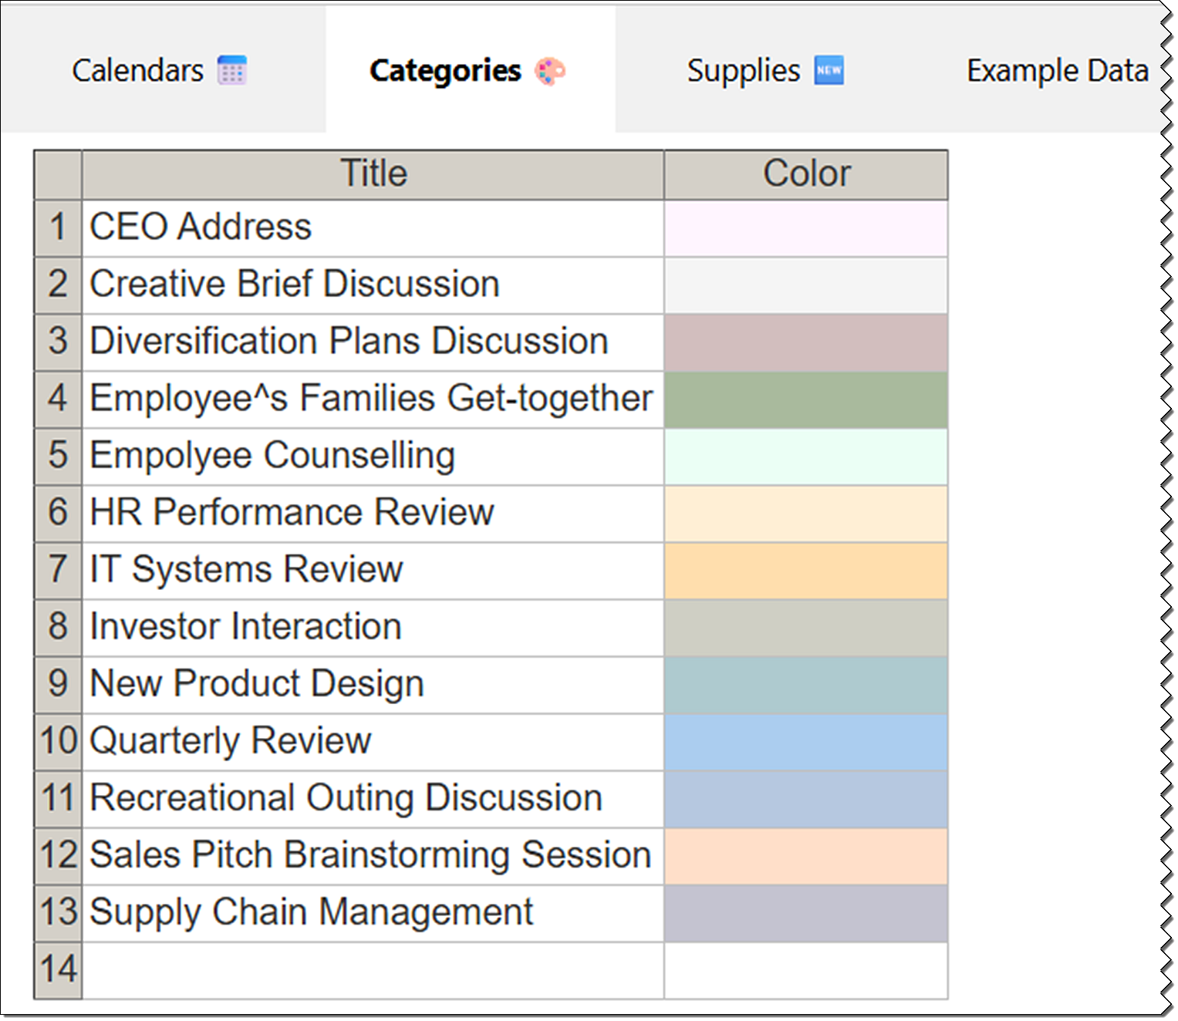

Supplies
Under the supplies tab, you can specify all supplies that might be needed with the resource and the cost for each item. The currency will be the one already specified for your system.
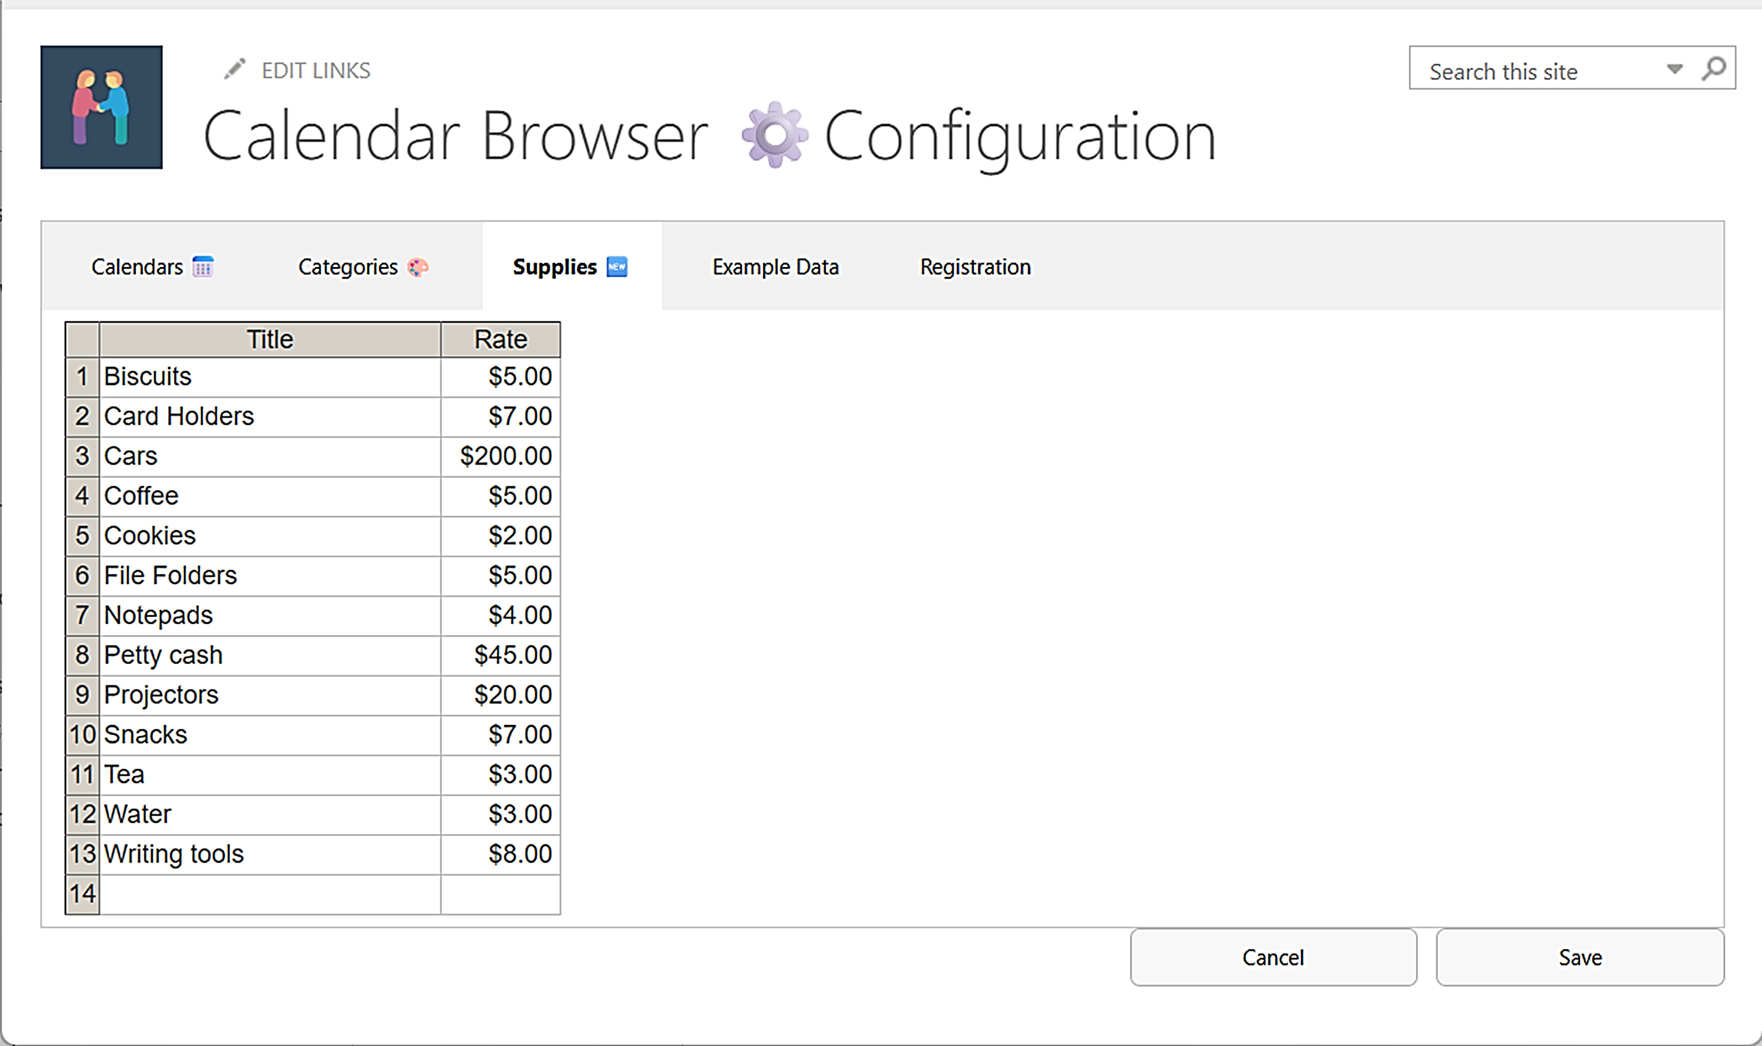
When an item is removed from the Supplies items list, it will only be removed from the Supplies items list, so that it is not available for future bookings. It will not be removed from existing events unless a user edits that event.

Registration for Standard Subscribers
This information is only valid for organizations with a Standard Subscription. Premium Subscribers do not need to register their installations, so there is no Registration tab in the Premium copies.
Register Calendar Browser by clicking the Registration button under the Registration tab in the Configuration. Here, you can also see how many days are left of the evaluation period.
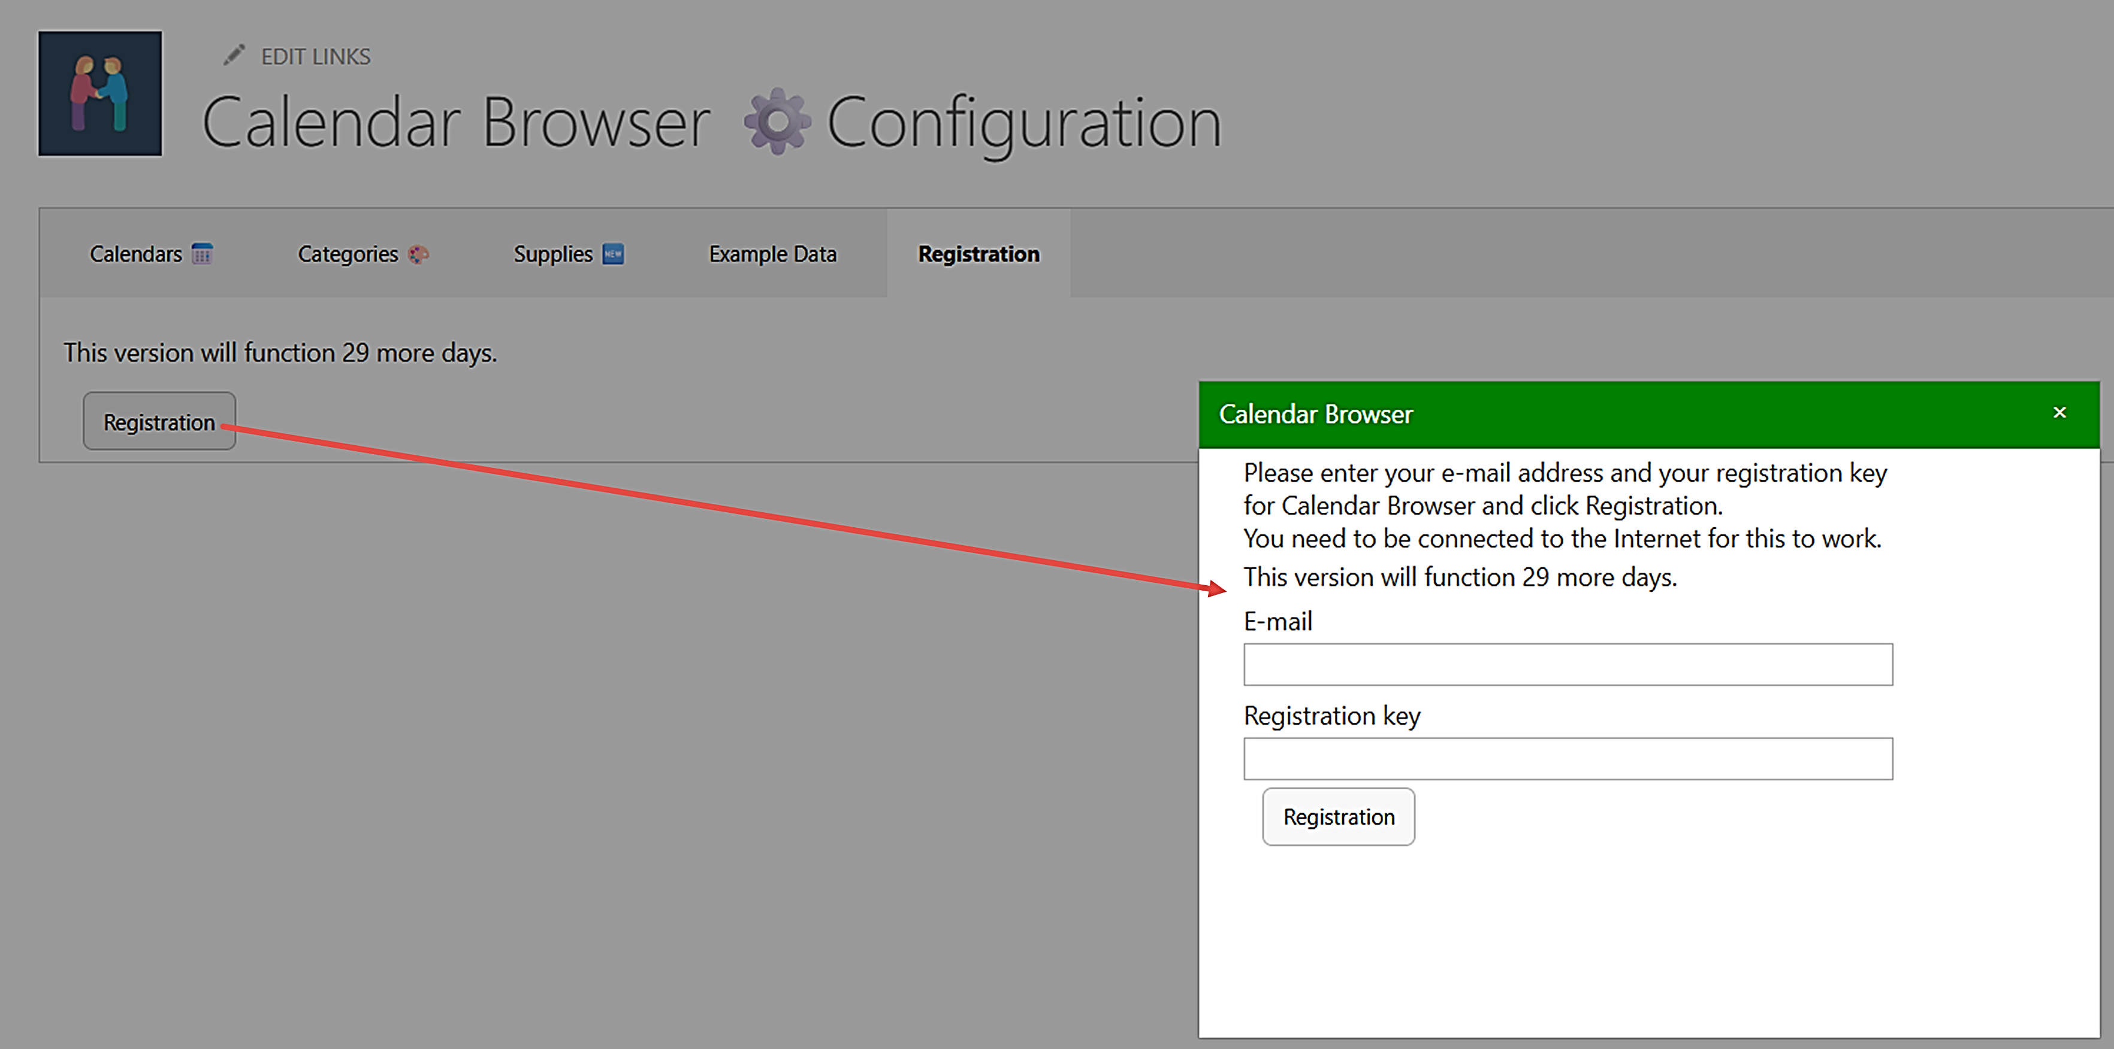
The person who registers Calendar Browser should have Owner permission on the site. Each site installation needs to be registered.
Add an e-mail address with the domain name of your company/organization and the registration key you have received from kalmstrom.com.

Upgrade and Removal
We have made our utmost to make the Calendar Browser upgrade process easy and quick, and we also want the removal process to be smooth if your organization should decide not to use Calendar Browser anymore.

Upgrade
Upgrades are free for all subscribers to kalmstrom.com products, and we recommend that you always use the latest version of Calendar Browser. That is the only version we support, so we have made our utmost to make the upgrade process easy and quick.
Premium subscribers will have an e-mail when their unique copies of Calendar Browser have been updated. Standard subscribers can download the new version of Calendar Browser from the kalmstrom.com website. At major updates, we will send an e-mail also to Standard subscribers.
You can see all the revisions and file numbers at:
https://www.kalmstrom.com/products/CalendarBrowser/RevisionsSP.htm
The Sandboxed solution och PowerShell package use the same folders, so you can very well upgrade the Sandboxed solution installations with the PowerShell script and vice versa.
The ​SPFX editions are different, so you cannot upgrade these installations with a Sandboxed solution .wsp file or PowerShell script, and vice versa.
If you still have the old version after upgrade, it is probably left in your browser cache. Please clear the cache to solve that problem.

Upgrade the SPFX edition
All the tenant's installations of Calendar Browser will be upgraded automatically when you add the new SPPKG file to the app catalog.
- Download the file.
- Remove the old Calendar Browser SPPKG file from the app catalog.
- Upload the new SPPKG file to the app catalog.
- Enable the SPPKG file.
- All Calendar Browser installations will now be upgraded automatically.

Upgrade the Sandboxed Solution Manually
To upgrade Calendar Browser, replace the old Calendar Browser WSP file with a new version of the file. This is the upgrade process for each site collection where Calendar Browser is used:
- Deactivate and remove Calendar Browser under Site settings >Solutions in each (root) site where it is used.
- Delete the Calendar Browser files in the Site Assets library.
- Upload the new Calendar Browser WSP file to the Solutions gallery and activate it.
- Activate Calendar Browser under 'Manage site features' on each site.
SharePoint Online: custom scripts must be allowed in the site before you upgrade Calendar Browser with the WSP file.

Upgrade with a PowerShell Script
Use this upgrade method whether you have installed Calendar Browser with the PowerShell script or with the WSP file and want to upgrade using PowerShell.
- Open the new Calendar Browser script in PowerShell ISE or Visual Studio Code.
- Modify the script so that it suits your installations. This is quickly done if you have saved the part of the old script that contains the sites where Calendar Browser was installed.
- Run the script to upgrade the installations in all sites that are included in the script.

Remove Calendar Browser
We of course hope that you will be satisfied with Calendar Browser, but if you want to remove it from a site that is an easy process.
If your organization cancels the Calendar Browser subscription, the product must be removed in all sites. Resource calendars will not be removed if you delete the Calendar Browser installation files.
- To remove the Calendar Browser SPFX edition, remove the file from the App catalog/Apps site. The web part will still be left in the pages where it has been used. If you don't remove it, these web parts will be populated if you install Calendar Browser again.
- To remove the Calendar Browser Sandboxed solution WSP installation, follow step 1-2 in the Upgrade instruction above.
- To remove Calendar Browser with a PowerShell script, run the parts of the script that remove Calendar Browser.

Support
To use Calendar Browser you must have a valid subscription. Free upgrades and the kalmstrom.com Support Services are included in all subscriptions. Support is also free for evaluators, and we welcome all communication.

Contact
The solutions of kalmstrom.com are designed to be very easy to deploy, use and manage. However, if you have any kind of problems or questions about our software, there are several ways of contacting us:
E-mail | support@kalmstrom.com | Technical issues
 | sales@kalmstrom.com | General and sales issues
 | finance@kalmstrom.com | Subscription issues
Teams | peter@kalmstrom.com
Zoom | peter@kalmstrom.com
Telephone | +46 739 206 106

More SharePoint Tips
You surely have noticed that Calendar Browser for SharePoint uses what is best in SharePoint. For tips on SharePoint usage in general, please refer to the Tips section of the kalmstrom.com website.

